MaskGen

**Journaling Tool**

**Batch Project**

**26 July 2017**

Prepared for:

**Submitted by:**

|  |  |  |  |
| --- | --- | --- | --- |
| **REVISION RECORD** | | | |
| **REVISION** | **DATE** | **DESCRIPTION & PAGE AFFECTED** | **AUTHOR** |
|  | 7/26/16 | Initial Revision |  |

**Table of Contents**

1) Overview 1

2) SPEcIFICATION 1

2.1 Overall File Structure 2

2.2 Operations 2

2.3 Plugin Review 4

2.4 Argument Types 4

2.5 Using the InputMaskPlugin 6

2.6 Critical Plugins 6

2.6.1 Select Region 6

2.6.2 Paste Splice 8

2.6.3 Pre Segmented Images 9

2.6.4 Design Paste Clone 9

2.7 Permutations 10

2.7.1 Saving State 11

3) Example 12

3.1 Crop Example with Permutations 12

3.1.1 Reusing the Same Image for Multiple Projects. 12

3.1.2 Defining Permutations for the Crop Region 13

3.1.3 Using Permutations in Crop 13

3.1.4 Running this example. 14

**List of Figures**

Figure 1 Example Specification Layout 1

Figure 2 InputMaskPlugin Process Specification 6

Figure 3 Example Specification with Sample Resulting Project 12

# Overview

The batch project creates projects from start to finish using plugins. A project specification describes the specific manipulations to perform. Parameters for those manipulations can be selected using randomized selectors, lists, specific values, input masks, and computed values. Groups of parameter values can be organized into permutation groups to control specific permutation of parameters across multiple projects generated on behalf of a batch project specification.

Plugins perform most of the work performed in the batch projects. A special class of plugins support preselection and analysis of data images to provide inputs into other plugins. For example, a plugin can select a mask from a from mask image presenting color-coded classified segments of an associated image. This integrates presegmented images by a machine learning algorithm to be used as part localization tasks.

# SPEcIFICATION

A specification is a dependency graph that mirrors (with some exceptions) the structure of the final projects.

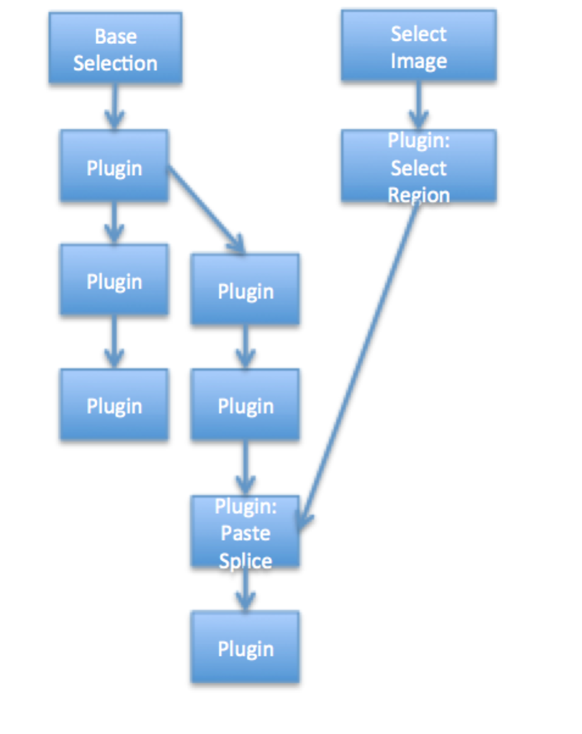

Figure Example Specification Layout

Each node in the graph is an operation. Each link is a dependency. A node operation is not executed until its dependency nodes have been executed. Each operation is parameterized in the specification to direct the operation’s execution. Parameters

**Operation Nodes**:

**Select Image**: Provided a pool (directory) of images

**Base Selection**: Same as Select Image, except start new project using the selected image name.

**Plugin**: Execute a plugin operation to create a new manipulated image. *Requires consistent parameters.*

**Input Mask Plugin:** Execute a plugin on a image to produce an (input) mask and any additional name/value pairs to be used to as parameters in subsequent operations. Input masks highlight groups of pixels (full intensity) as constraints to other plugins.

## Overall File Structure

The specification is a JSON file using networkx format. The file is broken up into three sections, encased a shell. The graph section contains overall properties for the resulting projects, the node section lists all the operation nodes and the links section forms the dependencies between the nodes.

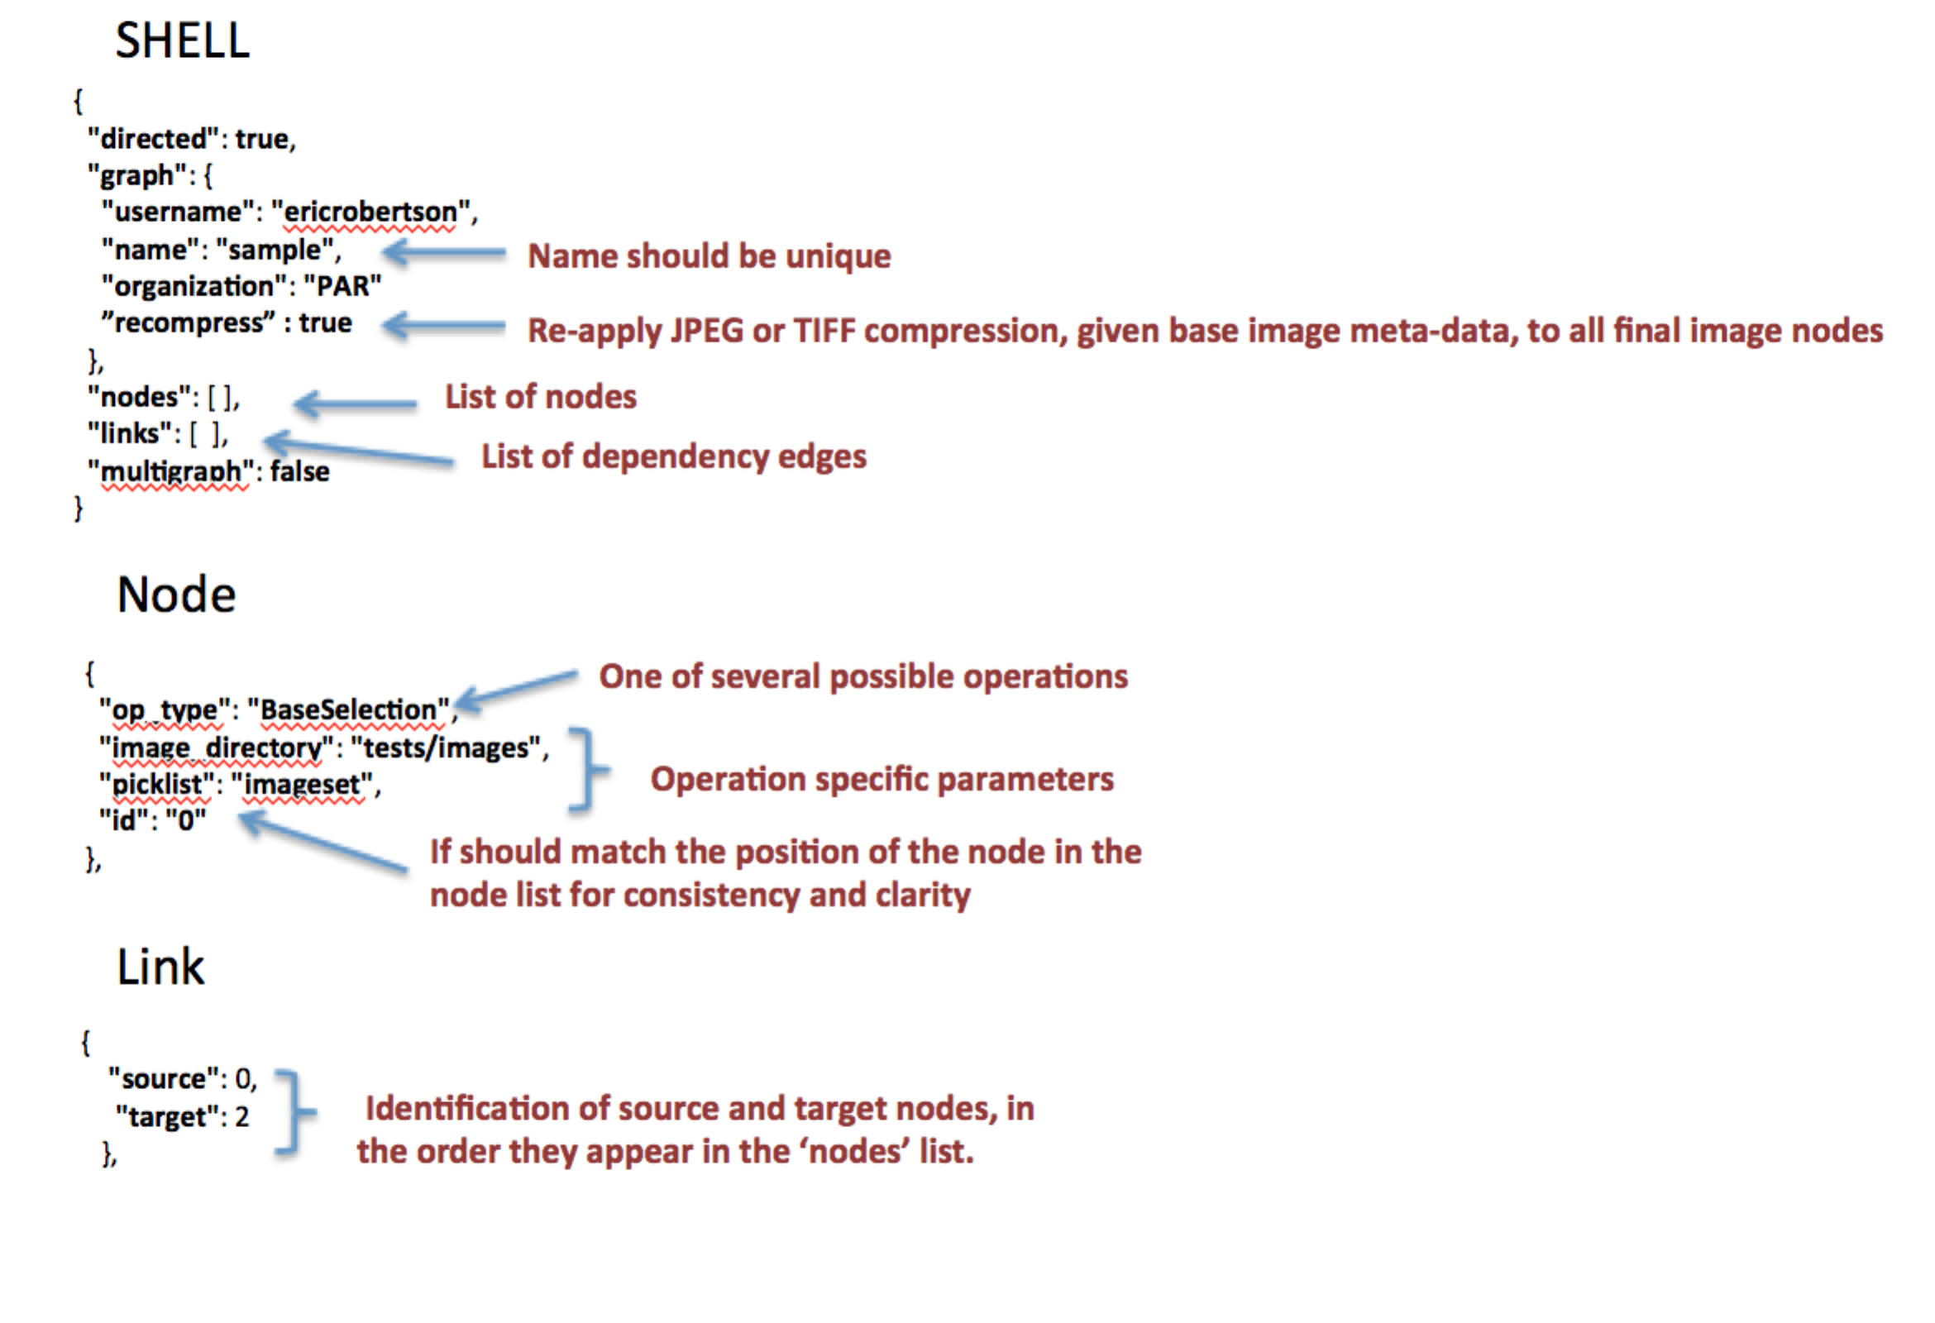

## Operations

**BaseSelection**

Select an image from a pool of images maintained in a directory. The base selection provides a single image used to start a new project. The selected image provides the name of the project. The image is expected to serve as a (the) base image for the project that is to be manipulated. There must be one and only one BaseSelection node; it must not have any predecessor nodes.

Parameters:

* + **"image_directory”** = a directory of a pool of images to select from (randomly)
  + **"picklist"**: an in memory structure tracking the names of image files already picked from projects to prevent future selection. A file is created with the same name in the ‘working directory’, retaining the pick list selection across multiple independent and sequential batch runs. In absence, the file with the same node as the node identifier is used to maintain the picklist, thus forcing the picklist to be unique to a single node.
  + **“permutegroup” =** those parameters sharing the same permutegroup are organized into a group to form permutations of all possible parameter values. Thus, a single image can be used to produce multiple projects, each with variations to the results of the plugins in response to the different parameters provided.

**ImageSelection**

Select an image from a pool of images maintained in a directory. Like BaseSelection, an ImageSelection node most not have any predecessor nodes. Unlike BaseSelection, multiple ImageSelection nodes are permitted.

Parameters:

The parameters are the same as the BaseSelection. The image directory and picklist can use the same pool as other ImageSelection and BaseSelection nodes.

**PluginOperation**

Invoke a plugin, producing a manipulated target image given a source image. The source image is assumed to come from a direct dependent operation node. The plugin operation is invoked for each dependent node that is either ImageSelection, BaseSelection or PluginOperation. The source image from each dependent node is operated upon by the plugin producing a target image, associated target node in the resulting journal project and a link between the source and target nodes in the journal project.

Parameters:

* + **“plugin” =** the name of the plugin
  + **“arguments” =** the set of arguments to be provided to the plugin. Each argument as a type and supporting descriptions. Arguments fill **both** the requirements of the plugin and the requirements of the operation definition.

**InputMaskPluginOperation**

Invoke a plugin, producing an input mask and any additional name/value pairs based on the source image. The input mask and name/value airs can be used as parameters to other dependent plugins.

Parameters:

* + **“plugin” =** the name of the plugin
  + **“arguments” =** the set of arguments to be provided to the plugin. Each argument as a type and supporting descriptions. Arguments fill **both** the requirements of the plugin and the requirements of the operation definition.

## Plugin Review

* Plugins are operations.
* Plugins are provided, as inputs:
  + Filename of source image
  + Filename of target image
  + Additional arguments
* Plugins action:
  + Overwrite target image
  + Optionally return name/value pairs that may be used as to set parameters of subsequent plugins.

An input mask plugin pre-selects a group of pixels of a source image for alteration but subsequent operations.

## Argument Types

Each argument is a map containing a set of properties including a type.

* **imagefile =** select an image produced by another node. The image’s source node is identifier using it’s node id.

{  
 "type" : "imagefile",  
 "source" :"4"  
 }

* **mask=** select an image mask produced by another node. Change masks are specific to an edge: a source and target node pair. An edge is identified by source and target node ids. The mask is used by some plugins to identify regions within the source image to manipulate.

{  
 "type" : “mask",  
 "source" :"4"  
 “target" :“6“

}

* **value=** set a parameter to a specific value**.** The type of the value should match expected type for the associated parameterd by the plugin.

{   
 "type" : "value",  
 "value" :"yes"  
}

* **donor=** select the resulting image from any predecessor node. ‘source‘ is optional. In its absence, one of the direct decendant nodes is chosen.

{  
 "type" : ”donor",  
 “source”:”3”

}

* **list=**randomly pick from a set of values

{  
 "type" : ”list",  
 "values" :[”other”, “landscape”]

}

* **variable =** select an output name/value pair from a predecessor plugin node. The source node is provided using it’s node id. The pair’s value is identified by the name

{  
 "type" : “variable",  
 “name" : “box_altered“,

"source" :"4"  
 }

* **input=** identifies the name of input image file (input mask) from the output (target) image of another plugin**.** The source node is provided using it’s node id.

{  
 "type" : “input",  
 “source" :“6“

}

* **plugin=**call a plugin function registered through the Python setuptool‘s entry point *maskgen_specs*. The function name is the entry point name. The function accepts a dictionary of parameters, provided in the definition.

{  
 "type" : ”plugin”,

“name" : “kernel_builder“,

”parameters" : { “kernel_size”: 5}

}

* **int[low:high]=**select a value, uniform distribution over the range, inclusive**.**

{  
 "type" : ”int[1:100]”

}

* **float[low:high]=** select a value, gaussian distribution over the range, inclusive

{  
 "type" : ”float[0.0:1.0]”

}

* **yesyno=select yes or no**

{  
 "type" : ”yesno”

}

## Using the InputMaskPlugin

The InputMaskPlugin enables pre-selection of pixels and parameters give an image. The resulting masks and parameters are available to direct or indirect child plugin operations with the specification. This enables consistent processing across multiple plugins that coordinate in a complete manipulation.

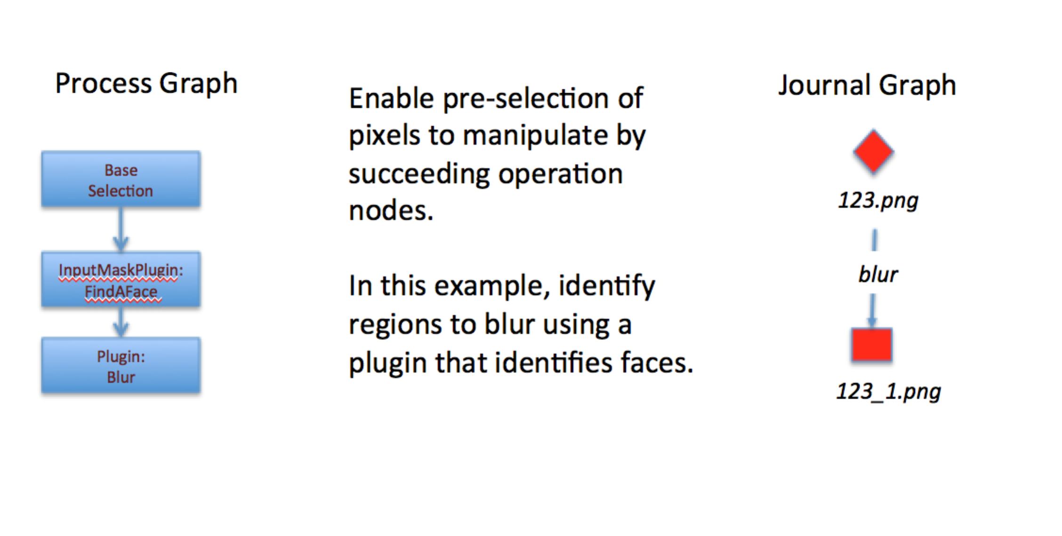

Figure InputMaskPlugin Process Specification

## Critical Plugins

### Select Region

Selecting a region of an image is effectively setting the alpha channel of an RGBA image, adding the alpha channel if necessary, such that selected pixels are 255 and unselected pixels are 0. SelectRegion is used prior to donation for operations such as Paste Splice.

There are three plugins that support Select region.

1. SelectRegion – The plugin uses Felzenszwalb  to segment the image. A single connected set of pixels are selected. The plugin returns ‘paste_x’ and ‘paste_y’ parameters selecting a suitable region within the selected image for use in paste clone type operations. SelectRegion can also be used to create a selection mask by setting the input parameter ‘alpha’ to ‘no’
2. SmartMaskSelector – The plugin uses SLIC to segment the image. The plugin accepts several size constraining parameters to tune the selection process. As with SelectRegion, SmartMaskSelector can also be used to create a selection mask by setting the input parameter ‘alpha’ to ‘no’. Unlike SelectRegion, the default alpha value is ‘no’. Furthermore, SmartMaskSelector also returns paste_x and paste_y parameters.
3. SelectionRegionWithMask – The plugin uses a previously selected or modified region, as indicated by an inputmask, to select the region.

**{  
 "id": "4",  
 "op_type": "PluginOperation",  
 "arguments": {  
 "mediumh": {  
 "type": "int[64:128]"  
 },  
 "smallw": {  
 "type": "int[32:64]"  
 },  
 "largew": {  
 "type": "int[128:512]"  
 },  
 "largeh": {  
 "type": "int[128:512]"  
 },  
 "op": {  
 "type": "list",  
 "values" : ["box","slic"]  
 },  
 "smallh": {  
 "type": "int[32:64]"  
 },  
 "size": {  
 "type": "int[1:3]"  
 },  
 "mediumw": {  
 "type": "int[64:128]"  
 },  
 "alpha": {  
 "type": "value",  
 "value": "yes"  
 }  
 },  
 "plugin": "SmartMaskSelector"  
},**

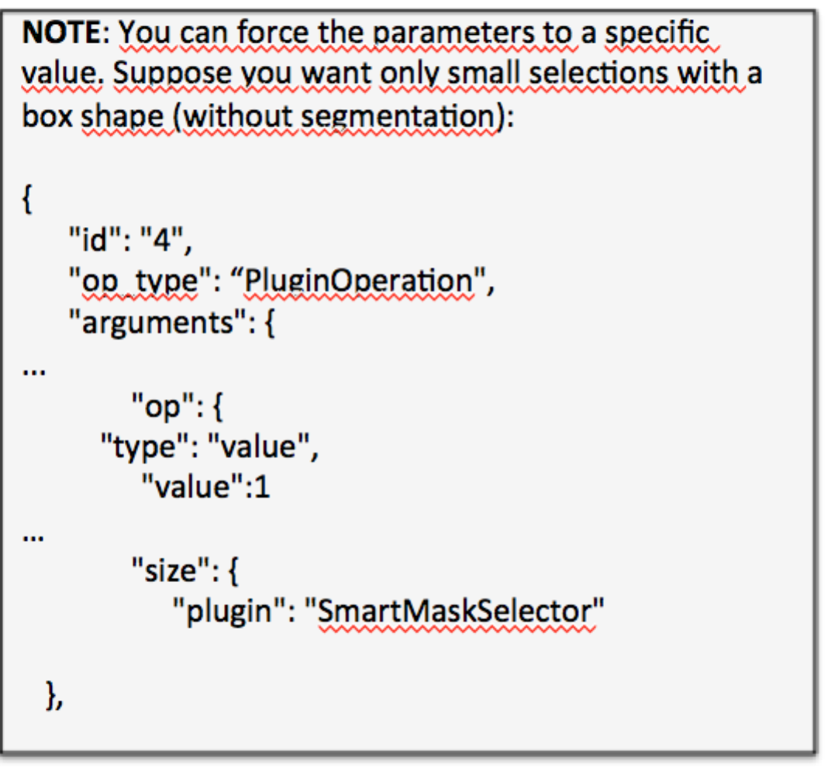

### Paste Splice

There are a number of plugins available to aid in Paste Splice. The example project specification tests/batch_process.json under maskgen contains an example paste splice configuration.

In the example, the SelectRegion plugin uses Felzenszwalb to segment the source image to find a spliced object.

By default. the PasteSplice plugin places a selected image on a random selected area in the target image with rescale or rotation. This approach is called ‘simple’. A ‘random’ approach includes random resizing and rotation. PasteSplice also supports a complex placement solution using either SLIC (segment value of ‘slic) or Felzenszwalb (segment value of ‘felzenszwalb’) to select a placement region of some uniformity (texture).  It includes rescale and rotation, as needed, to fit the pasted object into the selected placement region.  Naturally, this approach is slower. This option is turned on by setting ‘approach’ to ’texture’ on the PasteSplice plugin (show below).

**{  
 "op_type": "PluginOperation",  
 "plugin": "PasteSplice",  
 "id": "5",  
 "arguments": {  
 "approach": {  
 "type":"value",  
 "value": "texture"  
 },  
 "segment": {  
 "type":"value",  
 "value": "slic"  
 },  
 "donor" : {  
 "type": "donor"  
 }  
 }  
}**

The PasteSplice plugin returns the ‘transform_matrix’ parameter recording the transformation applied to the donor image. The matrix is a 3x3 transform matrix.

### Pre Segmented Images

Another option for selecting a region of an image is the PreSegmentedSelectionRegion plugin.    The plugin is designed to be used with a custom segmentation algorithm, like a deep learning approach.  The intent is to have a set of images pre segmented, each with an associated RGB mask image that color-codes the regions of the segmented images.

The plugin mask expects the pre-segmentation algorithm to create output image masks with the same name as the image (suffix with .png), placed in a separate directory.   Within that same directory, a classification.csv file contains the mappings of color to subject descriptor, in accordance the SelectRegion plugin categorization, those classifications include “people","face","natural object","man-made object","large man-made object","landscape", and ”other”.

The arguments to the plugin include the segmented mask directory (segmentation_directory) and the color to use (color). The color is optional. In its absence, one will be chosen at random given the available classification colors in the chosen image. If a color appears in more than one connected component within the mask image, only one region of connected component is selected.

The color identified in the classifications.csv is the RGB color. Here is an example:

"[200,100,200]", natural object

### Design Paste Clone

The DesignPasteClone plugin supports paste sampled cloning. It requires in an input mask of the indicated the pixels to be cloned and a location (upper right corner) to paste the cloned region. The plugin requires a preselected input mask, paste_x and paste_x location parameters. The plugin is often provided these parameters by forming a dependency on either the SelectionRegion (alpha = ‘no’) or SmartMaskSelector plugins (alpha = ‘no’) configured as InputMaskPluginOperations.

**"id": "DesignPasteClone1",**

**"op_type": "PluginOperation",**

**"arguments": {**

**"inputmaskname": {**

**"source": "CloneMaskSelect",**

**"type": "input",**

**"description": "localized selector"**

**},**

**"paste_y": {**

**"source": "CloneMaskSelect",**

**"type": "variable",**

**"name": "paste_y",**

**"description": "localized y position paste"**

**},**

**"paste_x": {**

**"source": "CloneMaskSelect",**

**"type": "variable",**

**"name": "paste_x",**

**"description": "localized x position paste"**

**},**

**"purpose": {**

**"type": "value",**

**"value": "clone"**

**}**

**},**

**"experiment_id": null,**

**"plugin": "DesignPasteClone"**

**}**

## Permutations

Permutations are used to control the distribution of parameters for plugins across multiple projects. To permute values of a parameter with other parameters, add the parameter to the same permute group with the argument definition. In the example below, the percentage_height is placed in a permute group called image.

{

**"op_type"**: **"InputMaskPluginOperation"**,

**"plugin"**: **"CropPermutations"**,

**"id"**: **"2"**,

**"arguments"**: {

**"percentage_width"** : {

**"type"** : **"value"**,

**"value"** :0.2

},

**"percentage_height"** : {

**"permutegroup"** : **"image"**,

**"type"** : **"float[0.04:0.2:0.02]"**

}

}

},

The order of defining the parameters with the JSON file determines the order the parameters are adjusted across each project. Consider two parameters (x and y) in the same permute group:

**"arguments"**: {

**"x"** : {

**"permutegroup"** : **"example_group"**,

**"type"** : **"int[1:4]"**,

},

**"y"** : {

**"permutegroup"** : **" example_group "**,

**"type"** : **"list",**

**"values": [1,2,3]**

}

}

},

Given these parameters generated across 13 projects will have the following values.

* x=1,y=1
* x=1,y=2
* x=1,y=3
* x=2,y=1
* x=2,y=2
* …
* x=4,y=3
* x=1,y=1

The parameters will reset back to the start as needed.

Normally, images cannot be reused across projects. However, it may be useful to generate different permutations over the same image. To support this type of experiment, image selection can be added to a permutation group. It is important to add the image selection at the top of the definitions since the reuse rule still applies. The permutation group prevents the selection of a new image until other parameters in the permutation group have been exhausted.

{

**"op_type"**: **"BaseSelection"**,

**"permutegroup"**: **"image"**,

**"image_directory"**: **"tests/images"**,

**"picklist"**: **"imageset"**,

**"id"**: **"0"**

}

The image selection does **not** reset. Once an image and its associated permutation are exhausted, the image is removed from use in subsequent iterations.

### Saving State

The state of all parameters that iterate as part of a permutation group is preserved in a separate files under the working directory. Each parameter has its own state file containing the last known value. Image selection state files contain all images used thus far. The files are named using the node identification with the exception of Image selectors, which use the pick list name.

State saving helps recover where batch project left off in the case of a process failure.

# Example

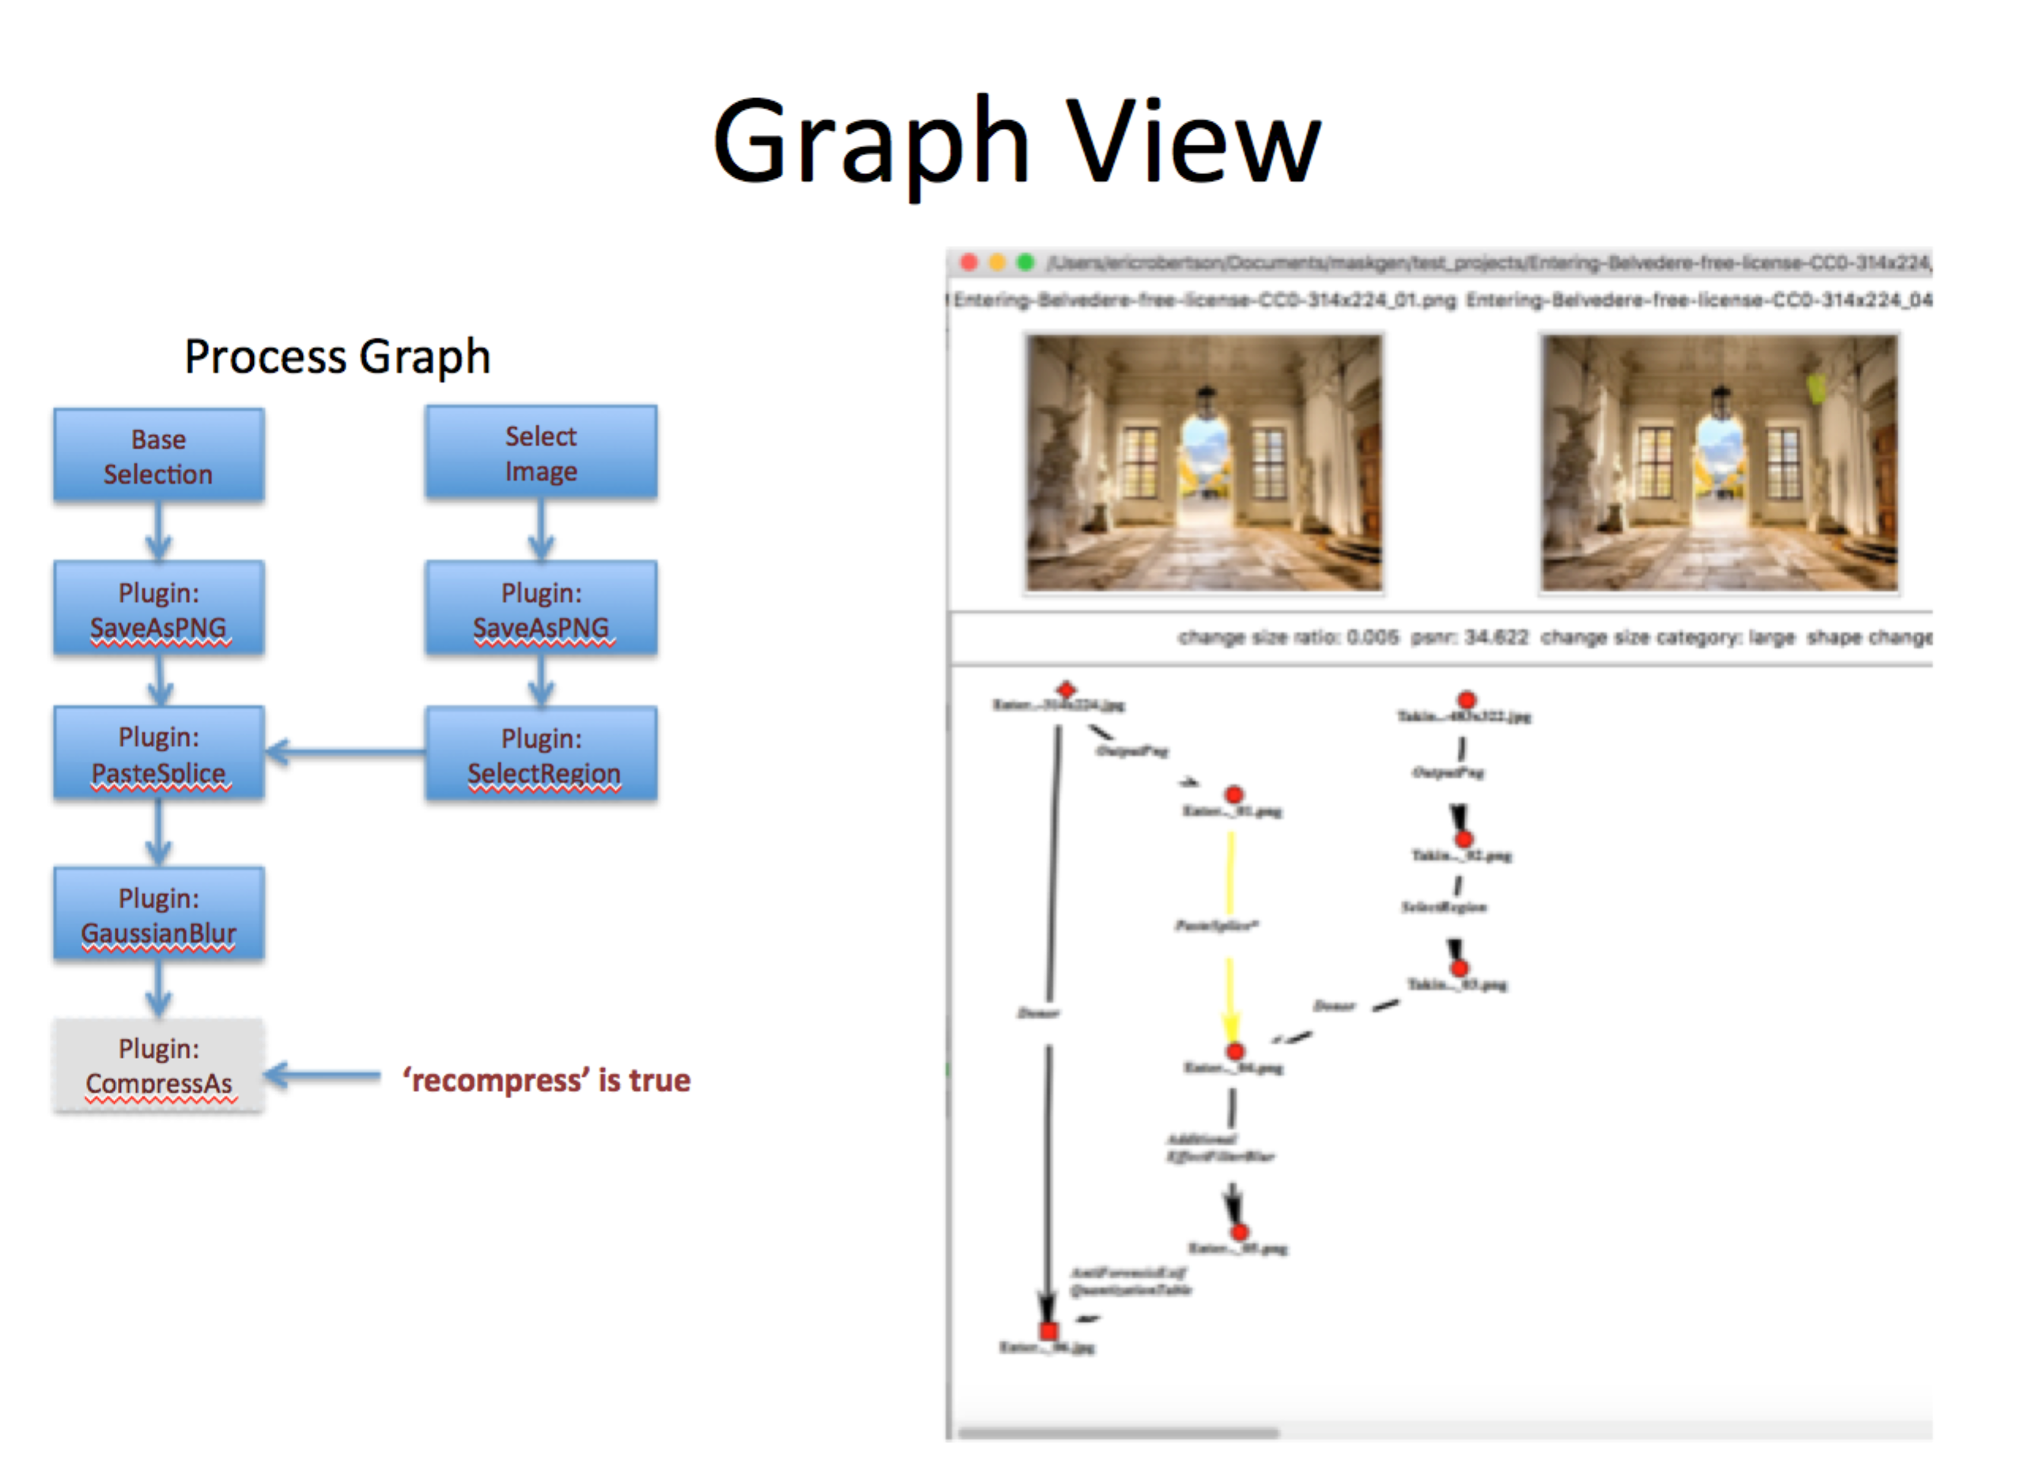

Figure Example Specification with Sample Resulting Project

## Crop Example with Permutations

### Reusing the Same Image for Multiple Projects.

Add permute group to image selection.   In this example, the group name is called ‘image’.

{

**"op_type"**: **"BaseSelection"**,

**"permutegroup"**: **"image"**,

**"image_directory"**: **"tests/images"**,

**"picklist"**: **"imageset"**,

**"id"**: **"0"**

}

### Defining Permutations for the Crop Region

One of the first steps **after** creating the PNG file is to obtain permutations over the selected image. Since the permutations of crop are based on the selected image, there needs to be a way for the permutation groups to be set based on the result of a plugin.

Parameter selector plugins (**InputMaskPluginOperation)** consume the image and produce values for parameters used by other plugins.  In this particular example, the CropPermutations plugin is used to produce the set of values to permute over for values of x and y defining the upper left crop position. The plugin consumes arguments defining the percentage width and height of a image to crop (remove).  Recall, these parameters can be permuted, set to specific values or picked randomly.   In the example, the width to a fixed 20%, the height as added to the ‘image’ permute group starting at 4% and increasing to 20% by 2% increments

{

**"op_type"**: **"InputMaskPluginOperation"**,

**"plugin"**: **"CropPermutations"**,

**"id"**: **"2"**,

**"arguments"**: {

**"percentage_width"** : {

**"type"** : **"value"**,

**"value"** :0.2

},

**"percentage_height"** : {

**"permutegroup"** : **"image"**,

**"type"** : **"float[0.04:0.2:0.02]"**

}

}

},

The result of this plugin is the specific pixel width and height cropped provided to the plugin (crop_width and crop_height) and two arguments that define the list of all possible values starting positions (crop_x and crop_y) on 8 bit increments given the shape of the image. The crop_x and crop_y are parameter specifics as they would appear in a plugin argument specification

### Using Permutations in Crop

The Crop plugin requires pixel width and height to crop in addition to a starting position (x,y).  All these values are consumed from output of the source CropPermutations (node id 2) as indicated by the type ‘variable’.   Since CropPermutation is returning permute group specifications for values crop_x and crop_y, the crop_x and copy_y arguments are added to the permute group (‘image' in this example).  Now the crop_x and crop_y inputs to crop will iterate through the list of values provided by CropPermutations.

At this point, the permute group ‘image’ consists of the image selection, percentage_height for CropPermutations, crop_x for Crop and crop_y for Crop.

{

**"op_type"**: **"PluginOperation"**,

**"plugin"**: **"Crop"**,

**"id"**: **"3"**,

**"arguments"**: {

**"pixel_width"** : {

**"type"** : **"variable"**,

**"source"**:**"2"**,

**"name"** :**"crop_width"**

},

**"pixel_height"** : {

**"type"** : **"variable"**,

**"source"**:**"2"**,

**"name"** :**"crop_height"**

},

**"crop_x"** : {

**"permutegroup"** : **"image"**,

**"type"** : **"variable"**,

**"source"**:**"2"**,

**"name"** :**"crop_x"**

},

**"crop_y"** : {

**"permutegroup"** : **"image"**,

**"type"** : **"variable"**,

**"source"**:**"2"**,

**"name"** :**"crop_y"**

}

}

}

### Running this example.

Create a sample directory of images  (stay over 1000x1000), make a copy of the batch process JSON file and change the location of the **image_directory** created directory.  Create an empty directory for the resulting projects.  Run the command:

% jtproject --json permutation_batch_process.json.json --results myresultprojectsdirectory –graph --loglevel 0 --threads 1