The login page – You’re also able to create a new account form this page. Utilize a collapsible menu. If you are unauthenticated and attempt to access the main.html page, you’re automatically redirected here.

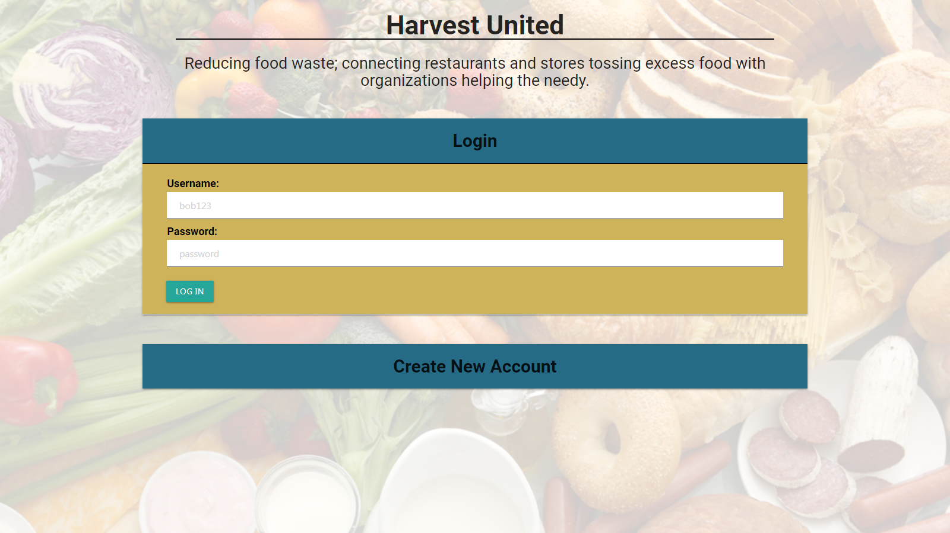

This is the main page. You’re able to access any of your entries from here. The top navigation bar enables you to create a new entry, search for entries, or log out.

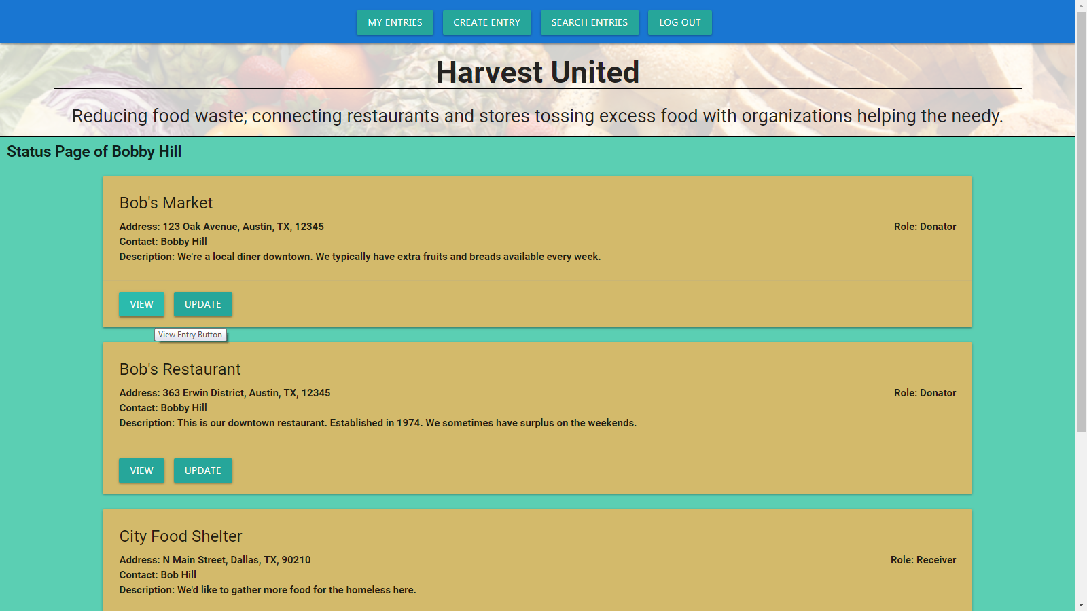

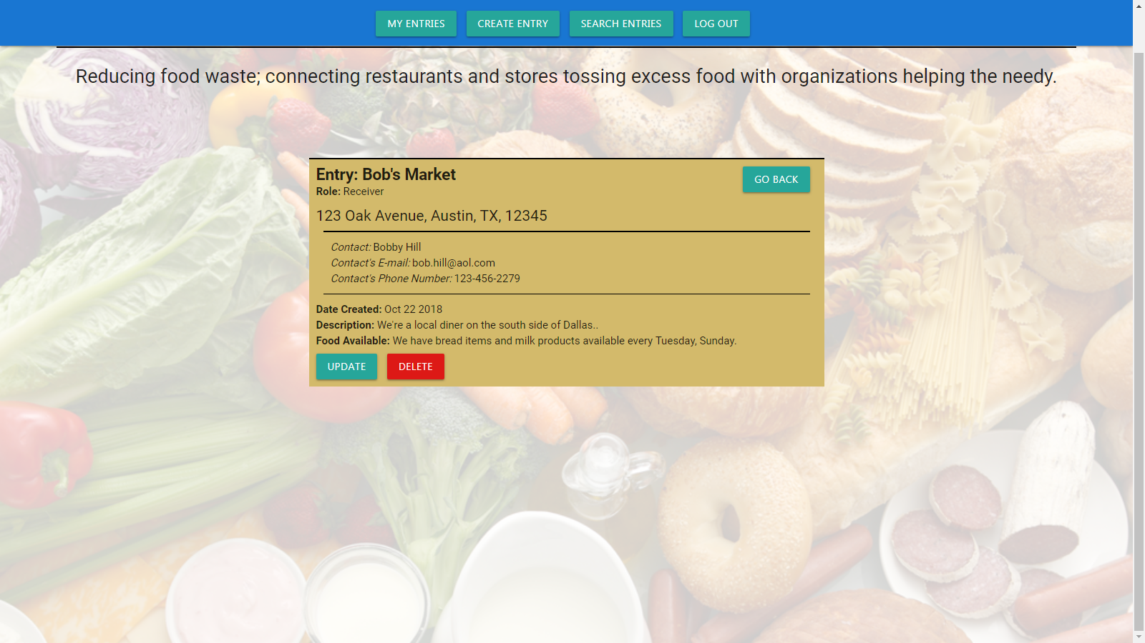When you click to view an entry (whether it’s yours or not), you are able to see the details of the entry. If the entry belongs to the user who viewed it, they’re also able to edit or delete the entry.

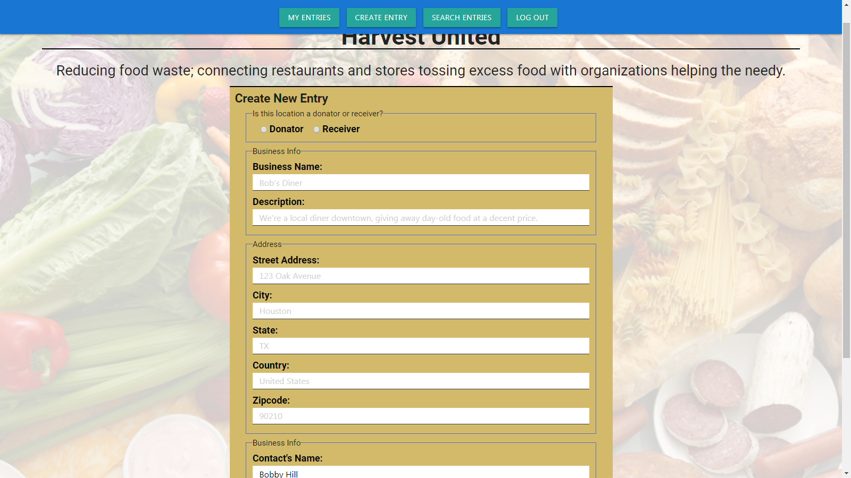When you create an entry, or update a current entry, a form appears. It’s prepopulated with your previously entered information (just contact info if creating an entry, but shows all your current info if updating your entry).

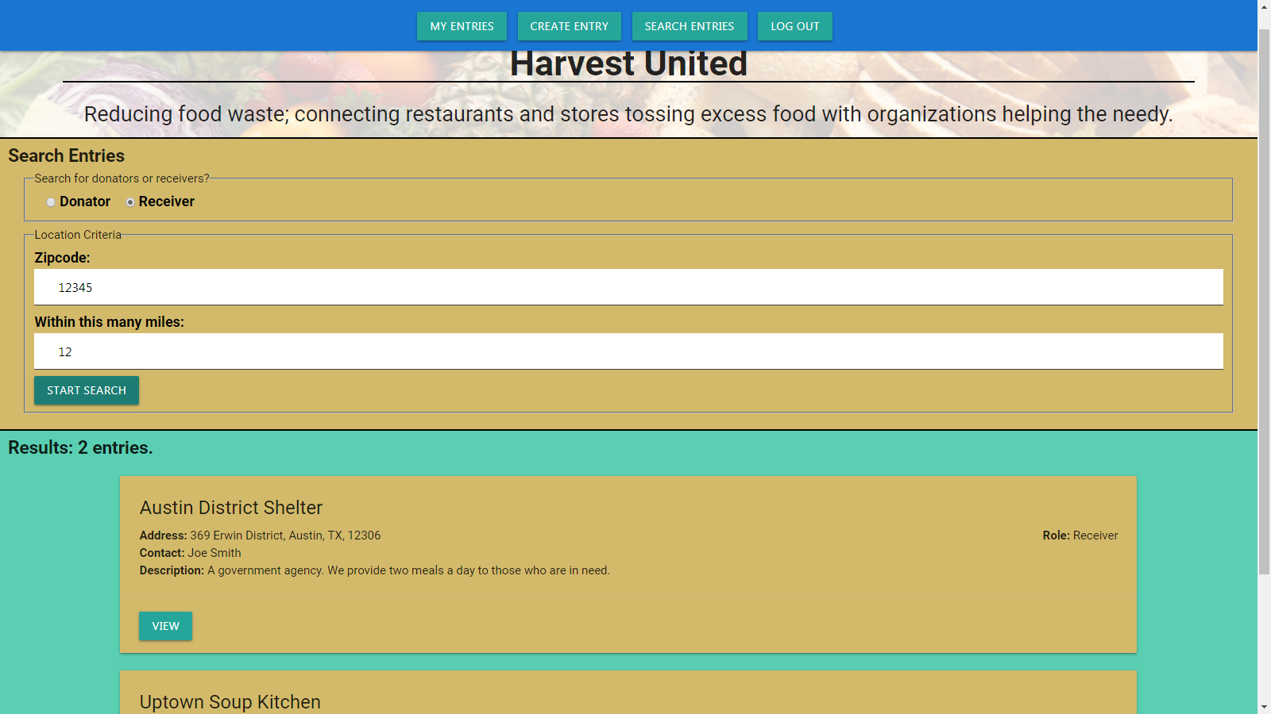The search page allows you to search based on zipcode, and whether you’re looking for donators or receivers. You can then view any of the search results. You’re able to update/delete any of your entries that show up in the search.