EXP NO 22. Create a Simple Web Application using Java or Python and host it in any Public Cloud Service Provider (Azure/GCP/AWS) to demonstrate Platform as a Service (PaaS).
AIM:
To Create a Simple Web Application using Java or Python and host it in any Public Cloud Service Provider (Azure/GCP/AWS) to demonstrate Platform as a Service (PaaS).
Procedure:

Procedure:
- Create Flask App:
  - Create a folder FlaskApp.
  - Create app.py with:
from flask import Flask app = Flask( name ) @app.route('/')
def home():
return "Hello! Flask App on Azure PaaS" if name == ' main ':
app.run()
Create requirements.txt:
flask gunicorn

Log in to Azure Portal:
  - Go to https://portal.azure.com
  - Sign in.

Create Web App (PaaS):
  - Click Create a Resource → Web App
  - Fill details:
    - Resource Group: PaaS-Flask-RG
    - Name: flask-paas-demo
    - Runtime: Python 3.x
    - Region: nearest
  - Click Create.

Deploy App:
  - Compress the folder as .zip.
  - In Azure Portal → your Web App → Deployment → ZIP Deploy
  - Upload the .zip file.

Test the App:
  - Click Browse in the Web App Overview
  - Open the link, you will see:
  - Hello! Flask App on Azure PaaS

Cleanup (Optional):
  - Delete the Resource Group to stop charges.
Design:

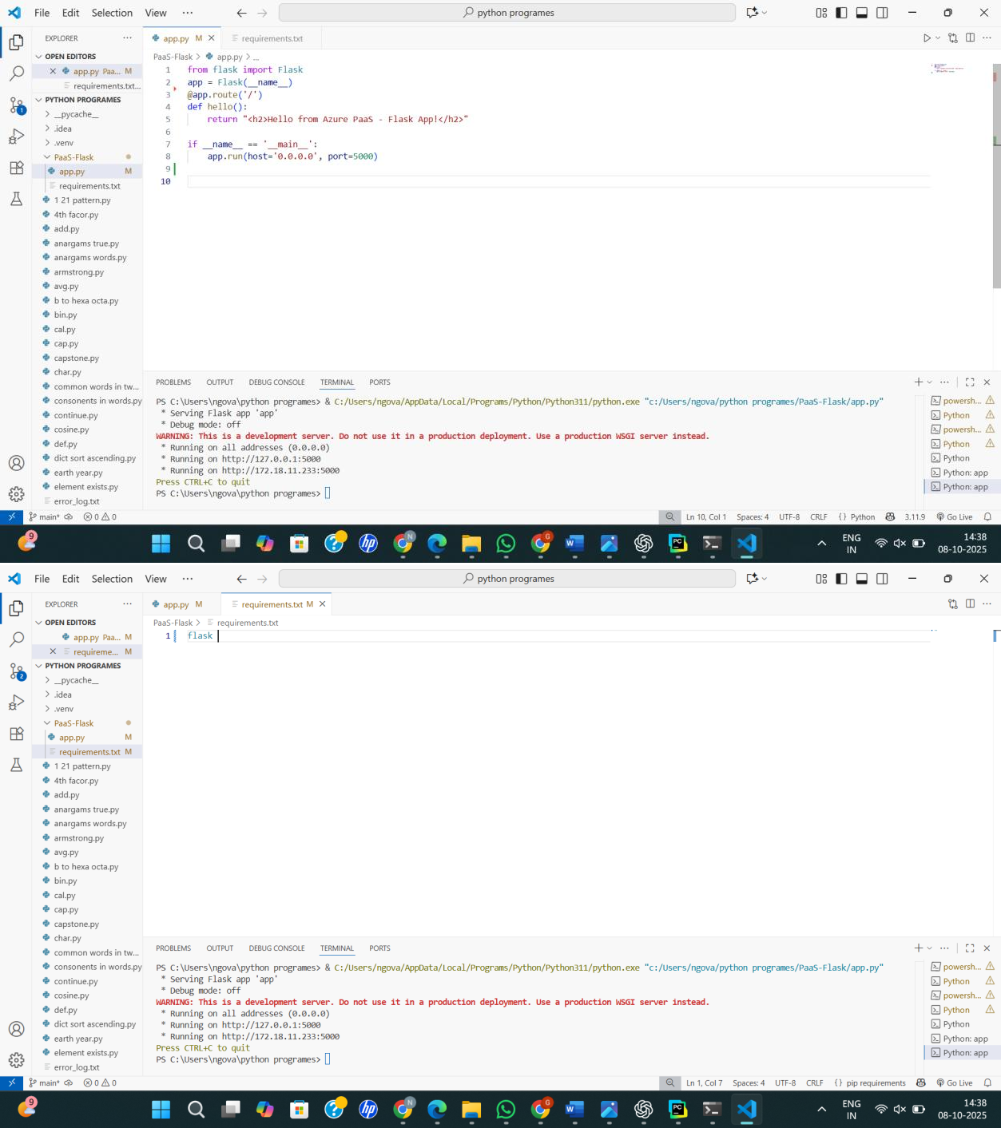

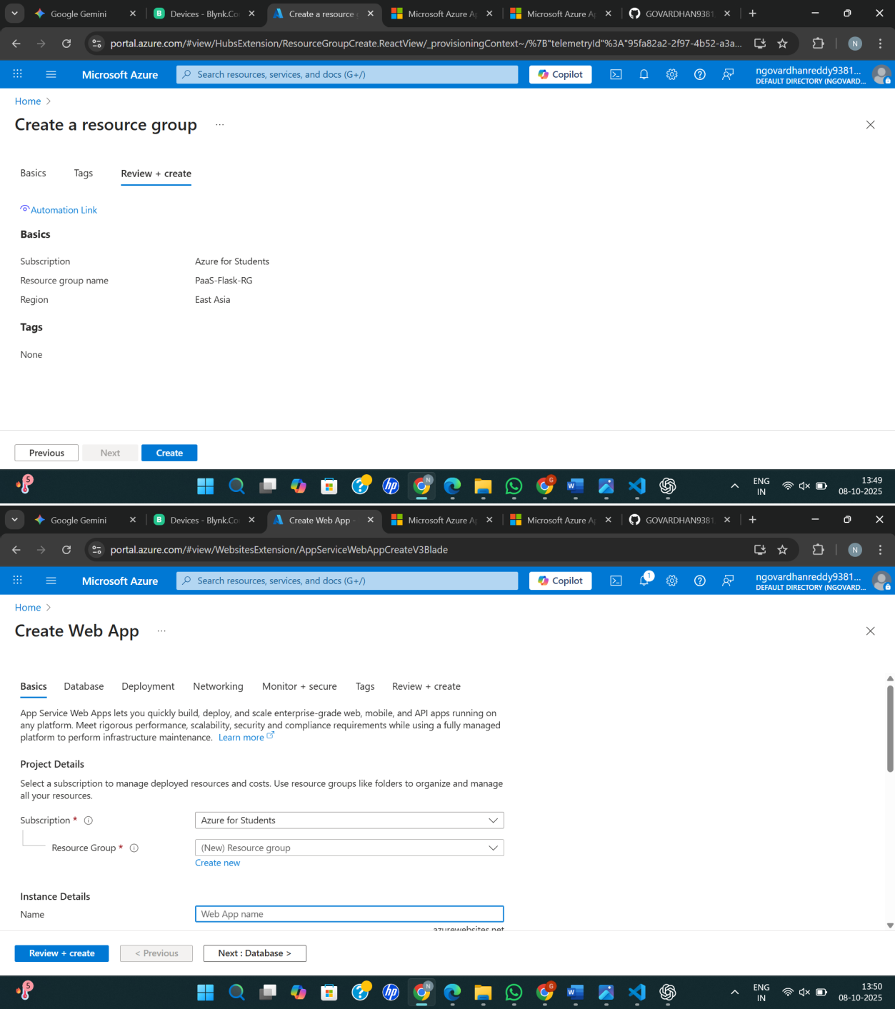

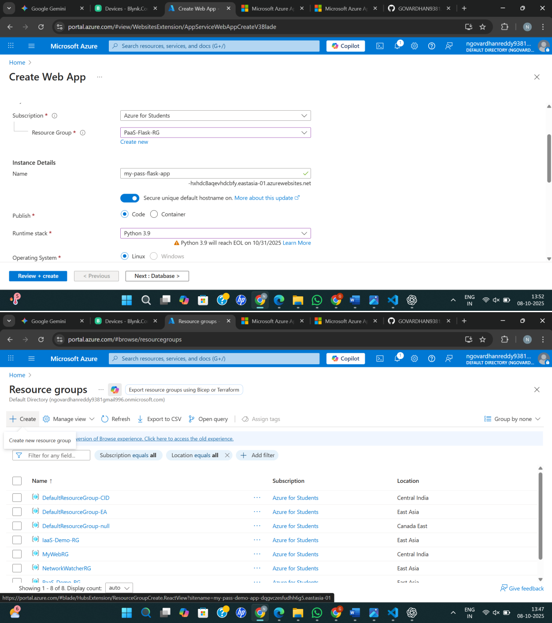

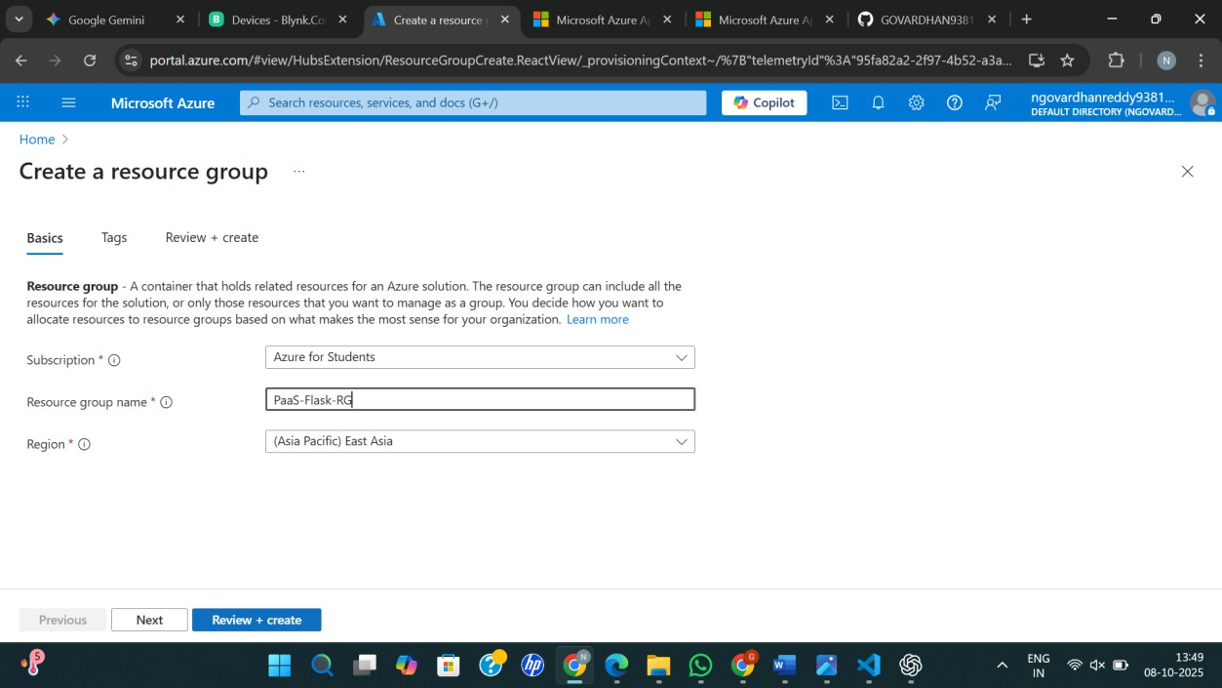

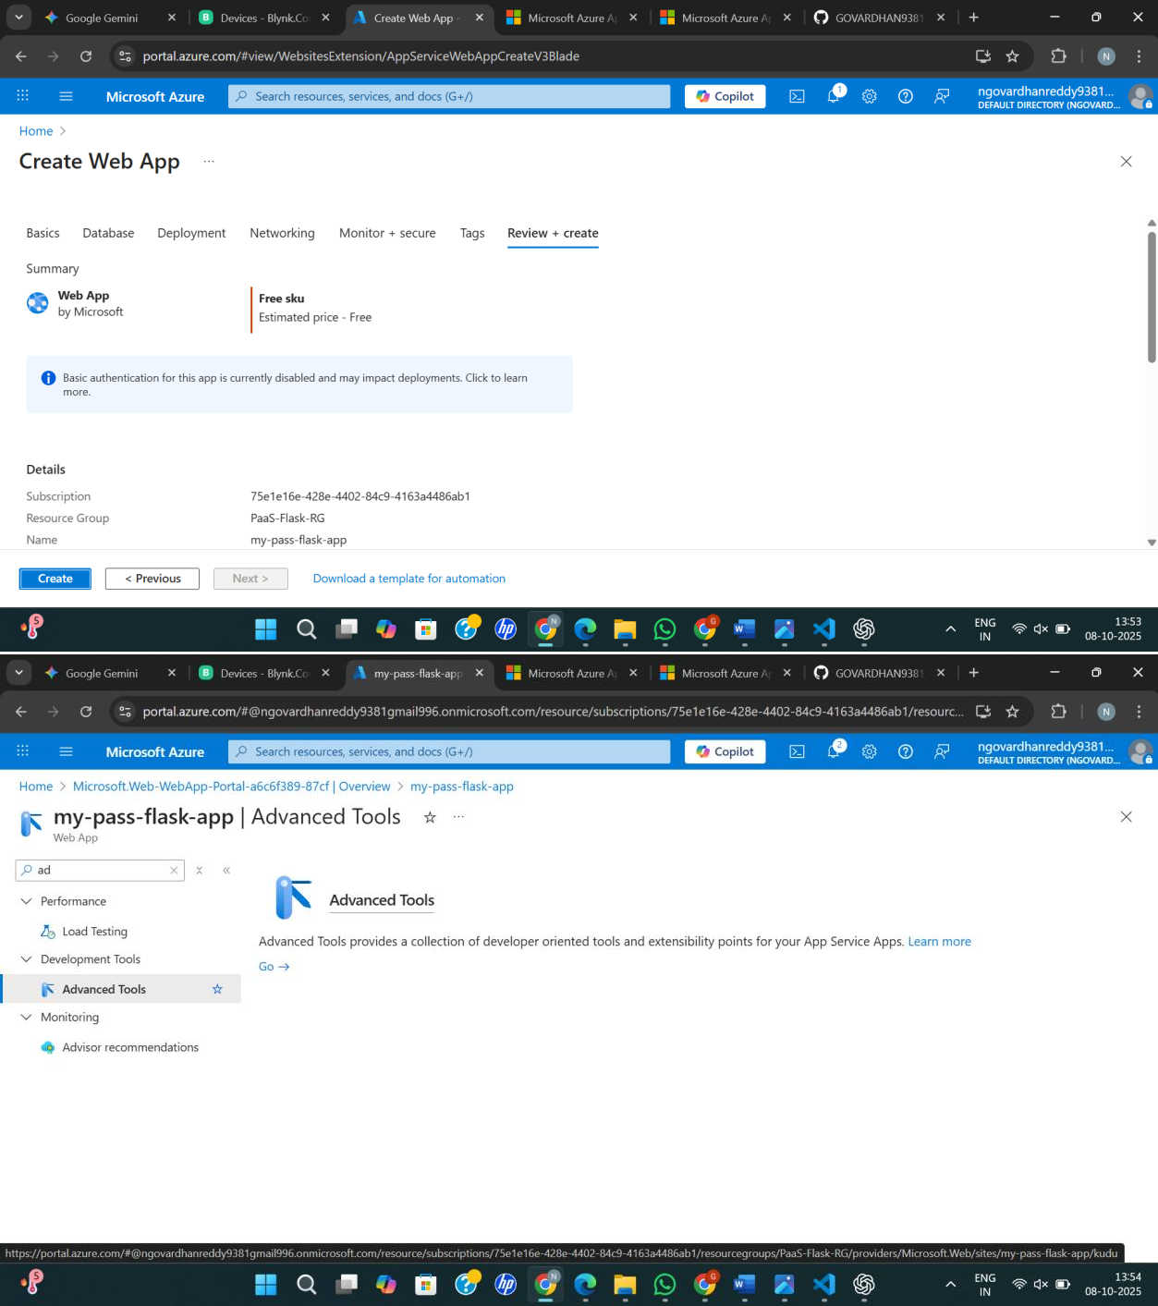

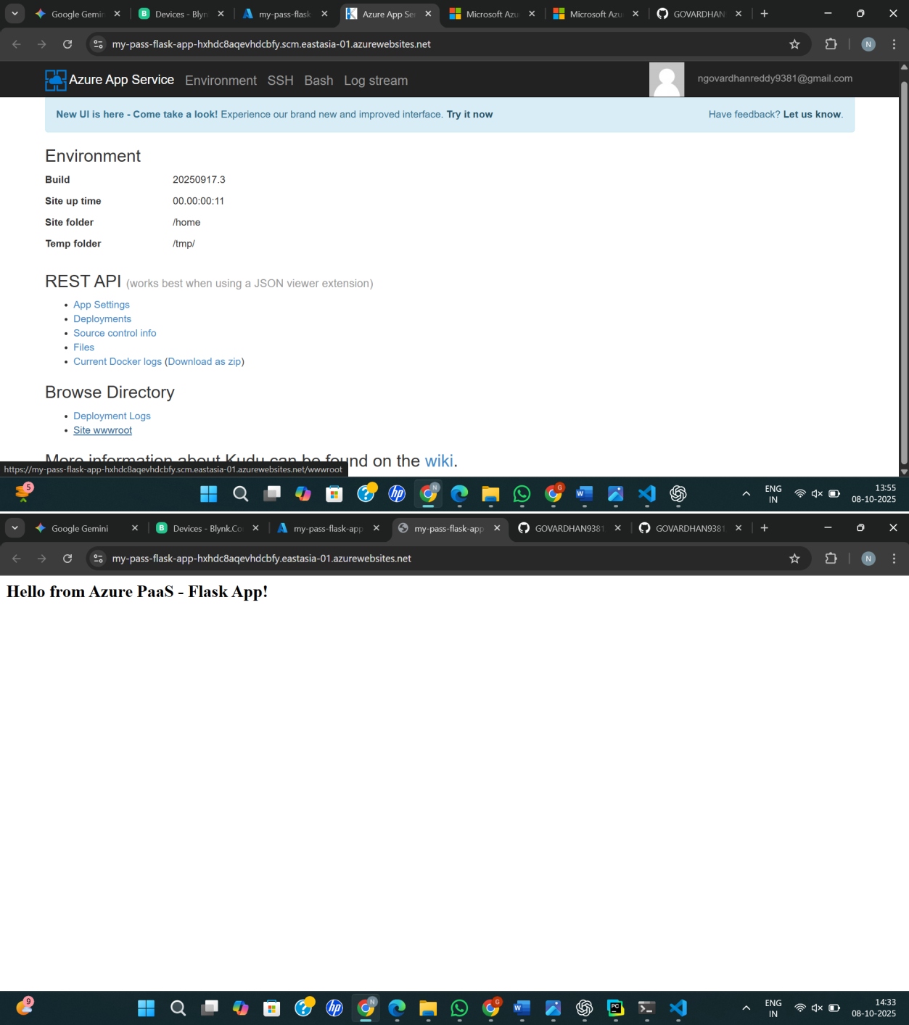

RESULT:
Created a Simple Web Application using Java or Python and host it in any Public Cloud Service Provider (Azure/GCP/AWS) to demonstrate Platform as a Service (PaaS).

