EXP NO 6: DEMONSTRATE VIRTUALIZATION BY INSTALLING TYPE-2 HYPERVISOR IN YOUR DEVICE, CREATE AND CONFIGURE VM IMAGE WITH A HOST OPERATING SYSTEM (EITHER WINDOWS/LINUX).
DATE:5.11.2025
AIM:
To demonstrate virtualization by installing type-2 hypervisor in your device, create and configure VM image with a host operating system (either windows/linux).
PROCEDURE:
STEP 1:Dowload VMware workstation and installed as type 2hypervisor.
STEP2:Dowload ubuntu or tiny OS as iso image file.
STEP 3: In VMware workstation->create new VM.
STEP 4: Do the basic configuration settings.
STEP 5: Created tiny OS virtual machine.
STEP 6: Launch the VM.
IMPLEMENTATION:
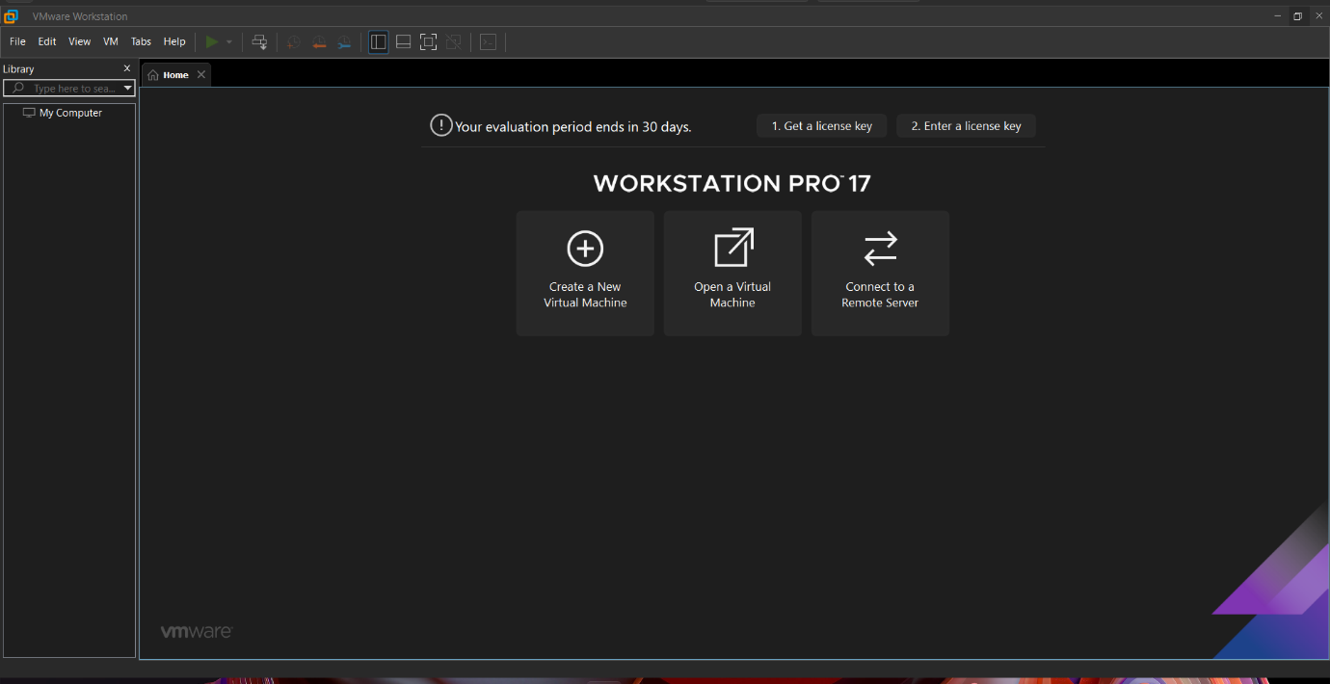

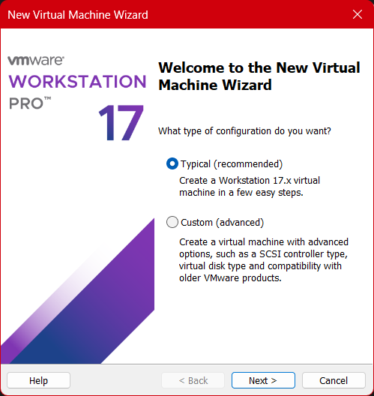

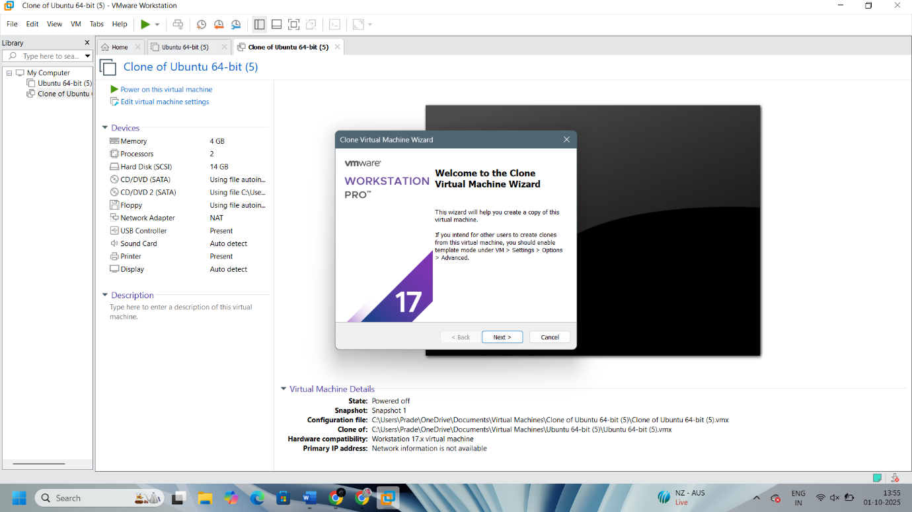

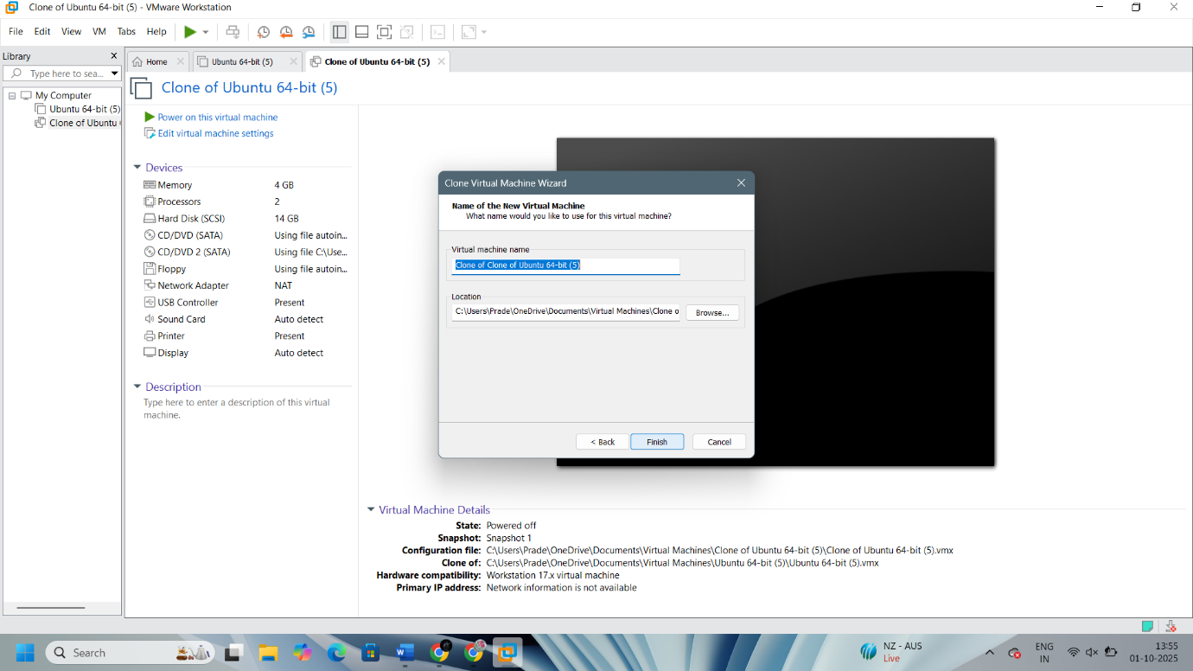

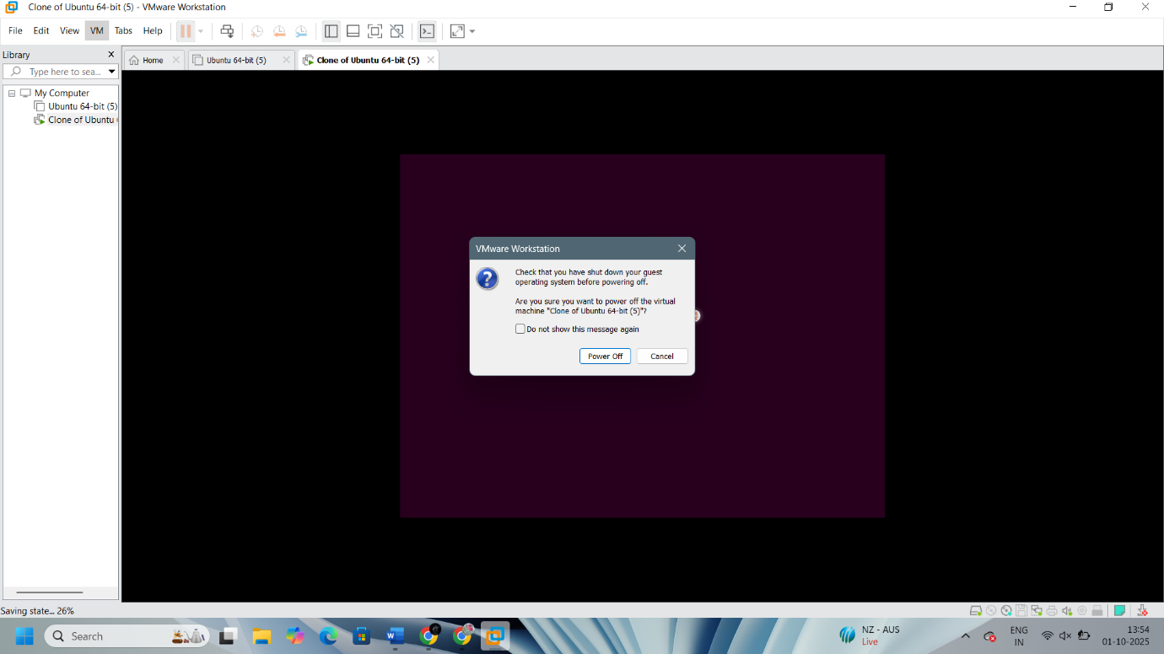

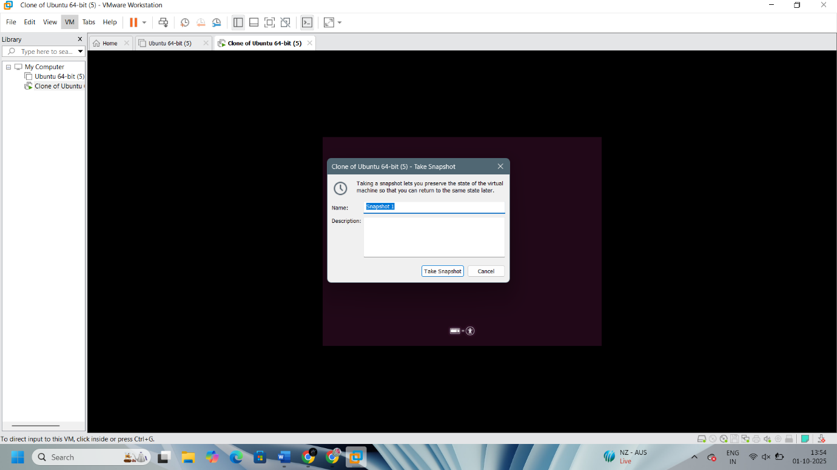
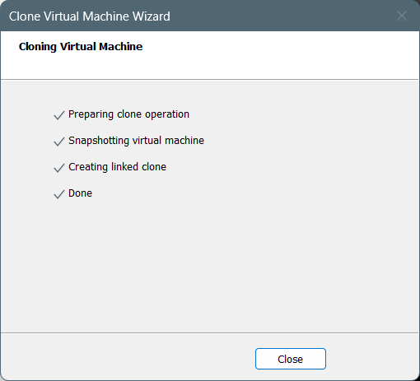

Result:
Thus virtualization by installing type-2 hypervisor in your device, create and configure VM image with a host operating system windows has been demonstrated.

