trax
Haunted Attraction Staff Manager
Design Specification
v0.2

Primary User Stories

Volunteer Database
As the volunteer coordinator (VC), I want to register new volunteers into the system, so we can track our volunteers.
As the VC, I want to edit volunteer records, so I can keep them current.
As the VC, I want to delete or mark as inactive a volunteer record, so I can keep my volunteer database clean.
As the VC, I want to send messages to select groups of volunteers, so I can keep communications open with them.
As the VC, I want reports listing all my volunteers and their hours served, roles, and other info, so I can review the data and stay aware of what's going on.
As the VC, I want to know which volunteers need to sign forms and paperwork, so I can go after them to do so!
As the VC, I want to automatically generate Community Service letters for volunteers, so I can submit them to the required agencies.

Time Tracking
As a volunteer, I want to “punch-in” when I arrive each day, so my time tracking is started.
As a volunteer, I want to “punch-out” when I leave each day, so I get credit for my time worked.
As a volunteer with a bluetooth-enabled device, I want the system to automatically detect my presence on site, so I don't have to manually punch-in or out.
As a volunteer, I want to see the total hours I've served, so I know my progress towards hourly goals.

Architecture

TODO: redo this section, it's a mixture of features, ideas, and architecture!
On-site interface, with in/out scanners/swipers/fingerprint readers. Single combo in/out reader, or separate in & out may be used. Perhaps even detect a staffer's bluetooth signature of their cell phone via a bluetooth scanner app.
On-site interface may “speak” names when user arrives/departs (use esddsp festival)
Master database on-site
Web interface with slave database, synch'd by upload from master, and changes pulled down by master.

Main Features
Timeclock – records in and out times for all staff members.
Staff Manager – authoritative list of all staff, with contact information, and roles.
Mail List – Manages email list memberships, such as actor list, all staff list, 2011 staff list, construction list, etc. By role and by subscription.
Goal-tracking – Required sign-offs, etc: TBD – want to record if they've signed liability on file (scanned?), got parental approval (for minors), and so on.
Scheduler – Keeps schedule of who's signed up for various roles and dates, including early departures or late arrivals. Ties into timeclock system to indicate who actually showed up, who is missing, who's extra.

Web-Access Too
Most of the above features available via a web UI. Authentication is with user's email address and a simple password.
Failed login attempts incur a 3-second delay. Parallel logins are limited to 5 at a time, to discourage parallel attacks.

Design

Presence-to-Interval Algorithm
User time tracking is done via a set of “presence” indications. When a user arrives, they scan or swipe their badge, key-in on a touchscreen, or are detected via the bluetooth scanner. A similar thing happens when they they depart. These events are “presence indications” – called “blips” for short. These blips may happen multiple times during the day, not just at the beginning and end, especially with the bluetooth scanner.
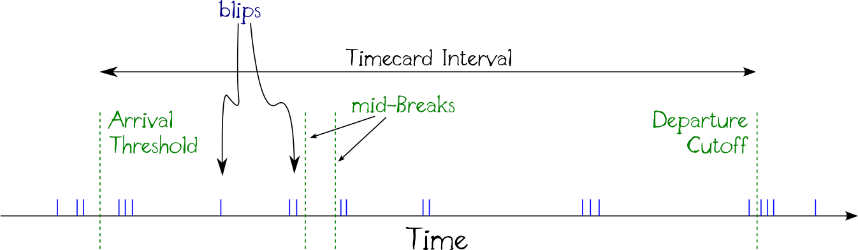
Yet a user's time is tracked as a series of intervals. Each interval is represented by a timecard record. Thus we must convert these blips into timecards.

Arrival Threshold
For a given day's work, there's a start time for the work shift. Yet workers may arrive earlier than that start time. The optional arrival threshold is the official start time for the shift, any arrivals prior to that do not earn time credit for the user.
Arrival thresholds may be applied to individual users, to classes of users (by their roles), or to all users.

Departure Cutoff
At the end of the day's work, there's an end time for the work shift. Yet workers may linger past the end of their shift. The optional departure cutoff is the official end time for the shift; any blips past that cutoff do not earn time credit for the user.
Departure cutoffs may be applied to individual users, to classes of users (by their roles), or to all users.

Mid-Breaks
Mid-day breaks, such as lunch breaks, are NOT tracked by this system. Instead, two timecard records may be used – a morning and an evening, for example.

Basic Interval Algorithm
For each user, a work day is partitioned such that no timecard interval crosses that day. In most cases, this partition time comes from a default value. This partition time is typically set to 3am. That means that we never expect the user's work time to start earlier than 3am on a given day, nor go past 3am at night.
Within each day partition, we then look for the first blip and use that as the start time for the timecard interval. If an arrival threshold exists for that user on that day, and the first blip is sooner than the threshold, instead we use the threshold as the start time.
Then the latest blip is found within the day partition, and that is used for the end time. If a departure cutoff is in effect for that user on that day, and the last blip is past the cutoff, then the cutoff time is used instead.

Maximum Interval
A maximum interval time may apply to a day partition. For example, 12 hours. TODO – how to use this?

Missed Arrival
If a user fails to clock-in at the start of their work shift, a supervisor may enter an estimated start time for the user.

Missed Departure
If a user fails to clock-out at the end of their work shift, a supervisor may enter an estimated end time for the the user

Interval Override
A supervisor may supply a time duration to override the automatically calculated interval. That override duration will be used when calculating time totals.

Time Credit Factors
For worker incentive purposes, bonus hours and multiplicative factors (“50% time bonus”) may be applied to the timecard interval (or override duration) for workers. For example, Sunday work may be credited at 1.5x the normal amount.
This factor applies only to incentive credit totals, and not the actual totals as is reported on labor forms or community service tracking.
TODO: Should this be here, or moved to a separate “credits” reporting subsystem? Make it separate – keep it simple!

In/Out Hints
A blip may include an in- or out-hint. This hint tells the system that the intent is for clocking in or out. The punchclock system is given a hint that it can apply to all clockings (as the default, users can override), where this hint stays in effect for the next X minutes for example.
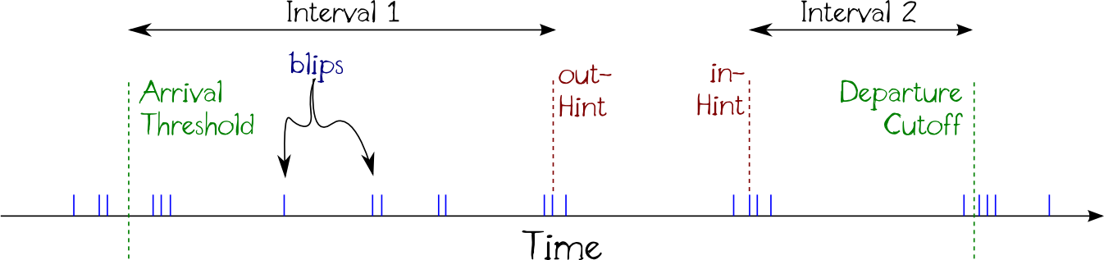
These hints allow the algorithm to split a day into more than one interval. Note that there are blips just after the out-hinted blip, and just prior-to the in-hinted blip.

Hinted Interval Algorithm
We can modify the basic interval determination algorithm to use these in/out hints to do a better job determining the intervals. Essentially, the algorithm uses the first in-hinted blip as the start of an interval, and the last out-hinted blip (of a series) as the end time for an interval. Un-hinted blips are treated as whatever the last hinted blip was. Thus:
Starting from the beginning of the partitioned day, we look for the first un-hinted or “in” blip and use that as the start time for a new timecard interval. If an arrival threshold is in place, use the threshold time instead. If the first blip we find is an “out” blip, disregard it (?) and continue looking forward.
Continue scanning forward, but not beyond the end of the partitioned day, ignoring any other “in” hinted blips for this user. But for every un-hinted or out-hinted blip, use that to update the end time for the current timecard. If past the departure cutoff time for the day, use the cutoff time as the end time and we're done scanning this day. Yet if we find another in- or un-hinted blip following an out-hinted blip, then consider the current timecard interval as done, and use this new in- or un-hinted blip as the start of a new interval.

Use Cases

On-site All Users
Functions available to all users, via the on-site interface

Arrive – Scan/Swipe
Staff members “punch-in” arrival time recorded by swiping/scanning/keying ID token.
In the database, if an open timecard record younger than 1? hour does not already exist, creates a new time card record with the current time for the arrival time. If an open timecard already exists, (updates the current time?)(warns the user?).
If configured, first and/or last name may be “spoken” by system on arrival. Example, “Hello Bob”. Can be done using festival.

Auto-detect Arrival
Automatic detection of a bluetooth device held by the staff member, instead of scan/swipe-in. Upon initial setup, the bt device is “discovered” (but not paired) so it's MAC address is learned and associated with the staffer. Multiple devices may be registered per staffer.
The system periodically scans for all known MAC addresses to see if they're in range (hcitool name xx-xx-...). For all discovered devices, it adds a “blip” record to the database to indicate presence of the staffer.

Depart
Staff member “punch-out” departure time recorded by swiping/scanning/keying ID token. Closes the open time card record, going back at most 24? hours. If no card found, creates a new card with no arrival time (null) but this departure time.
If configured, first and/or last name may be “spoken” by system on departure. Example, “Goodbye Bob”. Done using festival.

On-site Administrative
Functions available to administrative users via the on-site interface. Requires an administrative authorization to perform these functions.

Register Staff Member
New staff members may be entered into the system. Includes full name, address, email, phone(s), swipe/scan id (autogenerated), bluetooth device registration, two photos (normal and in-costume)

Edit Member
Present a list of members and allow selection of one, for editing member details.

Generate ID Card
Print a barcoded ID badge.

Encode ID Card
Encode a swipecard (magnetic card)

Enroll Fingerprints
Capture new or update existing fingerprint data for a member.

Admin Arrive
Administrator can perform arrival for a user. For example, if member forgot their scancard.

Admin Depart
Administrator can perform departure for a user. For example, if member forgot their scancard.

All-Depart
Administratively mark all on-site members as departed at the current or a given time. Useful for end-of-night mass-exit. In the database, finds all time card records opened within 24hours that are not closed, and closes them with the current (given) time. If more than one open record found in last 24hrs for a member, only the most recent one is closed.

Edit Time Card
Select a member and manually edit/override in/out times.

Apply Time Override
Select one or more members and give a time override. For example, count today's instance as 8 hours, regardless of actual time on-site. Time override may be zero or more. In the database, it's a non-null (zero allowed) value for the override time field of the time card record.

Apply Time Factor
Select one or more members and apply a time multiplication factor to the current or most recent time card. Selection may be done based on “those who worked on X day”. For example, today's work may be considered 1.5x the actual duration on-site. In the database, it's a non-unity value in the time factor field of the time card record.

Apply Time Credit
Add a fixed time credit to one or more members. This is a fixed amount of time in a new time record, independent of other in/out times. It may be used to add time if an administrative or hardware error occurred. In the database, it's a new time card record with no in/out times, but an override time of the given amount, and a unary time factor.

Generate Volunteer Letters
For selected members, produce an “official” PDF letter with time worked summary, and specific dates & times listed (option), including thank-you text, etc. Option to email letters to members, or combined and emailed to a given single-email so letters can be printed on letterhead and signed.

Reset Web Password
Select a staff member and reset their web-access password. An autogenerate random password function is available.

Sync with Web
Upload current information to web database. Retrieve updates from web database to here.

Who's Here?
Report or graphic listing who's here now with arrival times.
Could tie-into to a scheduling d/b to indicate who's expected to be here and is (green), or is missing (red), or extra (white). For accountability, for fire safety checks, etc.

Web-Access Functions
Staff members may use the web to access their information and perform certain functions.

Web Login
Members may log-in using email address and password credentials. Session valid for 13? minutes.

View and Edit My Profile
View my member information and update my profile information, including uploading new photos, reset password, etc.

View Timesheet
List my time worked, with credits, overrides, and factors, in a easily printable form.

Generate Volunteer Letter
Generate a volunteer letter for myself, with time worked summary, thank you text, and so on. PDF format, suitable for printing. May be emailed to self.

Forgot Password
Enter email address, PIN/password is sent to registered user.

Accountability Functions

Required Events Checkoff
Manual entry of “checkbox” items that can be set/cleared, with dates, to indicate that a staff member has completed some event. Example events are: Fire/safety training; liability release letter signed; parent approval received.
TBD: Related Use Cases for the above.

Command-Line and SQL-only Functions

Define Event
Add or update an event definition.

Define Role
Add or update a role definition.

Database
Database name: castkeep

User Table
Prefix: usr
Each record defines a staff member and records their information. Includes user's role(s).
usrId | Unique system generated numeric ID
usrKey | Scan/swipe unique key code
usrLastName | Family name of member
usrFirstName | First name or nick; example: Jordan “Nacho”
usrEmail | Email address for member
usrAddr1 | Mailing address – line 1
usrAddr2 | Mailing address – line 2
usrZip | Mailing zip code (implies city & state)
usrPhone | Contact phone number for member
usrPassword | Password, Not hashed, so it can be emailed
usrRole1 | rolId of Primary role, else null
usrRole2 | rolId of Secondary role, else null
usrRole3 | rolId of Tertiary role, else null
usrComSvc | Community service code, varchar(4)
usrComment | Free-text string for anything else

What about:
- if a minor, parent's contact info?
- age/is under 18 (minor) flag?

Timecard Table
Prefix: tcd
Each record is a “time card” that records for a member (user) their arrival, departure timestamps, override time, time factor, arrival & departure scan places, etc.
usrId | User Id to whith this record applies
tcdInTime | Arrival time, or null
tcdInUser | Credentials used for arrival record (usrId)
tcdInStation | Arrival station ID
tcdOutTime | Departure time, or null
tcdOutStation | Departure Station
tcdOutUser | Credentials used to enter departure record (usrId)
tcdOverrideTime | Credit this time as this duration, or null
tcdOverrideUser | Credentials of admin user granting override
tcdFactor | Multiplicative factor to use for time, null means unity
tcdFactorUser | usrId of admin user giving the factor

Design consideration: Should we just record scan/swipe times, then do the in/out correlation afterwards? The scan station can be used to identify in or out. If so, how are overrides and factors applied?

Event Table
Prefix: evt
Defines events, so we know the start and end times of various events. This allows correlation of times to these events. For example, “Haunted Mines 2011 Summer Construction”, “Haunted Mines 2011 Production”, “2011 Fire Training”. Used by the volunteer letter generator functions, or check-offs such as knowing attendance at trainings.
evtName | Name of the event
evtStart | Start time
evtEnd | End time of the event

Roles Table
Prefix: rol
Defines user roles. For example, “2011 Actor”, “2011 Construction”, “2011 Director”, “2011 Producer”.
rolId | Unique identifier for the role
rolName | Name of this role

Mailing Lists Table
Prefix: mls
Defines additional mailing lists, beyond the role-based lists.
mlsId | Unique int key
mlsList | List name; the short name for the list
mslName | Description of the mailing list

Subscriptions Table
Users subscribed to lists.
mlsList | fk to List ID
usrId | User subscribed to this list

