**EE-DCU**

**Risk Assessment Experimental Method Form for Undergraduate and Taught PG Projects**

All operations/procedures being assessed (give specific details):

All operations/procedures are purely theoretical or computational requiring no written risk assessment.

**Risk Category Rating:**

E

Known or expected hazards associated with the activity:

None

Precautions to be taken to reduce the level of risk:

None

**Training prerequisite**:

None

Risk remaining:

None

Emergency procedures:

None

**Detail references if any:**

For the Project Worker and Project Supervisor:

We have carried out a risk assessment for the above operation/procedure in accordance with those guidelines as detailed in the School Safety Handbook.

Signature of Project Worker: 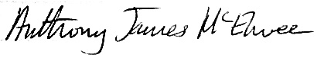 Date: 2023/02/05

Print name of Project Worker: **ANTHONY JAMES MC ELWEE**

Signature of Project Supervisor: …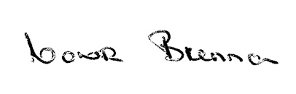 Date 27/02/2023

Print name of Project Supervisor: **DR CONOR BRENNAN**

Print name of Technical Officer assigned to Project: **CONOR MURPHY**

**N.B.**

* Copies of completed forms should be submitted to the Project Supervisor and the Technical Officer assigned to the project.
* A signed copy of the completed form should be kept in close proximity to the project bench/space where the project is taking place.