

School of Electronic Engineering

CB54: Machine Learning Algorithms for EM Wave Scattering Problems

Appendix F: Source Code Listing

Anthony James McElwee

ID Number: 20211330

August 2023

MEng in Electronic and Computer Engineering

Supervised by Dr Conor Brennan

Declaration

I hereby declare that, except where otherwise indicated, this document is entirely my own work and has not been submitted in whole or in part to any other university.

Signed: 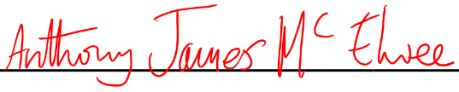 Date: 2023/08/20

# Source Code Location

All code is hosted on a GitHub repository at <https://github.com/spookworm/CB54> and will reside there until the final grade for the project is released. Aside from code, the repository also contains the documentats required for the final portfolio, legacy code that was used as raw reference during development and compilation commands that generate the conda environment and wrap the final documents together into the submission template.

# Code Description

The important code files with brief description are as follows:

[CHECK: TBC]