Petits carrés

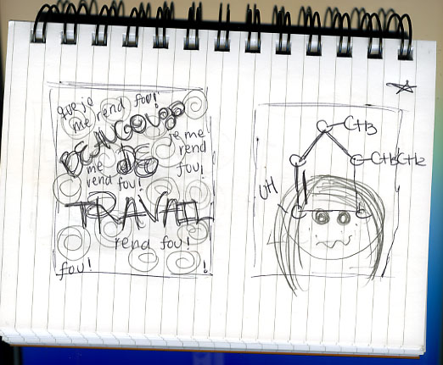

I have them select a small notebook at the beginning of each semester in which they will do their in-class writing. I encourage them to choose something they like to touch and handle. They also have to buy a set of fine-point colored pens or markers, so they can add color when they want.

“Petits carrés” are just that, little squares. They have to draw two little squares and write something in them in French. They can play with the graphics, color, ways in which form and content intertwine. I do this in class; it takes 2-4 minutes. See below for some examples of work by my students.

They also do their writing prompts (which involve three to five minutes of writing, no squares and usually no colors, much more text-focused) in the same notebook.

I encourage them to view this notebook as a store of ideas and beginnings for their at-home writing assignments.

