Kym Derriman

ONSET OF CHAOS

INTRODUCTION
In this experiment, we explore the onset of chaos in nonlinear systems through two complementary approaches: a practical investigation of a nonlinear RLC circuit and a computational study of the Logistic Equation. The experiment demonstrates how seemingly simple deterministic systems can exhibit complex, chaotic behavior under certain conditions. Through both physical measurements and numerical simulations, we examine the phenomenon of period doubling as a route to chaos and verify the universal nature of this behavior as described by Feigenbaum's theory.

BACKGROUND
The transition from ordered to chaotic behavior in nonlinear systems often follows a characteristic pattern known as period doubling. This phenomenon can be observed in both physical systems, such as our nonlinear RLC circuit, and mathematical models like the Logistic Equation.
The Logistic Equation, given by:
x(n+1) = ax(n)[1-x(n)]
where a is the growth parameter and x(n) represents the system state at step n, serves as a canonical example of how a simple nonlinear system can exhibit complex behavior. Despite its mathematical simplicity, this equation demonstrates four distinct behavioral regimes:
1. For 0 ≤ a < 1: The population crashes to zero regardless of initial conditions
2. For 1 ≤ a < 3: The system converges to a stable fixed point
3. For 3 ≤ a < 3.57: The system undergoes a series of period-doubling bifurcations
4. For a > 3.57: The system exhibits chaotic behavior, with occasional "windows" of stability

EXPERIMENTAL METHODS

Part A: Nonlinear RLC Circuit Analysis
[This section to be completed after we work through the circuit portion]

Part B: Logistic Equation Analysis
The computational analysis was performed using MATLAB. We created a series of scripts to:
1. Implement the logistic equation and iterate it for various parameter values
2. Examine system behavior for different growth parameters and initial conditions
3. Determine precise values where period doubling occurs
4. Analyze the convergence to chaos through calculation of the Feigenbaum constant
Each simulation was run with sufficient iterations to ensure the system reached steady state, with initial transients discarded from the analysis.

RESULTS AND DISCUSSION

Behavior of the Logistic Equation for a < 3
We examined the behavior of the logistic equation for various growth parameter values (a) in the range a < 3 using multiple initial conditions to verify the theoretical predictions. Figure [X] shows the evolution of x(n) for a = 0.5, 1.0, 1.5, and 2.9, each with three different random initial conditions.

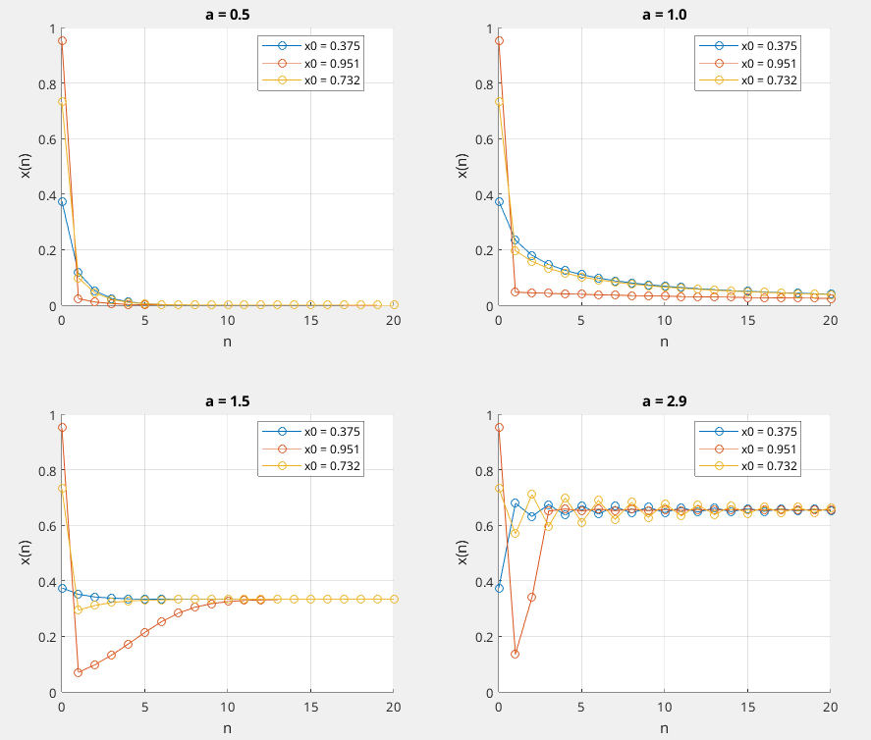
FIGURE X: Evolution of the logistic equation for different growth parameters a < 3. For a = 0.5, we observe that all trajectories rapidly decay to zero regardless of initial condition, confirming the theoretical prediction for 0 < a < 1 where the growth parameter is too small to sustain any population. The decay to zero occurs within approximately 7 iterations. At a = 1.0, the system still decays to zero but at a slower rate as this is the turning point. When a = 1.5, we see a non-zero stable fixed point. All trajectories converge to approximately x = 0.33, matching the theoretical prediction of x = 1 - 1/a. This demonstrates that for 1 < a < 3, the growth parameter is sufficient to sustain a non-zero steady state. At a = 2.9, approaching but still below the first period-doubling point (a = 3), we observe some oscillations and convergence to a single fixed point at approximately x = 0.66.
All of the trajectories below a value of 3 for the growth parameter lead to the same final state. This verifies that the steady-state solution is independent of initial conditions in this regime.

Period Doubling Onset Analysis (a ≈ 3)
We investigated the behavior of the logistic equation near the first period-doubling point (a = 3) using two specific growth parameter values (a = 2.99 and a = 3.01) and two initial conditions (x(0) = 0.667 and x(0) = 0.5). Figure Y shows the steady-state behavior for each combination.

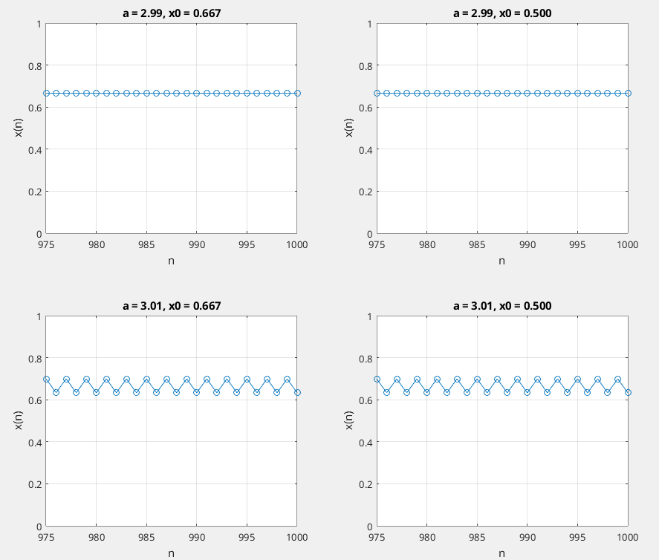
FIGURE Y: Four subplots showing steady-state behavior of x(n) vs n for different combinations of a and x(0). For clarity, only iterations 975-1000 are shown. Steady-state behavior near the first period-doubling point. Top row: a = 2.99 with x(0) = 0.667 (left) and x(0) = 0.5 (right). Bottom row: a = 3.01 with x(0) = 0.667 (left) and x(0) = 0.5 (right).

For a = 2.99, just below the period-doubling point, both initial conditions converge to a single fixed point at 0.6656, demonstrating that the steady-state solution remains independent of initial conditions in this regime, consistent with our findings from Task 2.
However, when a = 3.01, just above the period-doubling point, we observe that the system no longer converges to a single value but instead alternates between two values (0.6328 and 0.7000) regardless of the initial condition. This marks the onset of period-2 behavior, where the system requires two iterations to repeat its pattern. The numerical results confirm that both initial conditions lead to identical period-2 oscillations, showing that while the route to reach these alternating values may differ, the final period-2 values themselves are independent of initial conditions.
This analysis clearly demonstrates the qualitative change in system behavior as we cross the a = 3 threshold, showing the emergence of period doubling while confirming that the long-term behavior remains independent of initial conditions on both sides of this transition.

Period Doubling Cascade Analysis
To precisely determine the values of a where period doubling occurs, we examined the steady-state behavior of the system by analyzing pattern repetition after n ≈ 1000 iterations to ensure transients had died out. Table 1 shows the identified period doubling thresholds a₁, a₂, a₃, and a₄.
Table 1: Period doubling threshold values and their differences. The Feigenbaum constant is calculated using the ratio of successive differences.
1 | 2.9900 | 0.4553 | --
2 | 3.4453 | 0.1047 | 4.3479
3 | 3.5500 | 0.0184 | 5.6784
4 | 3.5684 | 0.0184 | 5.6784

Using these values, we calculated δₖ according to Eq. 3 in the lab manual. The values of δₖ show convergence toward Feigenbaum's theoretical value of 4.669, with our experimental values ranging from 4.3479 to 5.6784. Using Eqs. 2-4, we estimated a∞ = 3.5915 and S = 2.9023, indicating the approximate point where the period doubling cascade leads to chaos.

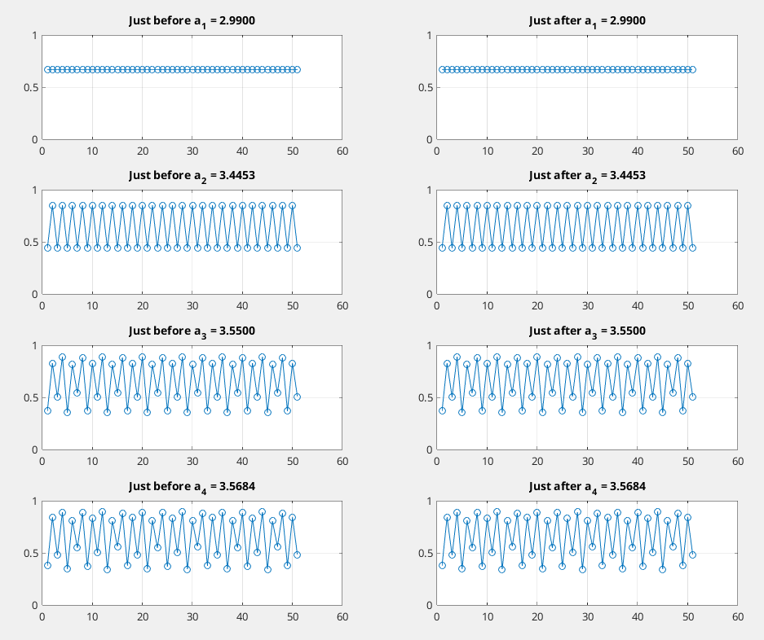
FIGURE Z: Phase plots demonstrating the period doubling cascade. For a₁ = 2.9900, we observe the first transition from period-1 to period-2 behavior. At a₂ = 3.4453, the system transitions from period-2 to period-4, showing increasingly complex oscillatory behavior. The third threshold at a₃ = 3.5500 marks the transition to period-8, and finally, at a₄ = 3.5684, we see the transition to period-16. For each threshold, the left plot shows behavior just before the transition and the right plot shows behavior just after.

