Kym Derriman
Section 4, Lab 7: Forced Harmonic Motion
Partner Evan Howell
10/28/2024

FORCED HARMONIC MOTION

INTRODUCTION

In this experiment a spring-mass system, subject to harmonic forced oscillation by a lever arm, and damping by a large paper plate, was observed. The effects of damping, as well as the resulting relationships among frequency, amplitude, and phase was analyzed.

BACKGROUND

Hooke’s Law describes the restoring force of the mass-spring system with . Combined with the force of gravity, , gives . Solving for displacement gives (1), where

(1)

is mass , is the spring constant , and is displacement from equilibrium. and are constants determined by the initial conditions. The angular frequency is and the period is . In the absence of external forces, the system undergoes undamped harmonic motion.

For a system undergoing damped harmonic motion, two additional parameters characterize the damping effects: , the damping coefficient, and , the retarding force coefficient, which is proportional to the mass’s speed. Damping is described by (2), while the frequency of damped oscillation is given by (3), assuming .
(2)
(3)
The damping force reduces the amplitude of oscillations over time. This is characteristic of under-damped motion, where the damping force is not strong enough to completely stop oscillations immediately. In this scenario, the system oscillates at a damped angular frequency , which is lower than the natural angular frequency due to the damping coefficient , described by (4).
(4)
When a driving force is added to the system, we have an additional term in the equation of motion, shown in (5).
(5)
When the force is turned on, the system undergoes some transient motion and the system eventually settles into motion described by (1), where the amplitude is given by (6) and the phase shift by (8).

(6)
(7)
Least-squares fitting was used to analyze our data, particularly for fitting the decay in amplitude and extracting the damping coefficient. This method minimizes the sum of the squares of the differences between the observed values and those predicted by the model, giving us a reliable way to quantify the damping effect, calculated by (4), (5), (6), (7), where . The uncertainties in and are given by (8).
(8)
(9)
(10)
(11)
(12)

APPARATUS

An apparatus, shown in Figure 1, was arranged such that a rotating arm was attached to a nylon cord which was fed through a sensor that measures rotary motion. The other end of the cord was attached to a spring, whose other end was connected to a weight holder and weight. The rotary arm was driven by an electric motor whose speed was controlled by a variable voltage supply. An ultrasonic position sensor was placed below the mass-spring system and both the rotary sensor and position sensor were connected to a computer to pass data to LoggerPro.
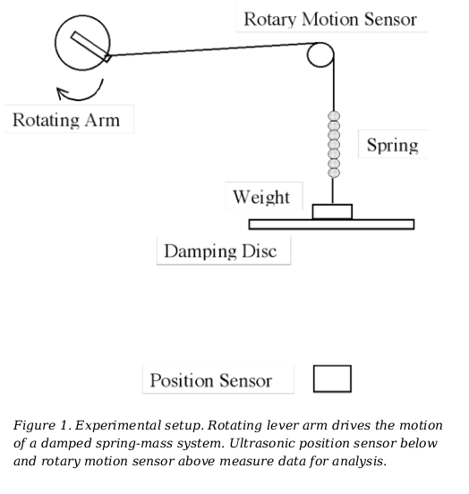
PROCEDURE

1. Measurement of Undamped “Natural” Frequency

The experiment was broadly divided into two parts. Part 1 dealt with determining the natural frequency of the system. To accomplish this, the oscillation of the mass spring system was measured in three configurations:
- Case 1: with no damping disk or equivalent weight;
- Case 2: with weight equivalent to the damping disk;
- Case 3: with the damping disk.
The purpose of this process was to isolate the damping variable as much as possible with the goal of establishing a baseline frequency which would be compared with the frequency of the damped oscillator.

2. Measurement and Characterization of Forced and Damped System

The motor's frequency was systematically varied after the damping disc had been installed. Vibrational responses were observed and recorded at each frequency point tested. The frequency at which maximum amplitude was observed was then identified as the approximate resonant frequency of the system.

The amplitude of the external force was increased by changing the length of the rotary arm such that the spring was stretched somewhat extensively without the mass hitting the sensor or altering the linear regime of the spring-mass system. The motions of oscillation were then recorded with LoggerPro with data from the ultrasonic position sensor and rotary arm sensor (displacement and angle, respectively), while the voltage was varied over its entire range.

The process described in sections 1 and 2 were repeated for the case of a paper plate and with the paper plate removed.

RESULTS AND DISCUSSION

All analysis was conducted with MATLAB. In Part 1, the oscillation of the system was measured in three configurations as described in the procedure section. The rotary arm angle, time, and position data were imported for analysis. The position data was shifted in each case to oscillate about zero by

(13)

The results were imported to MATLAB for analysis and are reported in Table 1.

Table 1: Frequency Analysis Results Large Damping Disk
 | Frequency (Hz) | Uncertainty (Hz)
Case 1 (no mass no disk) | 0.670 | 0.009
Case 2 (equivalent mass) | 0.432 | 0.005
Case 3 (damping disk) | 0.423 | 0.005

The data in Table 1 is consistent with theoretical expectations of harmonic oscillators. The three cases analyzed and the relative plots are displayed in Figure 2. Case 2 represents the most appropriate measure of the natural frequency of the system when comparing damping effects, as it isolates damping effects as the only significant variable by adding mass equivalent to the disk. We describe this case of an undamped harmonic oscillator by (14), where k is the spring constant, m is the mass of the system, , and f0 is the natural frequency. The equation shows that the natural frequency is inversely proportional to the square root of the mass, so as the mass increases, the natural frequency decreases.

(14)

When damping comes into play, the system’s behavior is described by (4), which is the equation for damped harmonic oscillators. From (4), we can derive the damped natural frequency shown in (15), where R is the damping coefficient.

(15)

The necessity for adding equivalent mass is demonstrated by the effect of mass between Case 1 and Case 2, with Figure 2 clearly showing a significant effect on frequency.

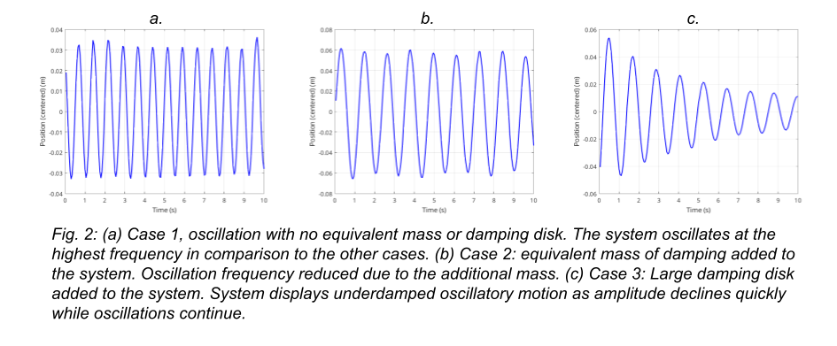
The frequency decreases from 0.670 Hz in Case 1 to 0.432 Hz in Case 2 when the equivalent mass is added.

In Case 3, a damping disk is added, which introduces damping not only by the air resistance from the large disk but also by its mass. The frequency decreases minimally to 0.423 Hz which is the average over the measurement time of the sample, but more notable is the drastic decrease in amplitude over the course of the measurement, which decreases from ~0.05 m to ~0.01 m.

This decrease in amplitude is described by (16), where is the damping ratio and A0 is the initial displacement.

(16)

The purpose of the second part of the experiment was to measure and characterize a forced harmonic oscillator with a large damping disk. Measurements were taken of the oscillating system with a driving force, the rotating lever arm. The driving force was first calibrated roughly by observing at which voltage the mass on the spring seemed to oscillate with the greatest amplitude. With that rough gauge of driving frequency observed, more precise measurements were taken around that frequency to more precisely identify the resonant frequency. The equation of motion for a damped, driven harmonic oscillator is described by (5), the stead-state amplitude A is given by (6), and the phase shift by (7).

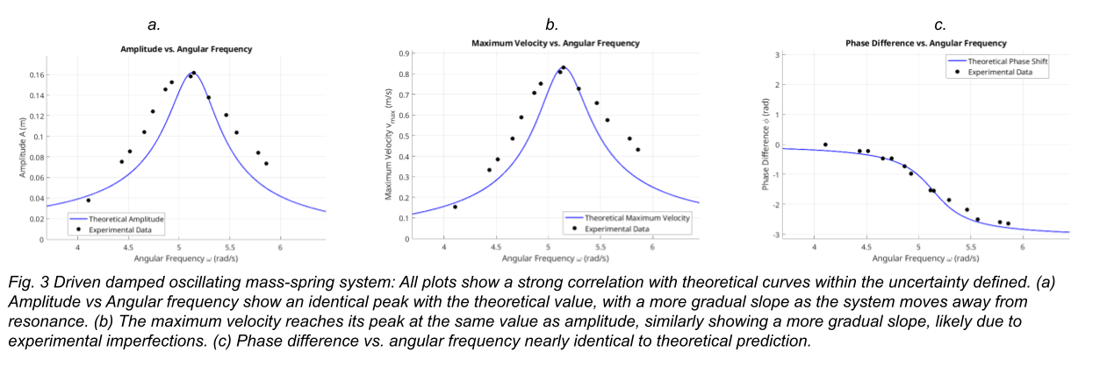
Figure 3 presents the plots of amplitude A, maximum velocity vmax​, and phase shift ϕ versus angular frequency ω.
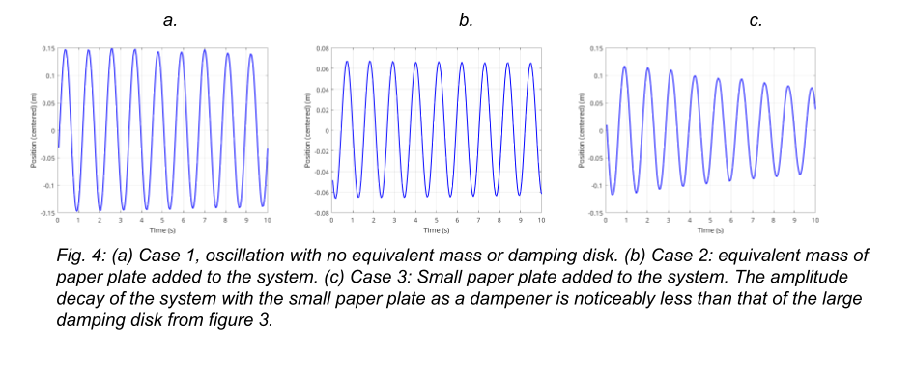
The amplitude reaches a maximum at the resonance frequency ωres​. The resonance peak is broadened due to damping, as predicted by the theoretical expression for A(ω). The experimental data closely follow the theoretical curve, confirming the relationship between driving frequency and amplitude.
The maximum velocity vmax​ is proportional to Aω. The plot shows a peak near the resonance frequency, consistent with the expected behavior of the system.
The phase shift ϕ transitions from 0 to π as the driving frequency increases from below to above the natural frequency. At resonance, the phase shift is 2π​, indicating that the response lags the driving force by a quarter of a cycle. This behavior matches the theoretical phase shift equation (7), and can be seen in Table 2.

Table 2: Frequency Analysis Results Large Damping Disk
 | Frequency (Hz) | Uncertainty (Hz)
Case 1 (no mass no plate) | 0.91 | 0.02
Case 2 (equivalent mass) | 0.90 | 0.01
Case 3 (damping plate) | 0.90 | 0.02

Table 2 shows that the pattern observed with the large disk is repeated in terms of the effect of the air resistance on frequency is minimal, with mass playing a larger role, however, the effect on amplitude over time is significant once again.
The expectation from the data of week 1 to week 2 was that the results for the natural frequency of the harmonic oscillator would have been the same, given that frequency has little effect on the frequency compared to the amplitude. This result is likely due to systematic error, as the patterns remain consistent.
Due to this, normalized plots were created to analyze these relationships as a ratio rather than by their raw values. Figure 6 shows the relationship between amplitude and frequency for both cases, figure 7 the maximum velocity vs frequency and figure 8 the phase vs frequency.

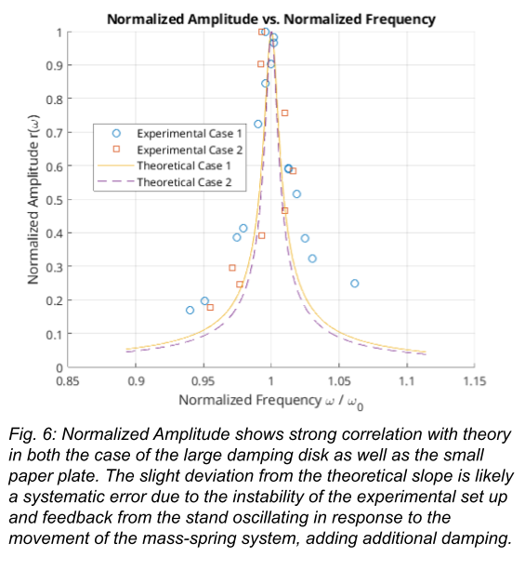

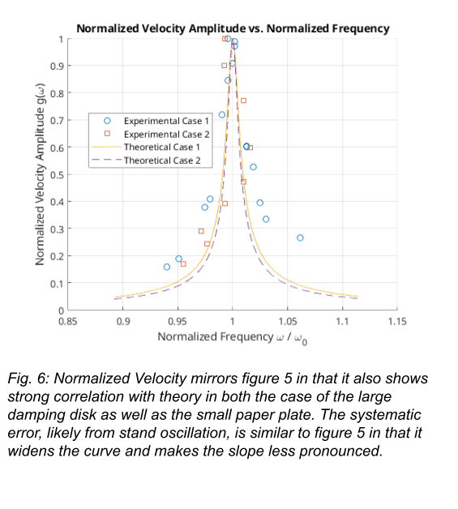
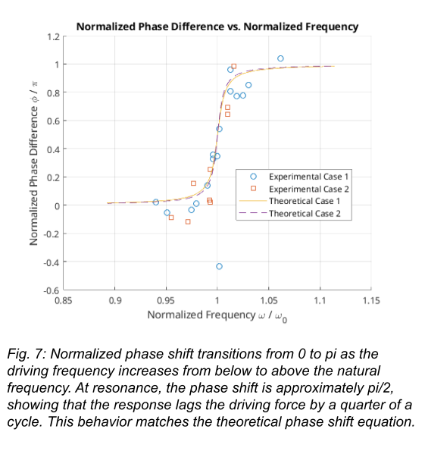

CONCLUSION
The experiment measured successfully the natural frequencies of the mass-spring system, as well as how the system reacts to added mass and added damping. Data of amplitude, max velocity and phase difference was gathered and analyzed for driven, damped oscillation and it aligned very well with theoretical predictions. The estimated damping coefficients reflected how the system behaved. The experiment was insightful and illustrated how driving forces, mass and damping play a role in how a harmonic oscillator behaves.

REFERENCES

[1] | J. G. Fox, J. Mahanty; The Effective Mass of an Oscillating Spring. Am. J. Phys. 1 January 1970; 38 (1): 98–100. https://doi.org/10.1119/1.1976240

