Kym Derriman
Section 4, Lab 7: Forced Harmonic Motion
10/28/2024

FORCED HARMONIC MOTION

INTRODUCTION

In this experiment a spring-mass system, subject to harmonic forced oscillation by a lever arm, and damping by a large paper plate, was observed. The effects of damping, as well as the resulting relationships among frequency, amplitude, and phase was analyzed.

BACKGROUND

Hooke’s Law describes the restoring force of the mass-spring system with . Combined with the force of gravity, , gives . Solving for displacement gives (1), where

(1)

is mass , is the spring constant , and is displacement from equilibrium. and are constants determined by the initial conditions. The angular frequency is and the period is . In the absence of external forces, the system undergoes undamped harmonic motion.

For a system undergoing damped harmonic motion, two additional parameters characterize the damping effects: , the damping coefficient, and , the retarding force coefficient, which is proportional to the mass’s speed. Damping is described by (2), while the frequency of damped oscillation is given by (3), assuming .
(2)
(3)
The damping force reduces the amplitude of oscillations over time. This is characteristic of under-damped motion, where the damping force is not strong enough to completely stop oscillations immediately. In this scenario, the system oscillates at a damped angular frequency , which is lower than the natural angular frequency due to the damping coefficient , described by (4).
(4)
When a driving force is added to the system, we have an additional term in the equation of motion, shown in (5).
(5)
When the force is turned on, the system undergoes some transient motion and the system eventually settles into motion described by (1), where the amplitude is given by (6) and the phase shift by (8).

(6)
(7)
Least-squares fitting was used to analyze our data, particularly for fitting the decay in amplitude and extracting the damping coefficient. This method minimizes the sum of the squares of the differences between the observed values and those predicted by the model, giving us a reliable way to quantify the damping effect, calculated by (4), (5), (6), (7), where . The uncertainties in and are given by (8).
(8)
(9)
(10)
(11)
(12)

APPARATUS

An apparatus, shown in Figure 1, was arranged such that a rotating arm was attached to a nylon cord which was fed through a sensor that measures rotary motion. The other end of the cord was attached to a spring, whose other end was connected to a weight holder and weight. The rotary arm was driven by an electric motor whose speed was controlled by a variable voltage supply. An ultrasonic position sensor was placed below the mass-spring system and both the rotary sensor and position sensor were connected to a computer to pass data to LoggerPro.
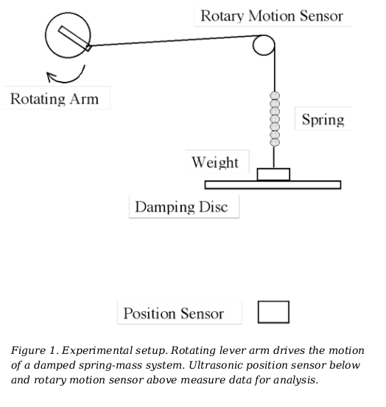
PROCEDURE

1. Measurement of Undamped “Natural” Frequency

The experiment was broadly divided into two parts. Part 1 dealt with determining the natural frequency of the system. To accomplish this, the oscillation of the mass spring system was measured in three configurations:
- with no damping disk or equivalent weight;
- with weight equivalent to the damping disk;
- with the damping disk.
The purpose of this process was to isolate the damping variable as much as possible with the goal of establishing a baseline frequency which would be compared with the frequency of the damped oscillator. The results were imported to MATLAB for analysis and are reported in Table 1.

The purpose of the second part of the experiment was to measure and characterize a forced harmonic oscillator with a large damping disk. We ran trial

2. Measurement and Characterization of Forced and Damped System

The motor's frequency was systematically varied after the damping disc had been installed. Vibrational responses were observed and recorded at each frequency point tested. The frequency at which maximum amplitude was observed was then identified as the approximate resonant frequency of the system.

The amplitude of the external force was increased by changing the length of the rotary arm such that the spring was stretched somewhat extensively without the mass hitting the sensor or altering the linear regime of the spring-mass system. The motions of oscillation were then recorded with LoggerPro with data from the ultrasonic position sensor and rotary arm sensor (displacement and angle, respectively), while the voltage was varied over its entire range.

The large cardboard disk was exchanged for a small paper plate and the preceding steps of part 2 were repeated. Finally, the small paper plate was exchanged for an even smaller paper plate and the preceding steps once again repeated.

RESULTS AND DISCUSSION

All analysis was conducted with MATLAB. In Part 1, the oscillation of the system was measured in three configurations as described in the procedure section. The rotary arm angle, time, and position data were imported for analysis. The position data was shifted in each case to oscillate about zero by

(13)

The zero-crossing points of the position and angle data was obtained by defining two logical arrays, one for positive positions/angles and one for negative positions/angles, and marking the indices where these changes from true (positive) to false (negative) occur. The corresponding times are then pulled from the time data array. After these times are identified, the average period is obtained by averaging the differences between each two consecutive crossings.

The time lag between the zero-crossings of the position and the angle data was used in (14) to calculate the phase difference, where is the time lag between zero-crossings of the rotary arm and position data and is the mean of the individual period measurements.

(14)

Table 1 shows that the frequency of each case was almost identical. The frequency that corresponds with the natural frequency is that of the equivalent mass, . The case with no disk or added mass does not account for the mass of the damping disk and the case of the disk includes damping effects which would alter the observed frequency.

Table 1. Part A Oscillation Data
Case | Average Period (s) | Frequency (Hz)
No disk or added mass | 2.31 +- 0.03 | 0.4324
Equivalent mass | 2.31 +- 0.03 | 0.4324
Disk | 2.33 +- 0.03 | 0.4301

The frequency from cases 1 and 2 are more closely related to the natural frequency of the system as there was no damping introduced in those scenarios. Specifically, case 2 would be the natural frequency (although they have the same values with this data), as case 2 incorporated the weight of the disk into the system by measuring the mass of the disk and placing an equivalent mass onto the system.

CONCLUSION

In conclusion,

REFERENCES

[1]

