Kym Derriman (Partner: Evan Howell)
Lab 09 & 10
Section 4
November 20, 2024

FOURIER ANALYSIS AND SYNTHESIS

INTRODUCTION

In this experiment, we explore the principles of Fourier analysis and synthesis, focusing on how periodic and real-world signals can be decomposed and analyzed. Fourier series and Fourier transforms provide tools to represent signals in terms of their basic frequencies. The lab covers synthesized signals (square, sawtooth, and triangular waves) and real-world signals (tuning fork vibrations and human voice). Using MATLAB, we perform signal synthesis and analysis, and we compare experimental data collected using an oscilloscope and the SR760 spectrum analyzer.

BACKGROUND

Fourier’s theorem states that any periodic function can be represented as an infinite series of sines and cosines with frequencies that are integer multiples of the fundamental frequency. For a periodic function \( f(t) \) with period \( T \), the Fourier series is given by:

(1)

Where:

- is the fundamental frequency.
- and are Fourier coefficients calculated as:

(2)

For non-periodic signals, the Fourier transform generalizes this concept, representing the function in terms of continuous frequencies:

(3)

In this lab, we apply Fourier series and Fourier transforms to both synthesized and real-world signals. Using MATLAB, we synthesize waveforms using their Fourier series expansions and analyze signals using the Fast Fourier Transform (FFT). We also compare our results with experimental data collected from an oscilloscope and the SR760 spectrum analyzer.

PROCEDURE

In this lab, we synthesized square and sawtooth waves using Fourier series and analyzed their frequency components with MATLAB. We then recorded real-world signals from tuning forks and human voice samples using a microphone connected to an oscilloscope and the SR760 spectrum analyzer. The oscilloscope captured time-domain waveforms, while the SR760 provided frequency spectra for further analysis. By comparing the synthesized and experimental data, we explored the practical applications of Fourier analysis and the behavior of signals in both time and frequency domains.

RESULTS AND DISCUSSION

Part A: Square Wave Synthesis

For a symmetric square wave with period T, the Fourier coefficients are:

(4)

Using MATLAB, we synthesized the square wave by summing the first N odd harmonics ( n = 1, 3, 5, 7, 9 ):

(5)

We plotted the partial sums for increasing numbers of harmonics to observe how the approximation improves. We examined the behavior near the discontinuities of the square wave, noting the overshoot that persists as more harmonics are added.

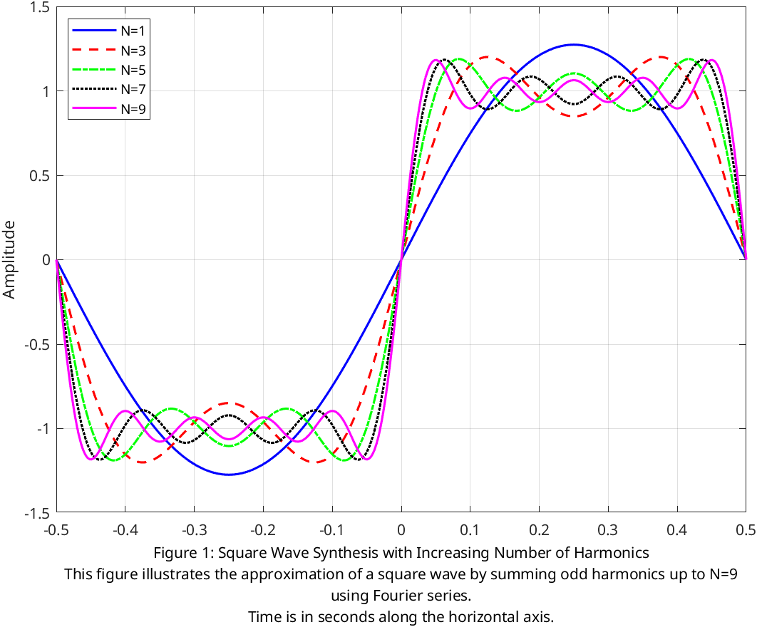

Part B: Sawtooth Wave Synthesis

For a sawtooth wave defined over -T/2 <= t <= T/2:

(6)

We synthesized the sawtooth wave using up to n = 5 harmonics:

(7)

We plotted the Fourier series approximation alongside the exact sawtooth function .

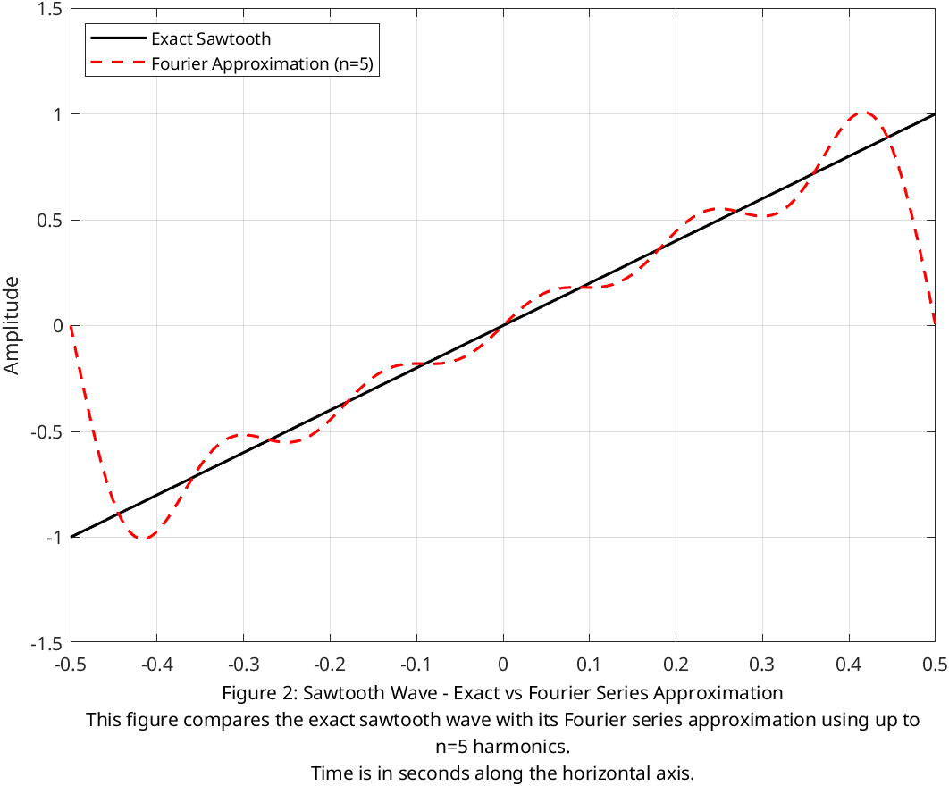

Part D: Waveform Analysis

We generated square and triangular waves using MATLAB and computed the FFT of these signals to obtain their frequency spectra.

For the square wave, we compared FFT magnitudes at harmonic frequencies with theoretical Fourier coefficients for odd n.
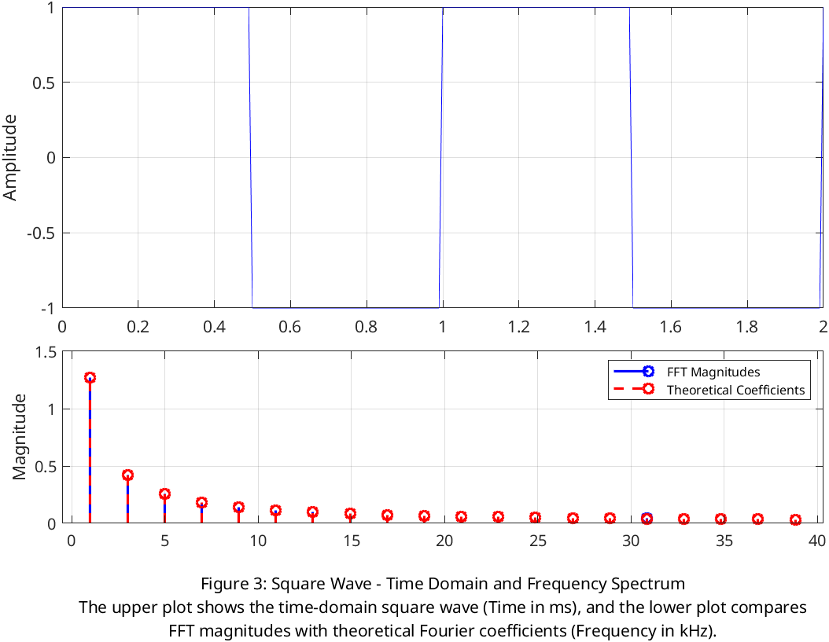

For the triangle wave, we compared FFT magnitudes with theoretical coefficients for odd n.

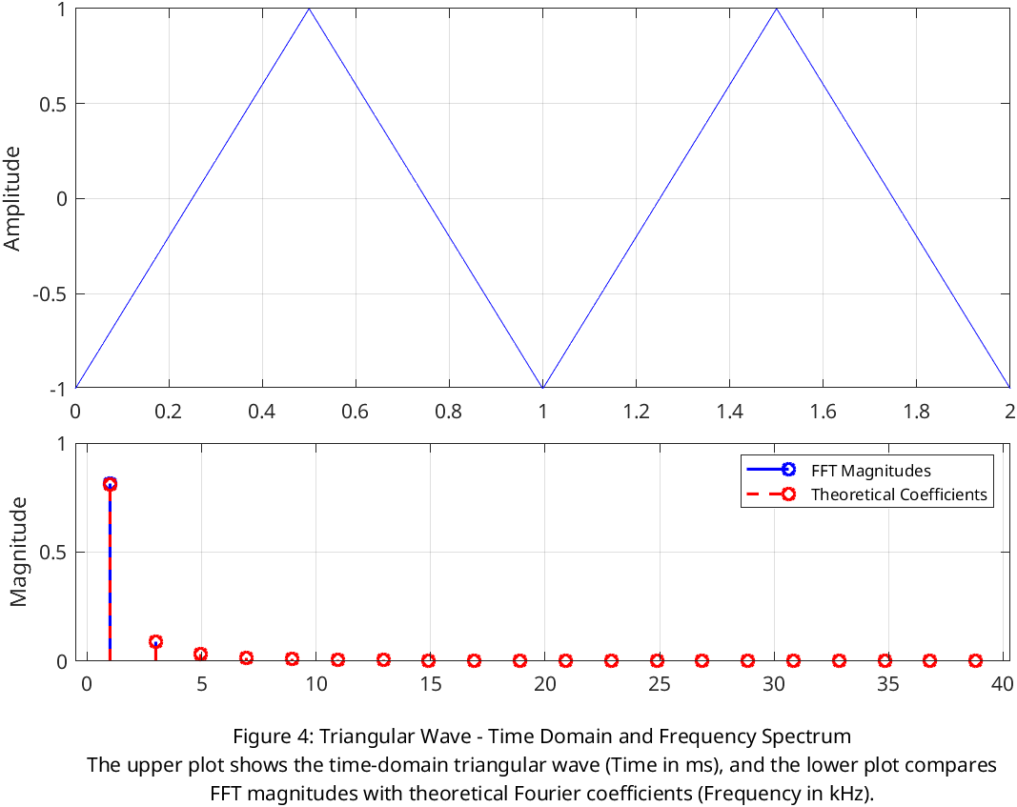

Part E: Tuning Fork Analysis

We recorded time-domain waveforms of three tuning forks (C4: 261.62 Hz, E4: 329.63 Hz, G4: 392.00 Hz) using a microphone connected to the oscilloscope. We then computed the FFT of the recorded waveforms to obtain frequency spectra. We read the SR760 spectrum analyzer data and compared it with the FFT results, shown in figures 5 through 10.

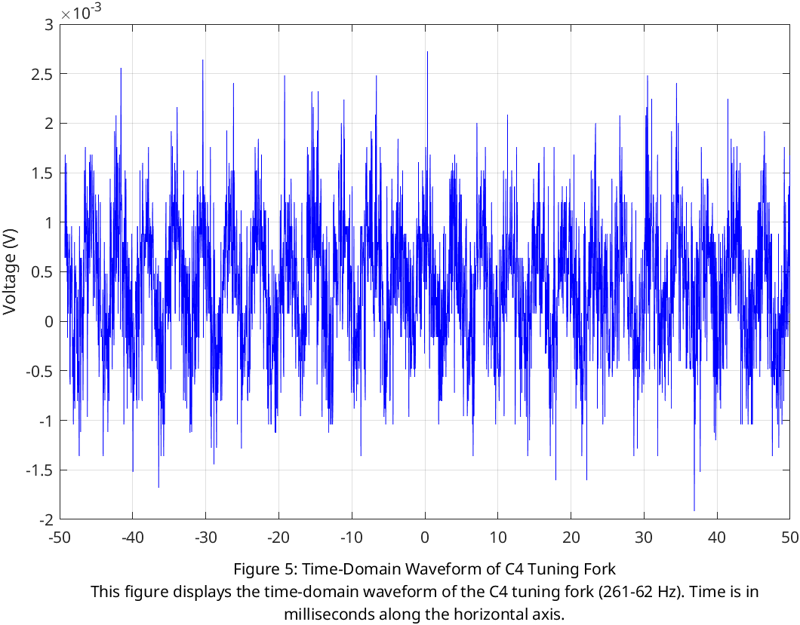

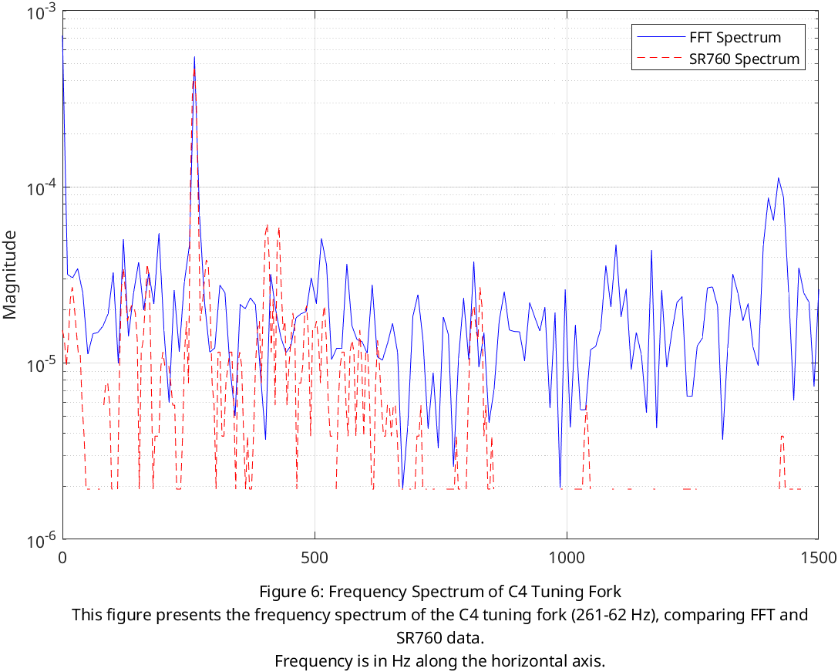

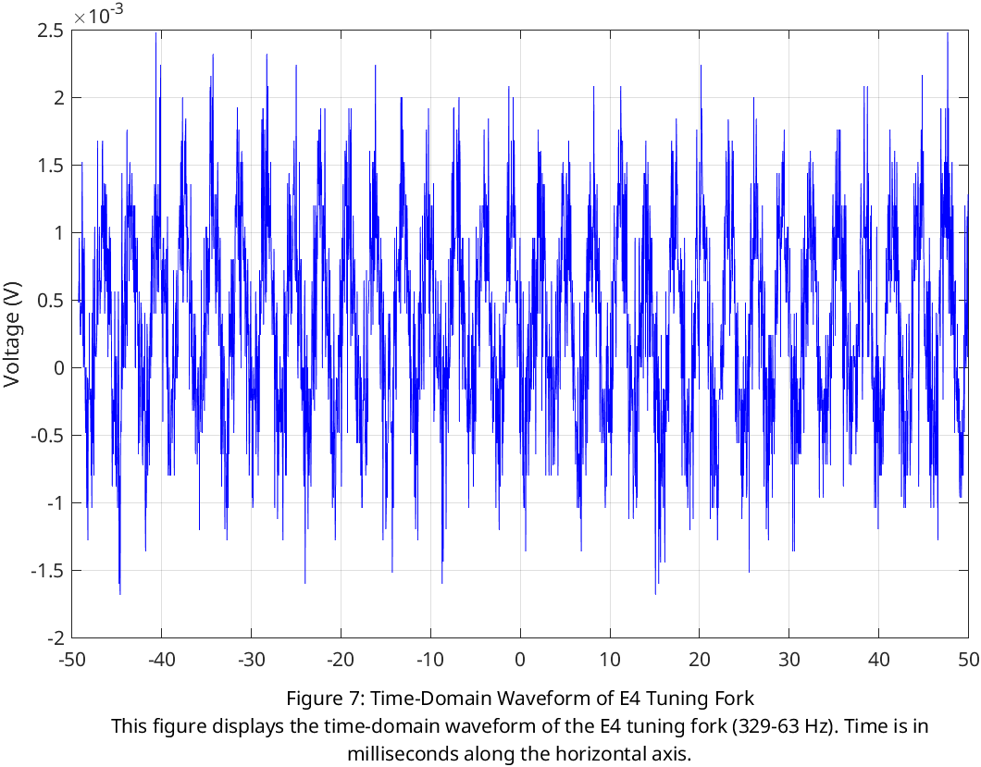

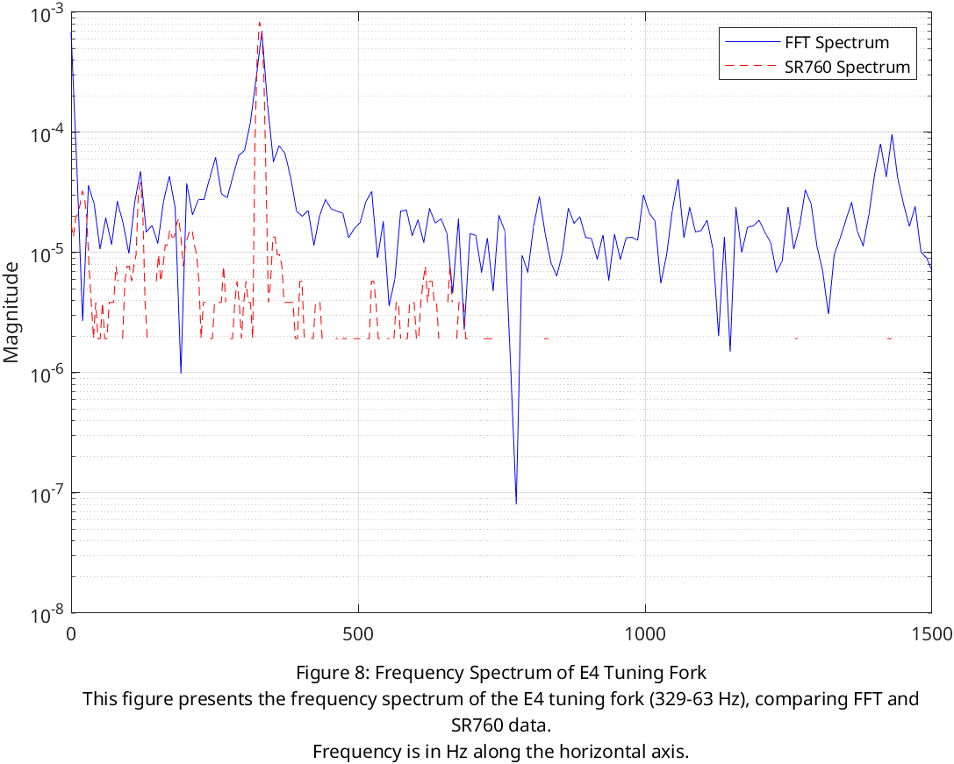

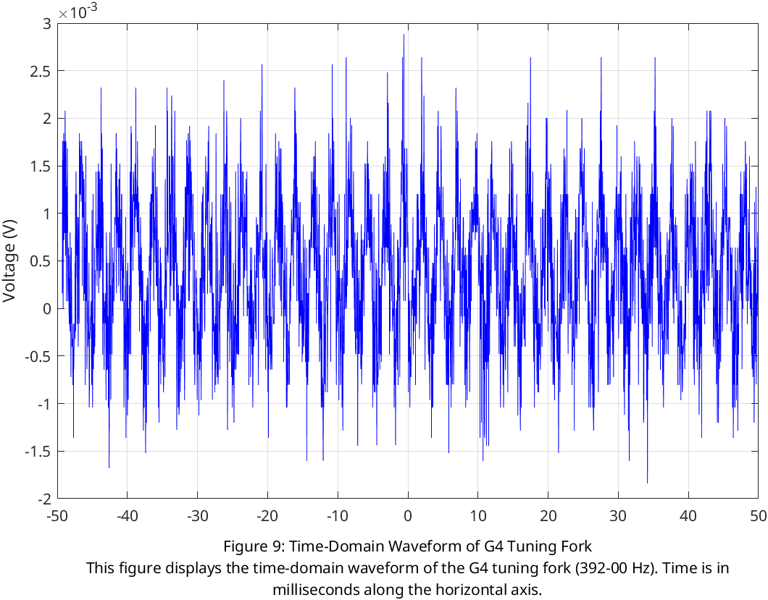
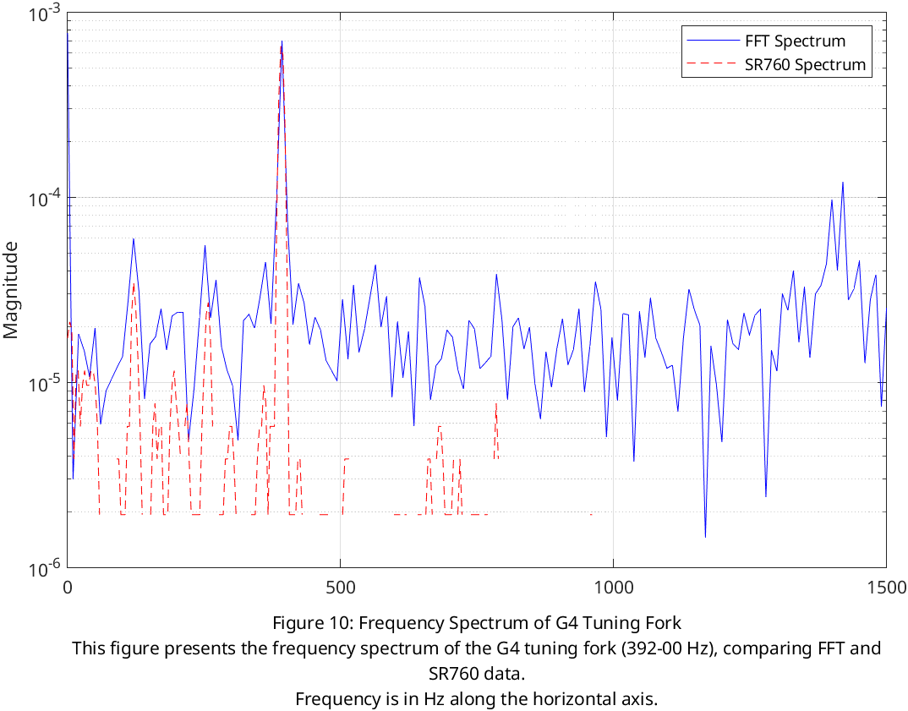

Part F: Voice Analysis

For part F, we recorded voice samples (Low, Medium, and High Tones) using a microphone connected to the oscilloscope. We then performed FFT on the recorded waveforms to obtain frequency spectra and read SR760 data for each voice sample and compared it with the FFT spectra. This analysis is shown in figures 11 through 16.

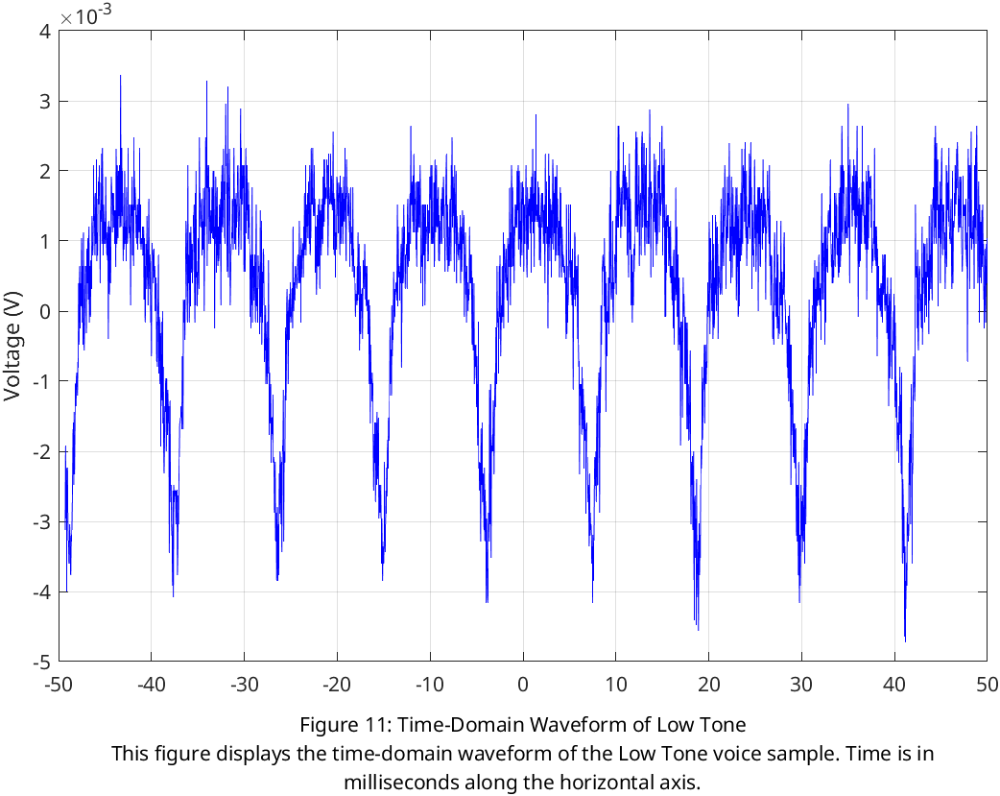
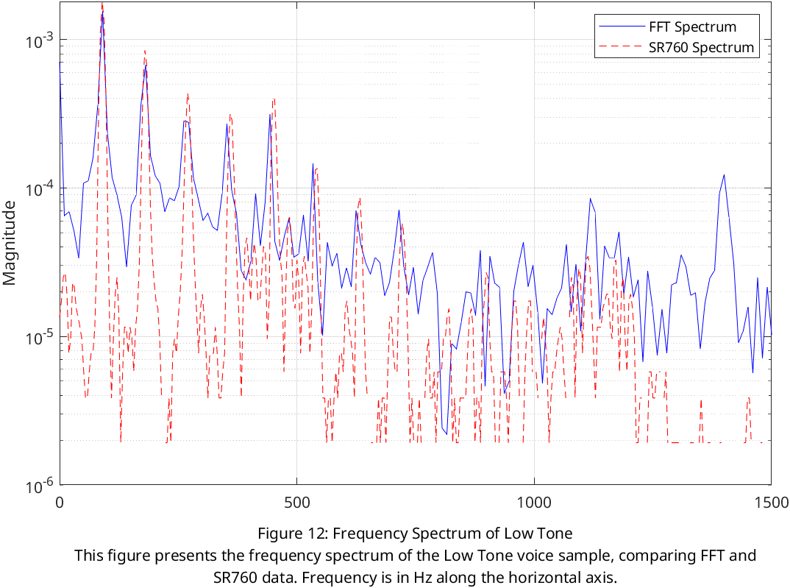
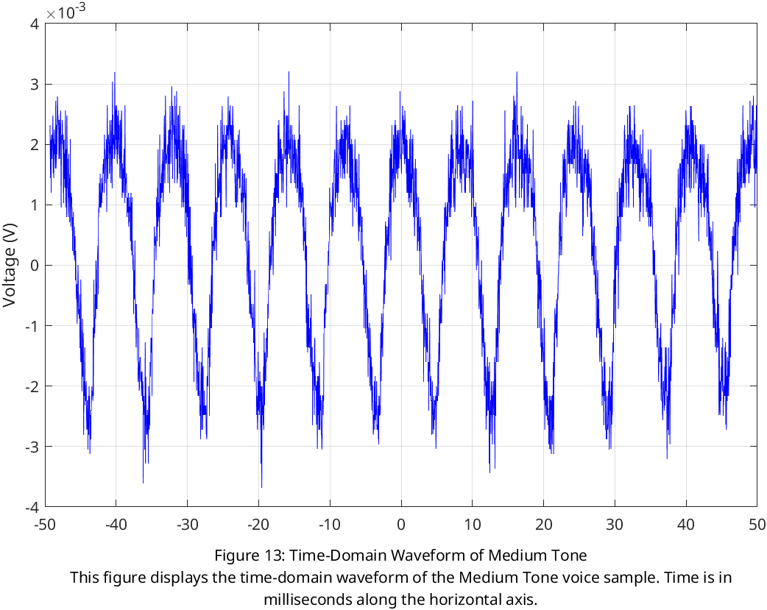
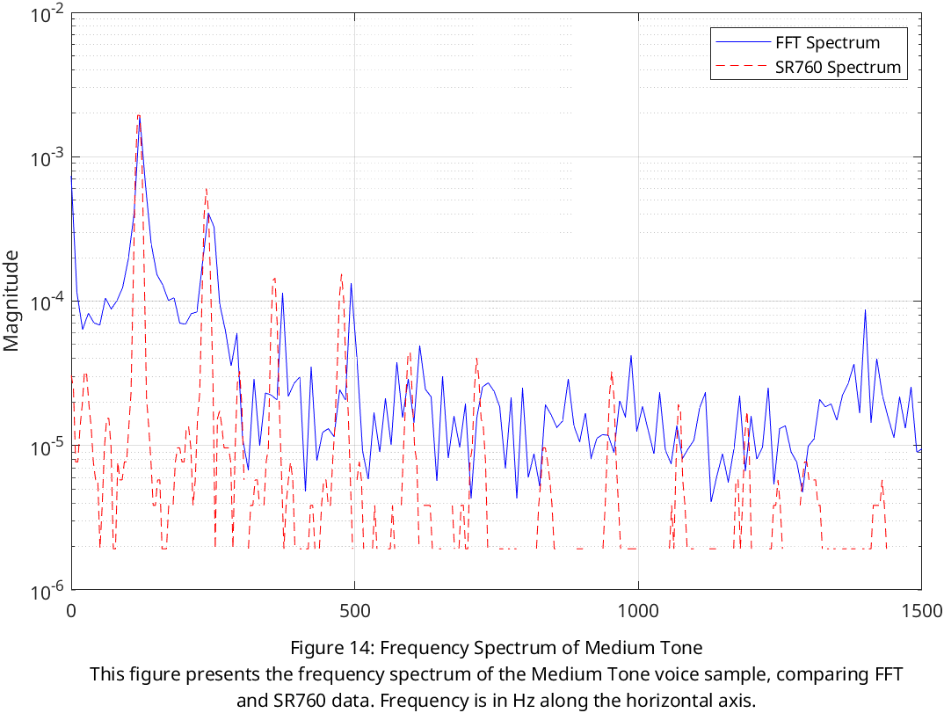

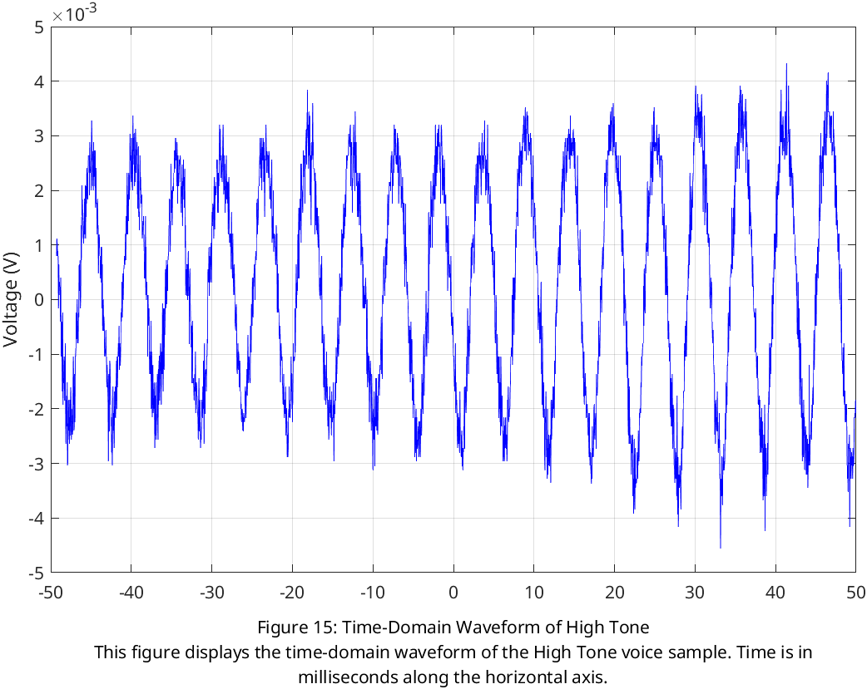
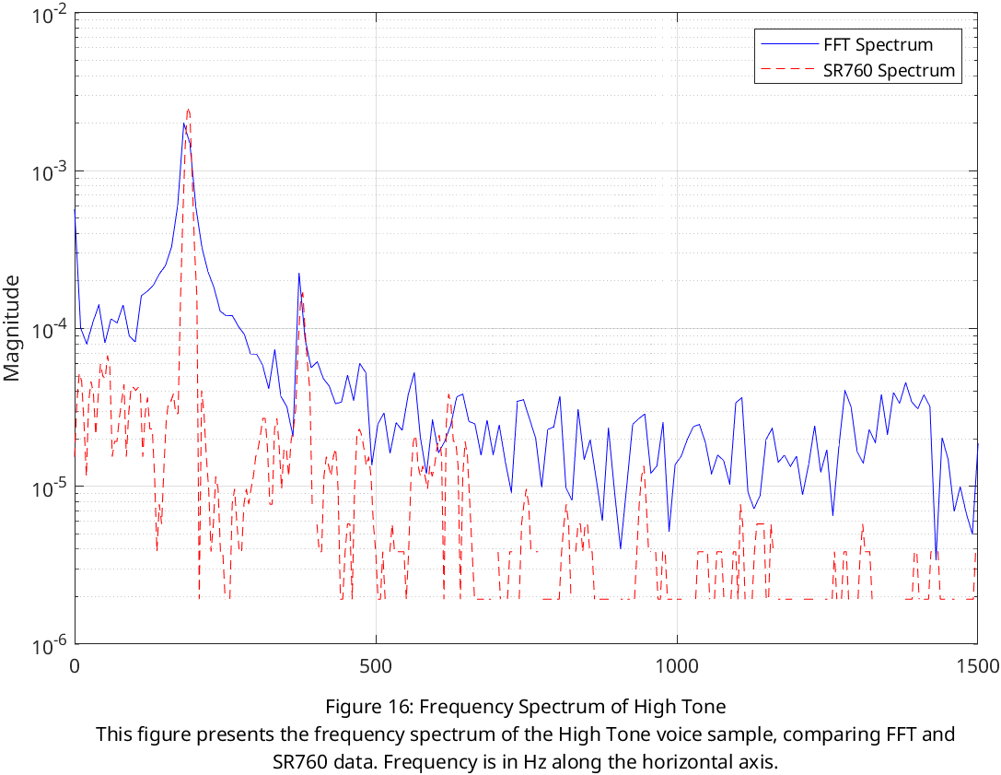

CONCLUSION

This lab demonstrated the application of Fourier analysis and synthesis to both theoretical and experimental signals. By synthesizing square and sawtooth waves using Fourier series in MATLAB, we observed how the addition of harmonics improves the approximation of periodic functions, and we noted phenomena such as the Gibbs phenomenon. Through FFT analysis of synthesized and real-world signals, we validated the theoretical Fourier coefficients and explored the frequency content of different waveforms.

The analysis of tuning fork vibrations and human voice samples highlighted the practical use of Fourier transforms in signal processing. In this lab, we explored Fourier analysis and synthesis to study both theoretical and experimental signals. By adding odd harmonics (up to n=9) in the Fourier series, we saw how square waves could be reconstructed with increasing accuracy, though the Gibbs phenomenon caused slight overshoots near discontinuities. Similarly, for sawtooth waves, the Fourier approximation converged to the exact function as more terms were added, demonstrating the effectiveness of the series. Using FFT in MATLAB, we analyzed the frequency components of synthesized square and triangular waves. The FFT results matched the theoretical Fourier coefficients, with square waves showing prominent odd harmonics and triangular waves exhibiting rapidly decaying harmonics consistent with their mathematical predictions.

