Kym Derriman
Section 4, Lab 7: Forced Harmonic Motion
10/28/2024

FORCED HARMONIC MOTION

INTRODUCTION

In this experiment a spring-mass system, subject to harmonic forced oscillation by a lever arm, and damping by a large paper plate, was observed. The effects of damping, as well as the resulting relationships among frequency, amplitude, and phase was analyzed.

BACKGROUND

Hooke’s Law describes the restoring force of the mass-spring system with . Combined with the force of gravity, , gives . Solving for displacement gives (1), where

(1)

is mass , is the spring constant , and is displacement from equilibrium. and are constants determined by the initial conditions. The angular frequency is and the period is . In the absence of external forces, the system undergoes undamped harmonic motion.

For a system undergoing damped harmonic motion, two additional parameters characterize the damping effects: , the damping coefficient, and , the retarding force coefficient, which is proportional to the mass’s speed. Damping is described by (2), while the frequency of damped oscillation is given by (3), assuming .

(2)
(3)

The damping force reduces the amplitude of oscillations over time. This is characteristic of under-damped motion, where the damping force is not strong enough to completely stop oscillations immediately. In this scenario, the system oscillates at a damped angular frequency , which is lower than the natural angular frequency due to the damping coefficient , described by (4).

(4)

When a driving force is added to the system, we have an additional term in the equation of motion, shown in (5).

(5)

When the force is turned on, the system undergoes some transient motion and the system eventually settles into motion described by (1), where the amplitude is given by (6) and the phase shift by (8).

(6)

(7)

Least-squares fitting was used to analyze our data, particularly for fitting the decay in amplitude and extracting the damping coefficient. This method minimizes the sum of the squares of the differences between the observed values and those predicted by the model, giving us a reliable way to quantify the damping effect, calculated by (4), (5), (6), (7), where . The uncertainties in and are given by (8).

(8)
(9)
(10)
(11)

(12)

APPARATUS

An apparatus, shown in Figure 1, was arranged such that a rotating arm was attached to a nylon cord which was fed through a sensor that measures rotary motion. The other end of the cord was attached to a spring, whose other end was connected to a weight holder and weight. The rotary arm was driven by an electric motor whose speed was controlled by a variable voltage supply.

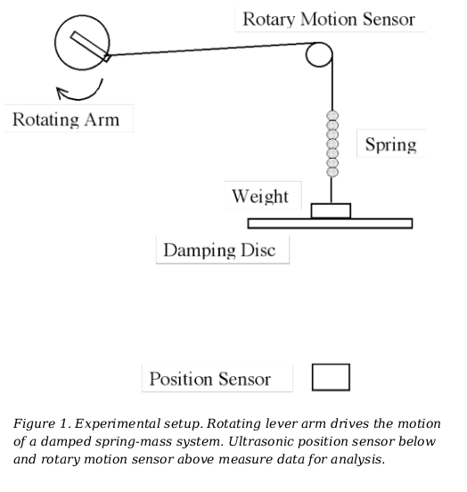
An ultrasonic position sensor was placed below the mass-spring system and both the rotary sensor and position sensor were connected to a computer to pass data to LoggerPro.

PROCEDURE

The experiment was broadly divided into two parts. Part 1 dealt with determining the natural frequency of the system. To accomplish this, the oscillation of the mass spring system was measured in three configurations:
- with no damping disk or equivalent weight;
- with weight equivalent to the damping disk;
- with the damping disk.

The results were imported to MATLAB for analysis.

Part 2

[INSERT PART 2 PROCEDURE HERE]

RESULTS AND DISCUSSION

In Part 1, the oscillation of the system was measured in three configurations as described in the procedure section. In all configurations, the rotary arm angle data, time data, and mass position data was imported to MATLAB. The position data was shifted in each case to oscillate about zero by (EQUATION#).

(13)

In MATLAB, the zero-crossing points of the position and rotary arm data was obtained by defining two logical arrays, one for positive positions/angles and one for negative positions/angles, and marking the indices where these changes from true (positive) to false (negative) occur. The corresponding times are then pulled from the time data array. After these times are identified, the average period is obtained by averaging the differences between each two consecutive crossings.

This was repeated for the zero-crossings of the rotary arm angle data and the time lag between the zero-crossings of the position and the angle data was used to calculate the phase difference.
(EQUATION#), where is the time lag between zero-crossings of the rotary arm and position data and is the mean of the individual period measurements.

(14)

The results determined by the calculations described above are presented in Table 1.

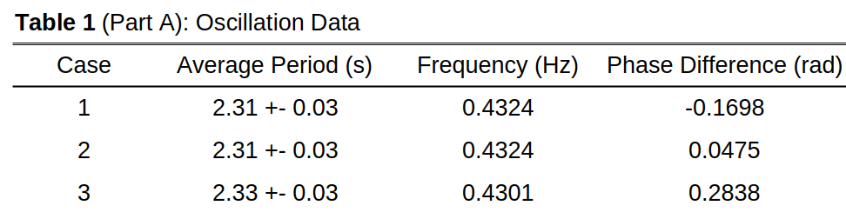

The frequency from cases 1 and 2 are more closely related to the natural frequency of the system as there was no damping introduced in those scenarios. Specifically, case 2 would be the natural frequency (although they have the same values with this data), as case 2 incorporated the weight of the disk into the system by measuring the mass of the disk and placing an equivalent mass onto the system.

CONCLUSION

In conclusion,

REFERENCES

[1]

