Kym Derriman
Section 4, Lab 6: Damped Harmonic Motion
10/21/2024

DAMPED HARMONIC MOTION

INTRODUCTION

In this experiment, the motion of a harmonic oscillator was studied by observing the undamped oscillation of a mass attached to a spring to determine the spring constant, then damping was introduced by attaching a paper plate to the mass, which increased air resistance. These methods compare undamped and damped harmonic motion, demonstrating how the damping force affects the oscillation of a system.

BACKGROUND

Hooke’s Law describes the restoring force of the mass-spring system with . Combined with the force of gravity, , gives . Solving for displacement gives (1), where

(1)

is mass , is the spring constant , and is displacement from equilibrium. and are constants determined by the initial conditions. The angular frequency is and the period is . In the absence of external forces, the system undergoes undamped harmonic motion.

For a system undergoing damped harmonic motion, two additional parameters characterize the damping effects: , the damping coefficient, and , the retarding force coefficient, which is proportional to the mass’s speed. Damping is described by (2), while the frequency of damped oscillation is given by (3), assuming .

(2)
(3)

The damping force reduces the amplitude of oscillations over time. This is characteristic of under-damped motion, where the damping force is not strong enough to completely stop oscillations immediately. In this scenario, the system oscillates at a damped angular frequency , which is lower than the natural angular frequency due to the damping coefficient .

Least-squares fitting was used to analyze our data, particularly for fitting the decay in amplitude and extracting the damping coefficient. This method minimizes the sum of the squares of the differences between the observed values and those predicted by the model, giving us a reliable way to quantify the damping effect, calculated by (4), (5), (6), (7), where . The uncertainties in and are given by (8).

(4)
(5)
(6)
(7)

(8)

PROCEDURE

In parts A - C, masses the an ultrasonic position sensor was set up below a mass-spring system to measure the displacement of the spring as mass was added in increments of 100 grams. The purpose here was to ascertain the spring constant of the spring used in this experiment.

In part D - H , a 500 gram mass was suspended from the spring and displaced slightly to start the oscillation, which was recorded for 30 seconds with LoggerPro. This is the mass that would be used for the rest of the experiment. The purpose of this part was to measure the undamped motion of the mass-spring system to get a baseline for the oscillation.

In parts I and J, we added damping by attaching a paper plate to the weight holder. Using the ultrasonic sensor, we measured the equilibrium position, initiated motion, and recorded oscillation amplitude until it decayed to 50% over 30 seconds. The purpose of this section was to compare the motion from the undamped system with this damped motion.

RESULTS AND DISCUSSION

In Parts A - C, the spring constant was determined by measuring spring displacement with varying masses. The displacement–mass relationship is described by (9), where is the initial displacement with zero mass.
(9)
Displacement data was collected for six masses from 0 to 0.5 kg. Since the ultrasonic sensor recorded decreasing positions as mass increased, displacement was calculated by subtracting each run's mean position from the maximum mean (10). This provided a more intuitive plot and avoided complex numbers in later analysis.

(10)

Figure 1 shows that the measurements align with the linear relationship predicted by Hooke’s Law.

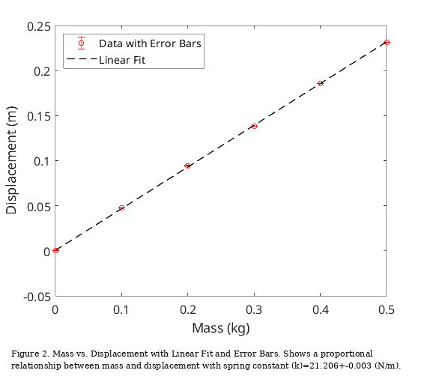

The data was fitted using the weighted method with the linear model in (11), where is displacement, is mass, is the y-intercept and is the slope. The slope is related to the spring constant by , where is the gravitational constant. Thus the fitted value of gives an estimate for .
(11)
The uncertainty in and is derived from the propagation of uncertainty in , given by . The weights for the fit were calculated as , to reflect the relative reliability of each mass-displacement measurement. Using the weighted linear least-squares fit method, we obtained the parameters: and . From these, we derive and . In the context of this experiment, represents any situation that makes this measurement imperfect. It might be random error or maybe it captures the fact that we manually displace the weight and in doing so could not be perfect in releasing it without influencing the motion in other ways (initial velocity, sideways displacement).

In Parts D – H, analysis was conducted to describe the motion of the 500 gram mass, undamped and damped. The undamped oscillation of the 500 gram mass-spring system is shown in Figure 3. The phase differences between velocity and position, as well as acceleration vs position are almost exactly as predicted, with a between velocity and position and between acceleration and position. The measured period was within the uncertainty bounds of the theoretical prediction of , where is the total mass of the system . The mass of the spring is based on the distribution of the oscillating segments of the spring. The coils closer to the attached mass oscillate with greater amplitude, and those near the stand don’t oscillate much at all in comparison. The effective mass of the spring in this calculation comes from the mean of the range determined by Fox and Mahanty, 1970, [1], which is .

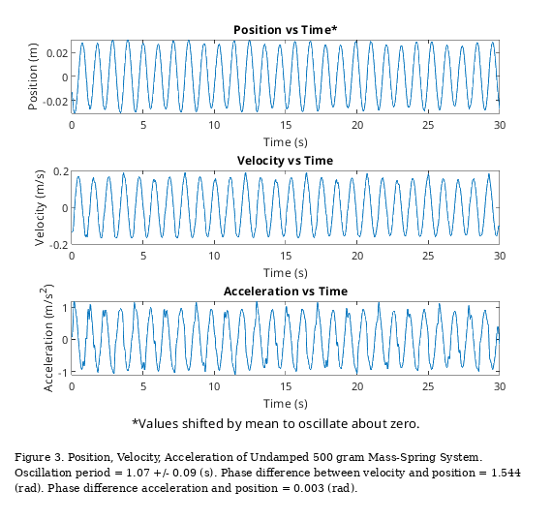
To show the oscillatory motion of the undamped spring, a phase space plot was produced, Figure 4. The plot predictably shows little dampening of motion, with only gradual tendency toward the center, which is in contrast to what a dampened system would show.

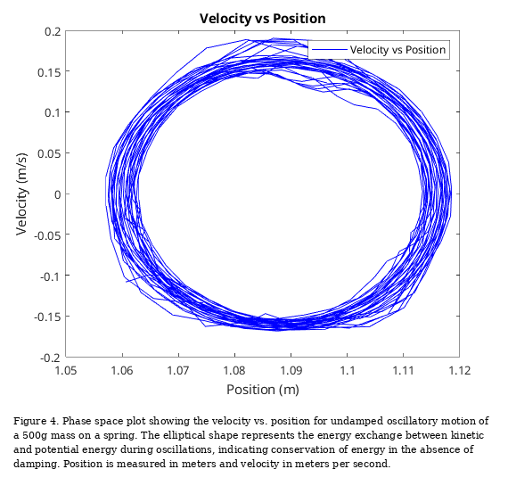

Having established a baseline for the mass-spring system absent any significant damping, the system was then modified to include a paper plate to act as a dampener and studied accordingly. We derive an expression for this image beginning with (1), which is the solution for the differential equation describing simple harmonic motion. From there we can take the derivative of (1) to obtain:

(12)
Then we use the trigonometric identity to get the final expression for the velocity for position phase space, where is the amplitude.

(13)

In the damped phase space plot, a striking difference can be seen in Figure 5. The motion tends toward the center much more rapidly.

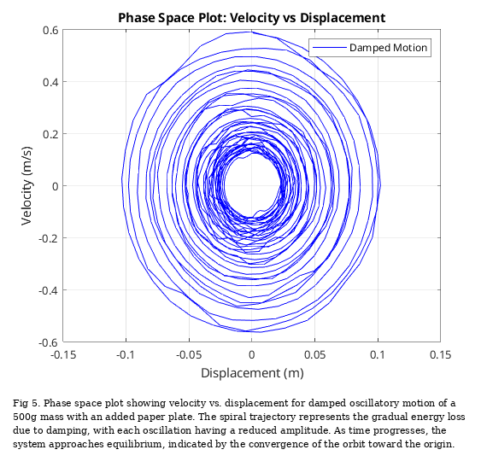
The motion can also be described by the linear fit of the amplitude vs time, seen in Figure 6. In this plot, the exponential decay can be readily seen, fitting with expectations of the impact of the coefficients of damped harmonic motion described by (2) and (3).

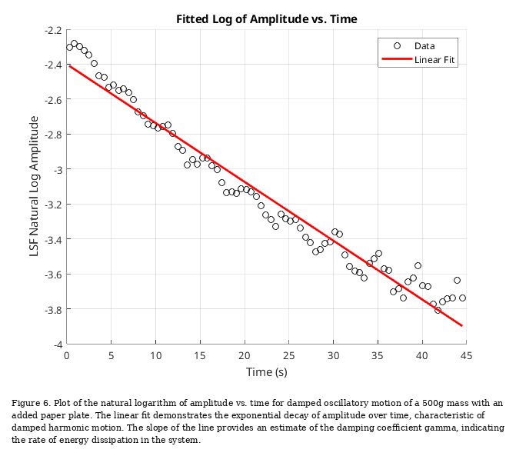

CONCLUSION

In conclusion, the phase space analysis and amplitude decay plots effectively illustrate the contrasting behaviors of damped and undamped oscillatory motion. In the undamped case, the phase space plot forms a closed ellipse, signifying consistent energy exchange between kinetic and potential energy without any loss, resulting in almost perpetual oscillations at a fixed amplitude.

Conversely, in the damped system with the added paper plate, the phase space plot shows a inward spiraling trajectory, reflecting continuous energy dissipation as each oscillation decreases in amplitude. The linear decay observed in the logarithmic amplitude plot confirms this energy loss, with the slope showing the impact of the damping coefficient from the paper plate. Together, these observations clearly show how damping affects the system’s motion, gradually bringing it to rest, in contrast to the sustained motion seen in the undamped case.

REFERENCES

[1] | J. G. Fox, J. Mahanty; The Effective Mass of an Oscillating Spring. Am. J. Phys. 1 January 1970; 38 (1): 98–100. https://doi.org/10.1119/1.1976240

