Lab 11 and 12, Section 4
Kym Derriman (Partner: Evan Howe)
December 15, 2024

ONSET OF CHAOS

INTRODUCTION
In this experiment, we explore the onset of chaos in nonlinear systems through two approaches, first investigating a nonlinear RLC circuit and then a computational study of the Logistic Equation. The experiment demonstrates how seemingly simple deterministic systems can exhibit complex, chaotic behavior under certain conditions. Through both physical measurements and numerical simulations, we examine the phenomenon of period doubling and how chaotic behavior emerges.

BACKGROUND
The transition from ordered to chaotic behavior in nonlinear systems often follows a characteristic pattern known as period doubling. This phenomenon can be observed in both physical systems, such as our nonlinear RLC circuit, and mathematical models like the Logistic Equation.
The Logistic Equation, given by:
(1)

where a is the growth parameter and represents the system state at step n. Even though this is a really simple equation, it turns out that some very interesting things happen as more and more iterations build up.
1. For 0 ≤ a < 1: The population crashes to zero regardless of initial conditions
2. For 1 ≤ a < 3: The system converges to a stable fixed point
3. For 3 ≤ a < 3.57: The system undergoes a series of period-doubling bifurcations
4. For a > 3.57: The system exhibits chaotic behavior (mostly)
In the case of the nonlinear RLC circuit, the response voltage is governed by the circuit's current, which can be described by the differential equation:
(2)

where is the charge, is the resistance, L is the inductance, and C is the capacitance. When the circuit is driven at certain amplitudes and frequencies, the nonlinear components of the system can lead to period doubling, eventually progressing into chaotic oscillations.

This dual framework of the Logistic Equation and the nonlinear RLC system highlights how deterministic rules and feedback mechanisms can give rise to emergent complexity and chaos, a characteristic of nonlinear dynamics.

EXPERIMENTAL METHODS

Part A: Nonlinear RLC Circuit Analysis
The experimental setup consisted of a series RLC circuit with a nonlinear capacitor implemented using a silicon diode. The diode's capacitance varies with applied voltage, introducing nonlinearity into the system. Key equipment included:
- Series RLC circuit with silicon diode
- Oscilloscope for time-domain measurements
- Sine wave generator (12.5 kHz)
- SR760 FFT spectrum analyzer
- 4-digit AC voltmeter
The circuit was driven with a sinusoidal voltage at approximately 12 kHz. We first adjusted to a small value by setting the control knob to its minimum position and turning back approximately one-half turn. The drive voltage was then set to achieve approximately 0.1 V on the voltmeter. The frequency was fine-tuned to maximize amplitude while maintaining an undistorted sinusoidal waveform.
Data collection proceeded through several stages:
1. Initial observation: Using both time-domain and Lissajous figure display modes on the oscilloscope, we observed the system's behavior as V₀ was gradually increased. The Lissajous figure proved particularly useful for detecting period doubling events, as seen in Figure 1.
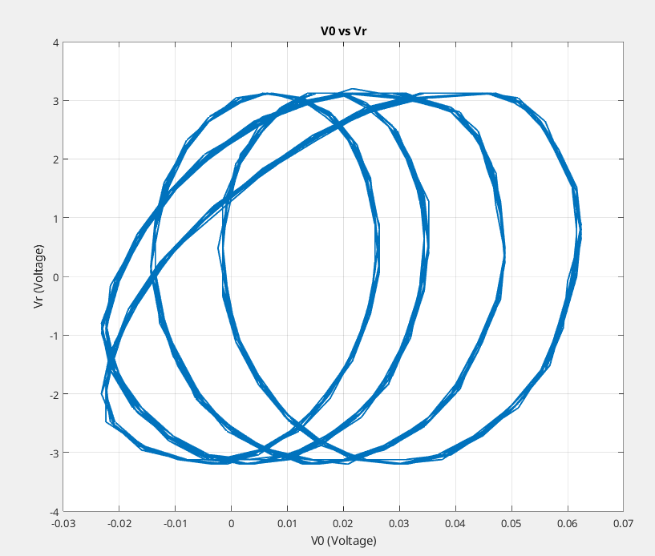Figure 1: Lissajous curve phase portrait of the RLC circuit showing (driving voltage) versus (response voltage). The closed, multi-loop structure illustrates periodic behavior, with the presence of multiple loops suggesting period doubling as the system approaches chaos.

2. The SR760 spectrum analyzer was configured with a 12.5 kHz frequency span to monitor the system's frequency content. The goal was to observe the emergence of subharmonic peaks, which serve as clear evidence of period doubling and the transition towards chaotic behavior.
3. Systematic Measurement:
For quantitative analysis, we:
- Recorded V₀ and waveforms for approximately 100 periods
- Captured FFT spectra at each measurement point
- Used the oscilloscope's averaging function to reduce noise
- Saved both time-domain and frequency-domain data for later analysis
4. Period Doubling Identification
We identified the threshold values of where period doubling occurred using a combination of FFT spectra and Lissajous figures:
FFT Analysis:
The appearance of subharmonic peaks (e.g., ) in the FFT spectra was used to detect period doubling. Near suspected threshold values, spectra were averaged across neighboring points to smooth out noise and confirm the emergence of subharmonics.
Lissajous Figures:
The versus phase portraits were examined to verify time-domain behavior. A single loop indicated stable Period-1 behavior. The transition to two loops confirmed Period-2 doubling. The threshold values were determined as the smallest amplitudes where both methods consistently showed evidence of period doubling.

Part B: Logistic Equation Analysis
The computational analysis was performed using MATLAB. We created a series of scripts to:
1. Implement the logistic equation and iterate it for various parameter values
2. Examine system behavior for different growth parameters and initial conditions
3. Determine precise values where period doubling occurs
4. Analyze the convergence to chaos through calculation of the Feigenbaum constant
Each simulation was run with sufficient iterations to ensure the system reached steady state, with initial transients discarded from the analysis.

RESULTS AND DISCUSSION

Nonlinear RLC Circuit Analysis
We began our investigation of chaotic behavior by analyzing the nonlinear RLC circuit's response to different driving voltages. The circuit's behavior is characterized by the relationship between the driving voltage (V₀) and the response voltage () measured across the resistor.
At low driving voltages, the circuit exhibits standard linear resonant behavior. As shown in Figure 2, the driving signal V₀ remains relatively small (±0.06V) while the response voltage VR shows larger amplitude oscillations (±3.2V), characteristic of a resonant circuit operating near its natural frequency. The sampling frequency of 250 kHz provides excellent temporal resolution of the waveforms.
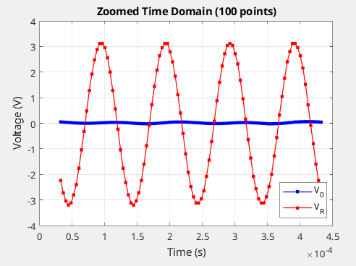Figure 2: Zoomed time-domain response of the nonlinear RLC circuit for a low driving voltage (blue) and the corresponding response voltage (red). The response voltage exhibits resonant oscillations with a significantly larger amplitude compared to the driving signal, characteristic of linear resonant behavior.

The relationship between V₀ and can be visualized using a Lissajous figure, which plots versus V₀. Figure 3 shows this phase relationship for the low-amplitude driving case. The pattern suggests a simple periodic response, indicating the system is still in its linear regime.

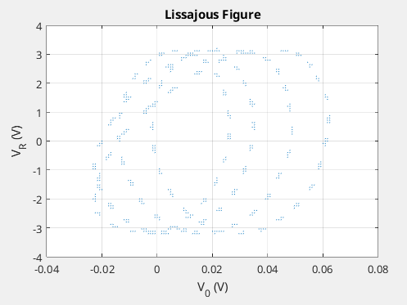Figure 3: Lissajous figure showing the phase relationship between the driving voltage V₀ and the response voltage for a low-amplitude driving case. The periodic elliptical pattern indicates a linear regime where the system exhibits simple harmonic behavior
To investigate the transition to chaos, we measured the circuit's response across a range of driving voltages. Figure 3 shows the RMS values of both V₀ and across all measurements, revealing several distinct regimes of behavior.
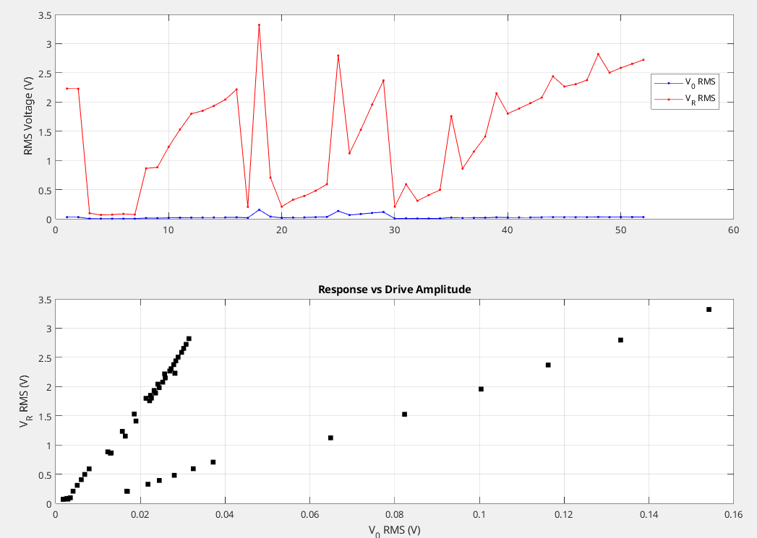Figure 4: Circuit response characteristics for varying driving amplitudes. (Top) Evolution of RMS voltages showing the driving voltage (V₀, blue) remaining small while the response voltage (, red) exhibits distinct transitions as driving amplitude increases. These transitions mark the boundaries between different dynamical regimes, from simple periodic motion through period doubling to potential chaos. (Bottom) Response voltage plotted directly against driving voltage , revealing branching behavior characteristic of period doubling bifurcations. The linear response region ( ) shows single-valued behavior, while higher driving amplitudes lead to multiple branches indicating period doubled states. Key features in these measurements: 1. Linear response region for where varies proportionally with drive. 2. First bifurcation occurring near . 3. Multiple subsequent bifurcations as drive amplitude increases. 4. Evidence of possible chaos in regions of scattered response amplitude.

The frequency spectra for various driving voltage amplitudes ​ were analyzed. As ​ increased, additional peaks corresponding to sub-harmonics (e.g., ) were detected, indicating the onset of period doubling. For sufficiently large , the spectra exhibited a broadening of frequency content, which is characteristic of chaotic dynamics.

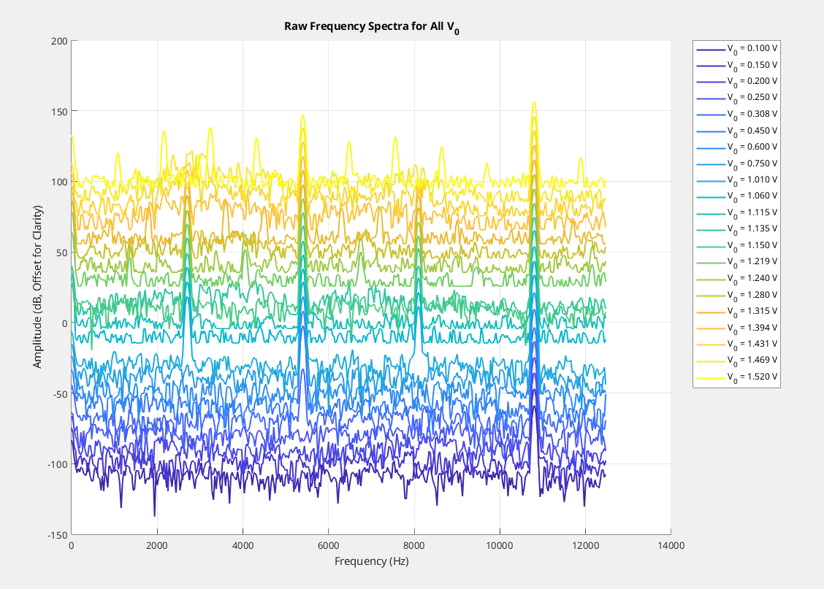Figure 5: Raw frequency spectra for varying driving voltage amplitudes ​ obtained from the SR760 spectrum analyzer. Each spectrum corresponds to a specific value, ranging from 0.100 V to 1.520 V, as indicated in the legend. The x-axis represents the frequency in Hz, while the y-axis shows the amplitude in dB, with vertical offsets applied to improve visibility and distinguish individual spectra. At lower values (darker curves), the spectra exhibit relatively weak peaks with a stable dominant frequency. As increases (towards lighter curves), the dominant frequency peaks become more pronounced, and additional peaks begin to emerge, particularly at lower frequencies, indicating the onset of period doubling. This behavior suggests a transition from stable periodic oscillations to more complex dynamics as increases, with potential subharmonics appearing alongside the fundamental frequency.

Behavior of the Logistic Equation for a < 3
We examined the behavior of the logistic equation for various growth parameter values (a) in the range a < 3 using multiple initial conditions to verify the theoretical predictions. Figure [X] shows the evolution of x(n) for a = 0.5, 1.0, 1.5, and 2.9, each with three different random initial conditions.

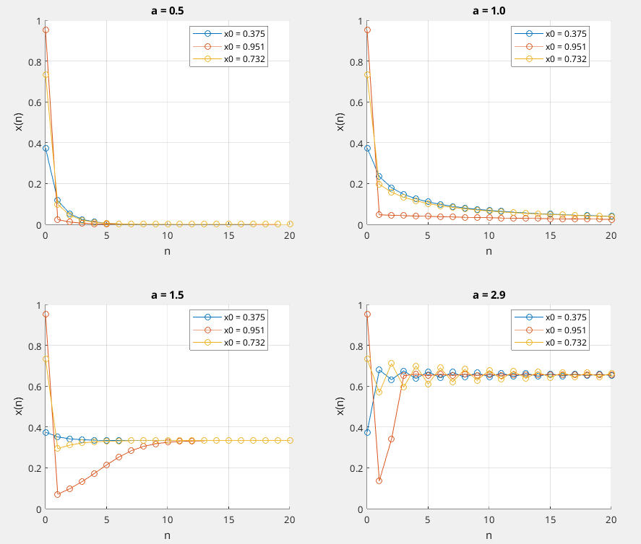Figure 6: Evolution of the logistic equation for different growth parameters a < 3. For a = 0.5, we observe that all trajectories rapidly decay to zero regardless of initial condition, confirming the theoretical prediction for 0 < a < 1 where the growth parameter is too small to sustain any population. The decay to zero occurs within approximately 7 iterations. At a = 1.0, the system still decays to zero but at a slower rate as this is the turning point. When a = 1.5, we see a non-zero stable fixed point. All trajectories converge to approximately x = 0.33, matching the theoretical prediction of x = 1 - 1/a. This demonstrates that for 1 < a < 3, the growth parameter is sufficient to sustain a non-zero steady state. At a = 2.9, approaching but still below the first period-doubling point (a = 3), we observe some oscillations and convergence to a single fixed point at approximately x = 0.66.

All of the trajectories below a value of 3 for the growth parameter lead to the same final state. This verifies that the steady-state solution is independent of initial conditions in this regime.

Period Doubling Onset Analysis (a ≈ 3)
We investigated the behavior of the logistic equation near the first period-doubling point (a = 3) using two specific growth parameter values (a = 2.99 and a = 3.01) and two initial conditions (x(0) = 0.667 and x(0) = 0.5). Figure 7 shows the steady-state behavior for each combination.

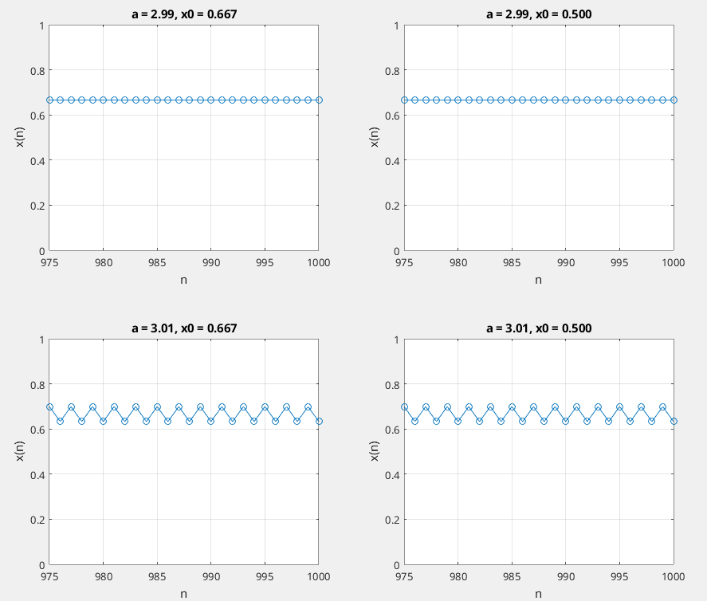Figure 7: Four subplots showing steady-state behavior of x(n) vs n for different combinations of a and x(0). For clarity, only iterations 975-1000 are shown. Steady-state behavior near the first period-doubling point. Top row: a = 2.99 with x(0) = 0.667 (left) and x(0) = 0.5 (right). Bottom row: a = 3.01 with x(0) = 0.667 (left) and x(0) = 0.5 (right).

For a = 2.99, just below the period-doubling point, both initial conditions converge to a single fixed point at 0.6656, demonstrating that the steady-state solution remains independent of initial conditions in this regime, consistent with our findings from Task 2.

However, when a = 3.01, just above the period-doubling point, we observe that the system no longer converges to a single value but instead alternates between two values (0.6328 and 0.7000) regardless of the initial condition. This marks the onset of period-2 behavior, where the system requires two iterations to repeat its pattern. The numerical results confirm that both initial conditions lead to identical period-2 oscillations, showing that while the route to reach these alternating values may differ, the final period-2 values themselves are independent of initial conditions.

This analysis clearly demonstrates the qualitative change in system behavior as we cross the a = 3 threshold, showing the emergence of period doubling while confirming that the long-term behavior remains independent of initial conditions on both sides of this transition.

Period Doubling Cascade Analysis
To precisely determine the values of a where period doubling occurs, we examined the steady-state behavior of the system by analyzing pattern repetition after n ≈ 1000 iterations to ensure transients had died out. Table 1 shows the identified period doubling thresholds a₁, a₂, a₃, and a₄.
Table 1: Period doubling threshold values and their differences. The Feigenbaum constant is calculated using the ratio of successive differences.

1 | 2.9900 | 0.4553 | --
2 | 3.4453 | 0.1047 | 4.3479
3 | 3.5500 | 0.0184 | 5.6784
4 | 3.5684 | 0.0184 | 5.6784

Using these values, we calculated δₖ according to Eq. 3 in the lab manual. The values of δₖ show convergence toward Feigenbaum's theoretical value of 4.669, with our experimental values ranging from 4.3479 to 5.6784. Using equations (2-4), we estimated and , indicating the approximate point where the period doubling cascade leads to chaos.

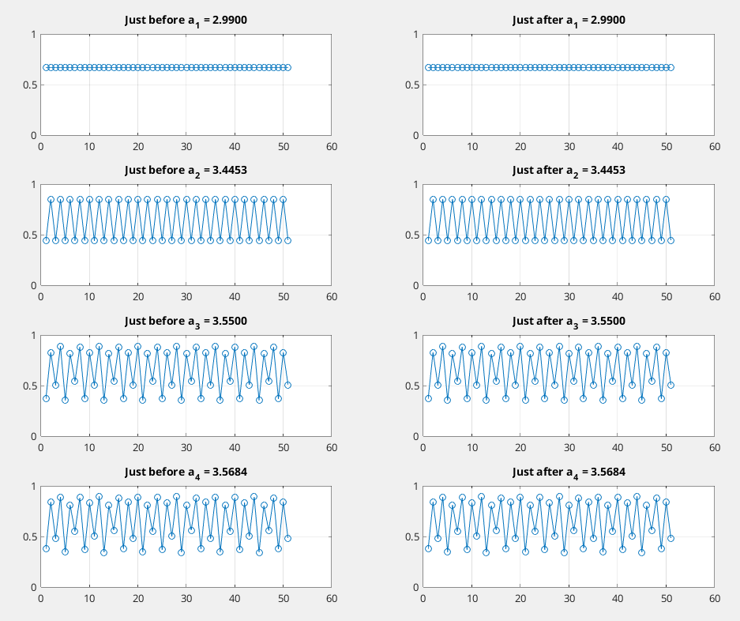Figure 8: Phase plots demonstrating the period doubling cascade. For a₁ = 2.9900, we observe the first transition from period-1 to period-2 behavior. At a₂ = 3.4453, the system transitions from period-2 to period-4, showing increasingly complex oscillatory behavior. The third threshold at a₃ = 3.5500 marks the transition to period-8, and finally, at a₄ = 3.5684, we see the transition to period-16. For each threshold, the left plot shows behavior just before the transition and the right plot shows behavior just after.

Conclusions
Our investigation of chaos through both a nonlinear RLC circuit and the Logistic Equation reveals similarities in how these systems transition from ordered to chaotic behavior. Both systems demonstrate initial stable behavior. The RLC circuit shows linear response at low drive amplitudes, while the Logistic Equation exhibits stable fixed points for a < 3.
Both systems also show a period doubling cascade where they go through a series of period-doubling bifurcations. In the RLC circuit, this appears as branching in the response amplitude and additional subharmonic peaks in the frequency spectrum. The Logistic Equation shows this through discrete bifurcations at specific values of the growth parameter a.
The period doubling cascade in both systems follows Feigenbaum's universal scaling. For the Logistic Equation, we found δ values ranging from 4.3479 to 5.6784, approaching the theoretical value of 4.669. The RLC circuit shows similar behavior in its bifurcation sequence, though measurement precision limits our ability to determine exact ratios.
Both systems ultimately transition to chaotic behavior, characterized by apparently random variations. This similar behavior between a simple mathematical model and a physical electronic circuit demonstrates the a strange phenomenon. It’s strange in the sense that one wouldn’t think that a physical system would so closely resemble a really simple equation and go into chaos.

