Kym Derriman (Partner Ethan Howell)

Lab 5: Least Square Fitting

10/10/2024

**LEAST SQUARE FITTING**

**INTRODUCTION**

In this experiment we explored the technique of least square fitting via an experiment to determine the lifetime of the metastable excited state of ${}_{}^{137}Ba^{*}$ before it gamma-decays into the stable ${}_{}^{137}Ba$. We find the best line fit that minimizes the difference between the observed data points and the true value using the $χ^{2}$ method and apply our knowledge of the radioactive decay process to determine the half-life and initial decay rate of ${}_{}^{137}Ba^{*}$.

**BACKGROUND**

The decay pathway of ${}_{}^{137}Cs$ is described by (1). The cesium regularly decays to metastable barium with the emission of a beta-minus particle ($β^{-}$, an electron). The half-life for that reaction is about 30 years. The metastable barium has a short half-life; it loses excess energy as low energy gamma radiation ($γ$) to form stable ${}_{}^{137}Ba$. The metastable barium can be isolated, and the gamma-decay measured by eluting the cesium with an isotope generator [1].

|  |  |  |
| --- | --- | --- |
|  | $${}_{}^{137}Cs ⟹ _{}^{137}Ba^{∗} + β^{−} , _{}^{137}Ba^{∗} ⟹ _{}^{137}Ba + γ$$ | (1) |

The general form of the exponential decay function is described in(2).

|  |  |  |
| --- | --- | --- |
|  | $$D\left(t\right) = D_{0} e^{−t / τ}$$ | (2) |

Here, $D\left(t\right)$ is a function that finds the decay rate at a given time, $D_{0}$ is the initial decay rate, and $τ$ is the mean lifetime of ${}_{}^{137}Ba^{*}$.

To find the half-life, we first set (2) with the initial conditions where $D\left(t\right) = \frac{D_{0}}{2}$ and $t = τ_{1/2}$, then divide through by $D_{0}$, take the natural log of both sides and solve for $τ_{1/2}$, giving (3).

|  |  |  |
| --- | --- | --- |
|  | $$τ_{1/2} = τ \ln\left(2\right)$$ | (3) |

To perform the method of least squares or least $χ^{2}$, we plot $\ln\left(D_{i}\right)$. We will obtain a straight line where the coefficients A and B are described by (4).

|  |  |  |
| --- | --- | --- |
|  | $$\ln\left(D\right) = \ln\left(D_{0}\right) − t / τ = A + Bt$$ | (4) |

Choosing the “best,” line, we assume that each time increment is assumed to have no error, $\left( t_{1} , … , t_{n}\right) = \left(x_{1} , … , x_{n}\right)$, and each decay count is represented as $\ln{} D_{n} = y_{n}$ and $y_{i}$, which is any measurement $\ln{} D_{i}$, is assumed to have uncertainty $σ_{i}$. We then “fit,” the straight line so that the overall discrepancy between the “true,” value $Y_{i}$ for each $x_{i}$ is minimized for the line $Y_{i } = A + Bx_{i}$.

We define the quantity $χ^{2}$ as the sum of the squared differences between the observed values $y_{i}$ and the predicted values $Y_{i}$, divided by the square of the uncertainty for each data point, given by Eq. (5). We then differentiate Eq. (5) with respect to A and B to minimize $χ^{2}$, setting the results equal to zero and solving for A and B as shown in Equations (6, 7, 8), where

$w_{i} = 1 / σ_{i}^{2}$.

|  |  |  |
| --- | --- | --- |
|  | $$χ^{2} = \sum_{ }^{ }{\frac{{\left(y_{i} - Y_{i}\right)}^{2}}{σ_{i}^{2}}}$$ | *(5)* |
|  |  |  |
|  | $$A = \frac{\left(\sum_{ }^{ }{w_{i}}x_{i}^{2}\right)\left(\sum_{ }^{ }{w_{i}}x_{i}\right) - \left(\sum_{ }^{ }{w_{i}}x_{i}\right)\left(\sum_{ }^{ }{w_{i}}x_{i}y_{i}\right)}{Δ}$$ | *(6)* |
|  |  |  |
|  | $$B = \frac{\left(\sum_{ }^{ }{{\text{w}}_{\text{i}}}\right)\left(\sum_{ }^{ }{w_{i}}x_{i}y_{i}\right) - \left(\sum_{ }^{ }{w_{i}}x_{i}\right)\left(\sum_{ }^{ }{w_{i}}y_{i}\right)}{Δ}$$ | *(7)* |
|  |  |  |
|  | $$\text{Δ} = \left(\sum_{ }^{ }{w_{i}}\right)\left(\sum_{ }^{ }{w_{i}}x_{i}^{2}\right) - {\left(\sum_{ }^{ }{w_{i}}x_{i}\right)}^{2}$$ | *(8)* |

We used the error propagation formula to derive uncertainties $σ_{i}$ for $\ln\left(D_{i}\right)$. We obtain uncertainties shown in (9) and (10) in this way.

|  |  |  |
| --- | --- | --- |
|  | $$σ_{A} = \sqrt{\frac{\sum_{ }^{ }{w_{i}}x_{i}^{2}}{Δ}}$$ | *(9)* |
|  |  |  |
|  | $$σ_{B} = \sqrt{\frac{\sum_{ }^{ }{wi}}{Δ}}$$ | *(10)* |

**EXPERIMENTAL METHODS**

1. A Geiger tube was connected to the BNC connector on the back of the counter, shown in figure 1b, and the DIG/SONIC1 input of the Lab Pro interface was connected to the serial port of the computer, see figure 1a.

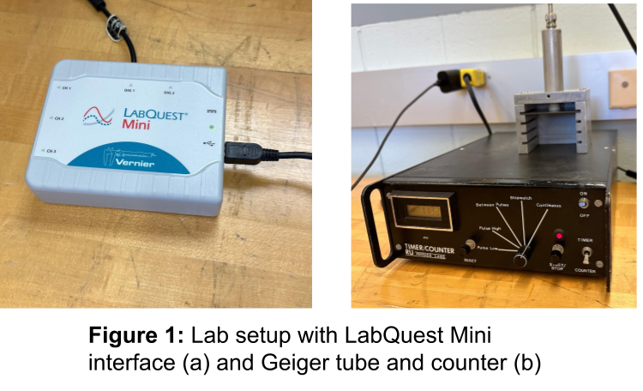

1. To measure the background radiation, we configured LoggerPro to run for 10 minutes

(600 seconds) at 10 second sample intervals. We placed the empty sample holder in the detector rack close to the Geiger tube and began data collection. The data was exported as a text file for later analysis.

1. The barium nuclei that are created by the radioactive ${}_{}^{137}Cs$ sample needed to be

separated and this was achieved with an isotope generator which elutes the sample with a weak EDTA solution. Immediately after this was done, we began collecting data for 10 minutes (600 seconds) at 10 second intervals. The data was exported as in the previous run.

1. To ensure that all the ${}_{}^{137}Ba^{*}$ atoms gamma-decayed into a stable state, we left the

sample as it was in the previous step and set a timer for 20 minutes to wait. Once 20 minutes passed, we collected another 10-minute (600 second) sample with 10-second intervals.

**RESULTS**

1. We imported the data from steps B, C, and D into MATLAB. We computed the average

number per interval of background radiation, ${\overline{D}}_{b1}$, and calculated the standard deviation, $σ_{b1}$ of the data collected in part B before sample loading; see table 1. We repeated these calculations for the data collected after the gamma-decay was depleted in the sample. The mean of this data being ${\overline{D}}_{b2}$ and uncertainty $σ_{b2}$. These values do not agree. The difference in background radiation indicates that the depleted sample somehow affects this number, possibly due to shielding effects or sample absorption, and should be used as the background radiation value ${\overline{D}}_{b}$ for analysis.

|  |  |  |
| --- | --- | --- |
| ***Table 1:*** *Distribution background radiation (counts/s)* | | |
| Best estimate decay rate | counts/s | uncertainty +/- counts/s |
| $${\bar{D}}_{b1}$$ | 23.0 | 0.7 |
| $${\bar{D}}_{b2}$$ | 6.7 | 0.3 |

We calculate the true decay rate of the sample with $D = D^{*} - D_{b}$ and calculate the error with (11), where $σ_{D_{b}}$ is the standard deviation of the mean.

$$σ_{D_{i}} = \sqrt{σ_{D_{i}^{*}}^{2}+ σ_{D_{b}}^{2}}$$

We find the uncertainty in $y_{i}$ by substituting (11) into (12), shown below.

$$σ_{y_{i}} = \frac{σ_{D_{i}}}{D_{i}} = \sqrt{σ_{D_{i}^{*}}^{2}+ σ_{D_{b}}^{2}}$$

1. We plot the results found in part E, $\left(D vs. t \right)$ and $\left(\ln\left(D\right) vs t\right)$. We use

the least square fit method with (6), (7), and (8) for the data shown in figures 2 and 3.

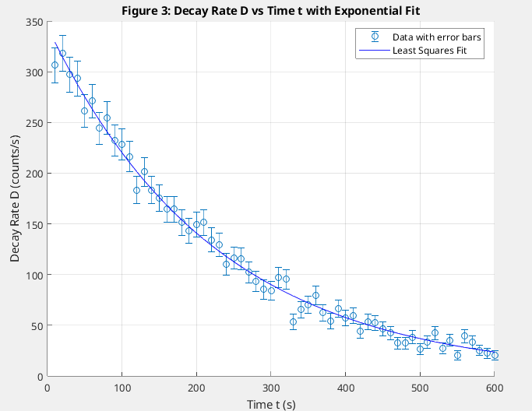

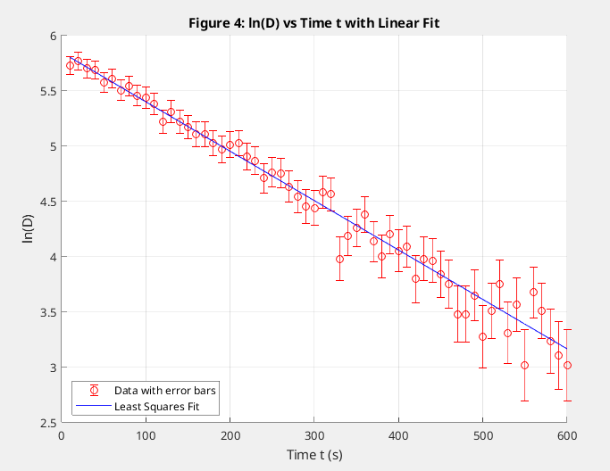

1. We $σ_{A}$, $σ_{B}$, and $χ^{2}$ shown in table 2 with (5), (9), and (10). The calculations proved

effective as the measured values correspond well with accepted values as discussed in the following section. We can see in the graphs that as time goes on, the individual error bars become larger. This makes sense because, as the sample gamma-decays, we have less and less counts and thus less and less data to reduce uncertainty. This corresponds to the theory of the Poisson distribution, in which more measurements imply reduced uncertainty.

|  |  |  |
| --- | --- | --- |
| ***Table 2:*** *Parameters A, B, Initial Decay Rate $D_{0}$, and half-life $τ_{1/2}$* | | |
| Parameter | value | uncertainty (+/-) |
| $$A$$ | 5.84 | 0.02 |
| $$B (1/ s)$$ | -0.00445 | 0.00009 |
| $D_{0} (counts/s)$ | 343 | 7 |
| $$χ^{2}$$ | 41.75 | - |
| $$τ_{1/2} (s)$$ | 156 | 3 |

1. We calculated $τ_{1/2}$ and $D_{0}$, as well as errors, from $A$, $B$, $σ_{A}$, and $σ_{B}$ as seen in table

2. The value of the half-life ($τ_{1/2}$) of ${}_{}^{137}Ba^{*}$ obtained from the data (156 +/- 3 seconds) agrees with the accepted value of approximately 153 seconds [3]. This result validates the experimental techniques used in this lab as well as the method of least squares fit for analyzing data of this form. Despite radioactive decay being a totally random process, this method provides consistent results with accepted values.

We can conclude that that the exponential decay law accurately describes the rate of nuclear decay in ${}_{}^{137}Ba^{*}$ and that the method of least squares fit, with Poisson statistics, is highly effective in describing and analyzing this phenomenon and handles the uncertainty propagation and linearizing the mathematical theory with observed results very well.

1. Part I contains instructions to ensure that the results section is complete.

**REFERENCES**

|  |  |
| --- | --- |
| [1] | Kweon, D.C., Choi, J., Dong, KR. et al. Use of a GM counter to measure the half-life of Ba-137m generated by using an isotope generator. Journal of the Korean Physical Society **65**, 532–540 (2014). https://doi.org/10.3938/jkps.65.532[1] |
| [2] | Lee, Sang-Hyuk, Physics 326 Lab Guide, “Least Square Fitting”, Rutgers University (2024) |
| [3] | MIDDELBOE, V. Half-lives of Barium-137m, Silver-109m and Rhodium-106 measured with Calculable Overall Accuracy. Nature 211, 283–284 (1966). https://doi.org/10.1038/211283a0 |

1.