# Dean Nicholson Cycling with his Stray Cat

* **Ignore: Dean**

Dean Nicholson decided to cycle from Scotland to Thailand, he packed a tent, a sleeping bag, a stove, a hammock, and a sound system for his music

Dean is 32 years old and had worked as a welder in a fish factory.

After a few months of cycling, he reached Bosnia. While cycling there he noticed a tiny grey and white kitten running after him. He got off his bicycle and fed her red pesto sauce from his food supplies.

He decided to take her to a vet in the nearest town. This was to find out whether anyone had lost their kitten. At the vet, nobody knew who the kitten belonged to.

Dean put her into the basket at the front of his bicycle and decided to take her with him on his cycling adventure. Now the kitten had to have a name, so he called her Nala. He then made space on his bicycle for toys, a harness, and a doll-sized umbrella for Nala.

Nala tried to escape out of the basket, but she did not run away. She only wanted a more comfortable space to sit. What Nala did to be comfortable made Dean decide to take her with on his adventure - she climbed up Dean's arm and fell asleep on his shoulder behind his neck. Dean said, "That is when I fell in love with her. "

He said "Having her opens up so many conversations with people. It is a talking point."

Dean and Nala spent their first winter together in Santorini, a Greek island where he worked as a kayak guide. Here he discovered that Nala also enjoyed being in a kayak on the water. The first time she went with him, she jumped into to kayak and sat while he paddled.

After Greece they biked through Turkey, Georgia, and Azerbaijan. Dean wanted to go to Iran but, because of the tense political situation and cats not being allowed in hotel rooms, they had to turn back.

During the corona virus pandemic, they stayed in Hungary for twelve weeks. During this time, Dean wrote his book about his and Nala's adventures. The book is called "Nala’s World: One Man, His Rescue Cat, and a Bike Ride Around the Globe."

They went to Austria where they are staying until travel restrictions are lifted. Dean wants to go to Russia and eventually Thailand. The reason Dean wants to go to Thailand is to drink from a coconut. Now he will have to order one for Nala as well. He said, “She might like coconut, but if she does not, then I will find her some cat milk."

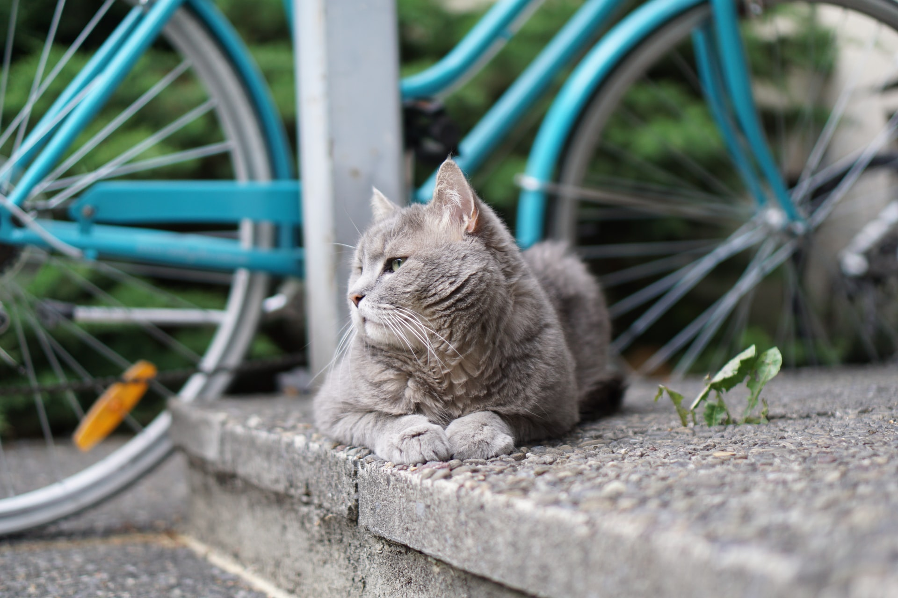

## Questions

1. For how long will Dean and Nala be staying in Austria?
2. During Dean and Nala's stay in Hungary for twelve weeks, what did Dean do?
3. Dean and Nala spent the winter in Santorini. What did Dean do there?
4. True or false. Nala did not like to get onto the kayak.
5. What colour is Nala?

## Collocations and Difficult Words

* **Welder** – a person who uses a machine to attach metal to metal.
* **Hammock** – a bed made of canvas or rope mesh hanging from two poles or trees by rope loops at both ends.
* **Kayak** – a light narrow boat that narrows to a point at the back and the front. A paddle is used to move the kayak in the water.
* **Talking point** – the pandemic was a talking point in the classroom. Something you can discuss.
* **Tense political situation** – a political event in a country where people do not know what is going to happen next and it makes them feel anxious.
* **Opens up conversations** – when someone comments on a subject it will start a conversation.
* **Lift travel restrictions** – when the pandemic is over, they will lift travel restrictions, we will be able to travel to other countries.
* **Around the globe** – all over the world.
* **Cycling adventure** – travelling on a bicycle for long distances to different areas.
* **Nearest town** – town closest to where you are.
* **Spent the winter** – stayed in one place until winter is over.
* **Rescue cat** – a cat that nobody wants, and you take it to care for.
* **Stray cat** – a cat that strayed from its home and is lost.
* **Kayak guide** – is a person who takes other people on kayak trips to show them interesting places or to make sure they do not get lost. They all go in their own kayaks.

## Countries, language, and demonyms

* Scotland Scottish Scots/Scottish
* Thailand Thai Thai/Siamese
* Greece Greek Greeks
* Turkey Turkish Turks/Turkish
* Bosnia Bosnian/Croatian/Serbian Bosnians
* Europe Europeans
* Montenegro Montenegrin Montenegrin
* Georgia Georgian Georgian
* Azerbaijan Azerbaijani Azerbaijani
* Iran Persian (Farsi) Iranians
* Hungary Hungarian Hungarians
* Austria Austrian Austrians
* Russia Russian Russians

## Highlighted vocabulary

words: **458** - **13** / **6** / **9** / **0** / **0**

458 - **Dean** Nicholson ***Cycling*** with his Stray Cat (November 24, 2020)  
  
Dean Nicholson decided to **cycle** from Scotland to Thailand, he ***packed*** a ***tent***, a sleeping bag, a stove, a hammock, and a **sound** **system** for his music. **Dean** is 32 years old and had worked as a welder in a fish factory.  
  
After a few months of ***cycling***, he reached Bosnia. While ***cycling*** there he noticed a tiny grey and white kitten running after him. He got off his bicycle and fed her red pesto **sauce** from his food supplies.  
  
He decided to take her to a vet in the nearest town. This was to find out whether anyone had lost their kitten. At the vet, nobody knew who the kitten belonged to.  
  
Dean put her into the basket at the front of his bicycle and decided to take her with him on his ***cycling*** **adventure**. Now the kitten had to have a ***name***, so he called her Nala. He then made space on his bicycle for toys, a **harness**, and a doll-sized umbrella for Nala.  
  
Nala tried to **escape** out of the basket, but she did not run away. She only wanted a more comfortable space to sit. What Nala did to be comfortable made **Dean** decide to take her with on his **adventure** - she climbed up **Dean**'s ***arm*** and **fell** asleep on his shoulder behind his neck. **Dean** said, "That is when I **fell** in love with her. "  
  
He said "Having her opens up so many ***conversations*** with people. It is a talking point."  
  
Dean and Nala spent their first winter together in Santorini, a Greek island where he worked as a kayak guide. Here he discovered that Nala also enjoyed being in a kayak on the water. The first ***time*** she went with him, she jumped into to kayak and sat while he paddled.  
  
After Greece they biked through Turkey, Georgia, and Azerbaijan. **Dean** wanted to go to Iran but, because of the **tense** ***political*** situation and cats not being ***allowed*** in hotel rooms, they had to turn back.  
  
During the corona **virus** pandemic, they stayed in Hungary for twelve weeks. During this ***time***, **Dean** wrote his book about his and Nala's ***adventures***. The book is called "Nala’s World: One Man, His **Rescue** Cat, and a Bike Ride Around the **Globe**."  
  
They went to Austria where they are staying until travel ***restrictions*** are ***lifted***. travel ***restrictions*** are ***lifted***. **Dean** wants to go to Russia and **eventually** Thailand. The ***reason*** **Dean** wants to go to Thailand is to drink from a coconut. Now he will have to order one for Nala as well. He said, “She might like coconut, but if she does not, then I will find her some cat **milk**."