# An Aurora might be the reason the Titanic sank

* **Preview: True**

A witness recalled that the northern lights were very strong on the night the Titanic sank.

The date was April 15, 1912. This disaster killed more than 1 500 passengers.

Auroras shimmered in skies over the northern Atlantic that night. An observer testified that the northern lights (the auroras) were very strong, and eyewitnesses described glows in the sky as the Titanic went down. New research hints that the storm behind the northern lights could have disrupted the ship's navigation and communication systems. It might even have hampered rescue efforts.

When high-speed streams of electrified gas shoot down to Earth from the sun, it is called a solar storm. Auroras form from solar storms. These solar storms create a lot of energy when they collide with Earth’s atmosphere. This causes them to glow green, red, purple, and blue.

If a solar storm was powerful enough to produce an aurora, it may have affected compasses and wireless communication on the Titanic. It would also have affected other ships in the area that tried to come to the rescue of the Titanic.

According to James Bisset, of the RMS Carpathia, there was no moon, but the Aurora glittered in the sky. The Carpathia was used in the rescue of the survivors of the Titanic.

The northern lights were also seen by the survivors from their lifeboats at around 3 a.m. Lawrence Beesley, a Titanic survivor, wrote that the glow "arched fanwise across the northern sky, with faint streamers reaching towards the Pole-star."

While the solar storm was generating a beautiful light in the sky, it could have also been disrupting the Titanic's compass. A mere 0.5 degrees would have been enough for the Titanic to go off-course and place it on a course where it collided with the iceberg.

It is proposed, that if the disruption from a solar storm did take place, it could have influenced distress signals that were sent out from the Titanic. This would have delayed the arrival of any rescue ships.

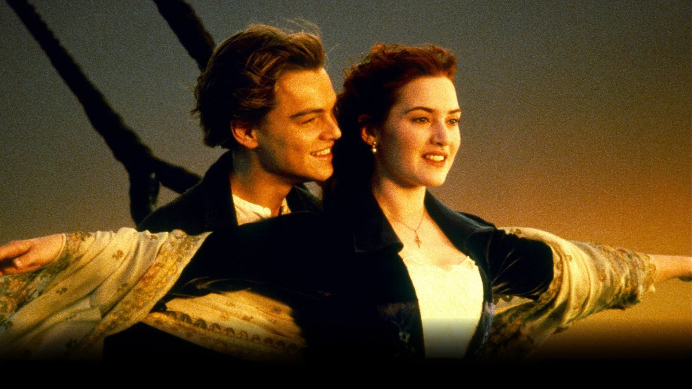

## Questions

1. What instrument on the Titanic could the solar storm have affected?
2. What is the purpose of that instrument?
3. They have established that a solar storm was definitely the cause of the Titanic disaster. True or False?
4. How many passengers died when the Titanic sank?
5. What was the name of the ship that rescued the Titanic survivors?
6. Would the solar storm have affected only the Titanic’s electronics?

## Collocations and Difficult Words

* **Eyewitness** – Somebody that saw an incident happen.
* **Shimmered** – shine with a soft light that seems to move.
* **Aurora** – A natural electric occurrence in the atmosphere which creates light and colour.

## Countries, Language, and Demonyms

## Highlighted Vocabulary

words: **402** - **24** / **15** / **21** / **0** / **0**

A **witness** ***recalled*** that the northern **lights** were very strong on the night the Titanic sank. The **date** was April 15, 1912. This **disaster** killer more than 1500 passengers.  
  
Auroras shimmered in skies over the northern Atlantic that night. An ***observer*** ***testified*** that the northern ***lights*** were very strong that night and eyewitnesses described aurora ***glows*** as the Titanic went down. New **research** ***hints*** that the storm behind the northern ***lights*** could have disrupted the ship's **navigation** and **communication** ***systems***. It might even have ***hampered*** **rescue** ***efforts***.  
  
When the sun ***expels*** high-speed streams of electrified gas that shoot down to Earth, it is called a **solar** storm. Auroras form from **solar** storms. These **solar** storms form ***charged*** ***particles*** and **created** a lot of **energy**, which when they **collide** with Earth's **atmosphere**. When they **collide** with the **atmosphere** some travel down **magnetic** field ***lines*** to **interact** with ***atmospheric*** gases. This ***causes*** them to **glow** green, red, **purple**, and blue, says NASA.  
  
If a **solar** storm is powerful enough to **produce** and aurora, it may have ***affected*** ***compasses*** and wireless **communication** on the Titanic. It would also have ***affected*** other ships in the **area** that tried to come to the **rescue** of the Titanic.  
  
According to James Bisset, second officer of the RMS Carpathia, says in his **log** that there was no moon, but the Aurora Borealis ***glittered*** like moonbeams shooting up from the **horizon**. Bisset wrote in the **log** five hours ***later*** that he could still see "greenish ***beams***" of the aurora as they neared the ***survivors*** on the lifeboats. The Carpathia was used in the ***rescued*** of the ***survivors*** of the Titanic.  
  
The northern ***lights*** were also seen by the ***survivors*** from their lifeboats at around 3 a.m. ***local*** ***time***. Lawrence Beesley, also a Titanic **survivor** wrote that the **glow** "***arched*** fanwise **across** the northern sky, with **faint** streamers reaching towards the Pole-star."  
  
While the **solar** storm's ***charged*** ***particles*** were ***generating*** a pretty **light** show, they could have also been disrupting the Titanic's **compass**. A **mere** 0.5 degrees would have been enough for the Titanic to get off-course and place it on a course where it ***collided*** with the iceberg.  
  
It is ***proposed***, that if geomagnetic disruption from a **solar** did take place, it could have ***influenced*** **distress** ***signals*** that were sent out from the Titanic. This would have ***delayed*** the arrival of any **rescue** ships.