# The Amur leopard - National Geographic - Scott Elder

Most people think that leopards are only found in Africa, but these predators can be found in many different countries and habitats.

The Amur River runs along the eastern Russian and northern Chinese borders and these spotted cats are to be found in the mountainous forests in both countries, with the Amur River running through them.

This is a harsh environment, and the Amur leopards are very well adapted to the bitter cold and snowy conditions. They have large paws that allows them to walk in the snow without sinking and their fur is exceptionally soft and dense to keep them dry and warm.

Although the Amur leopard weighs between 35 - 40kg which is 10 - 15kg less than the African leopard, they can still take down prey that is up to three times their size. They prefer to eat deer and boar but will also eat rabbits and mice if they cannot find anything bigger. As they are so good at sneaking up on their prey, scientist sometimes call them the "silent killers".

Amur leopards have become one of the rarest wild cats, due to poaching and loss of habitat. They are also the world's rarest leopards. In the early 2000s there were only about 30 of these leopards left. A new national park established along the Russian and Chinese border has helped the Amur leopard population to grow to about 80 leopards in 2018. This Park is known as the Land of the Leopard National Park and was created in 2012.

It is believed by officials that effective law enforcement in the park will help to increase the number of Amur leopards, and soon even more of these leopards will be seen.

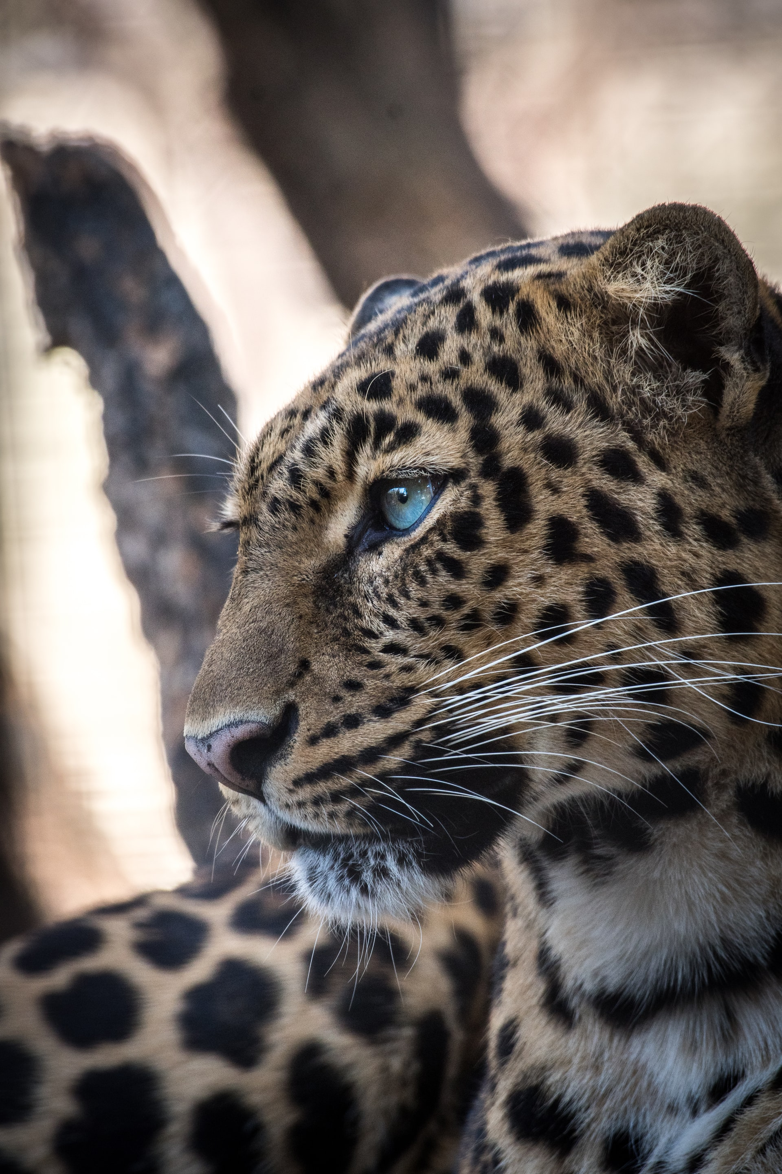

## Questions

1. Where are Amur leopards found?
2. Name two things that help them survive in these cold snowy conditions.
3. Leopards are only found in Africa. True or False?
4. Give two reasons why the Amur leopard is one of the rarest wild cats on Earth.
5. What has been established to help protect the Amur leopards?
6. Approximately how many Amur leopards where there in 2018?

## Collocations and Difficult Words

* **Habitats** –
* **Mountainous** –
* **Bitter cold** – extremely cold.

## Countries, Language and Demonyms

* China Chinese/Mandarin Chinese
* Russia Russian Russians

## Highlighted Vocabulary

words: **289** - **7** / **2** / **2** / **0** / **0**

Most people think that leopards are only **found** in Africa, but these predators can be **found** in many different countries and habitats. The Amur River runs **along** the eastern Russian and northern Chinese borders. These spotted cats are to be **found** in the mountainous forests in both countries, with the Amur River running through them.  
  
This is a **harsh** **environment**, and the Amur leopards are very well adapted to the **bitter** cold and snowy conditions. They have large paws that allows them to walk in the snow without sinking and their fur is exceptionally soft and **dense** to keep them dry and warm.  
  
Although the Amur **leopard** weighs between 35 - 40kg which is 10 - 15kg less than the African **leopard**, they can still take down **prey** that is up to three times their size. They prefer to eat deer and boar but will also eat rabbits and mice if they cannot find deer and boar. As they are so good at sneaking up on their **prey**, scientist sometimes call them the "silent killers".  
  
The Amur leopards have **become** one of the rarest wild cats, **due** to poaching and loss of habitat. They are also the world's rarest leopards. A new national park established **along** the Russian and Chinese **border** has helped the Amur **leopard** population to grow to about 80 leopards in 2018. In the early 2000s there were only about 30 of these leopards left. This Park is known as the Land of the **Leopard** National Park and was created in 2012.  
  
It is believed by officials that affective law enforcement in the park will help to increase the number of Amur leopards so that hopefully even more of these leopards will be seen soon.