# WOMAN FINDS NOTE IN BEDSIDE TABLE BOUGHT AT A CHARITY SHOP

* **Difficulty: Easy**
* **Preview: True**

*Shopping in a charity shop is a wonderful way to find interesting second-hand items*

Charity shop shopping is a clever way to find wonderful furniture, clothes, books, and many more second-hand items, and at bargain prices. One woman found more than what she expected when she bought a pair of bedside tables from a charity shop.

Valencia Walker, of San Diego in America, had a big surprise when she went through the drawers of the bedside tables. She found a note with her mom's cell phone number, their home number and her sister's name written on it. The home phone number is from 10 to 15 years ago, which is the last time her mom had a home phone. The note was written by a young child.

Valencia then started looking for the person who had written the note. This she did after she found the person’s last name on another piece of paper, also in a drawer in one of the bedside tables.

She shared her story on social media, and people were amazed by her discovery. Some said that it is a common occurrence if you buy second-hand goods in the same city you grew up in. She said that San Diego has a population of 3.3 million, and that it is rare for something like this to happen.

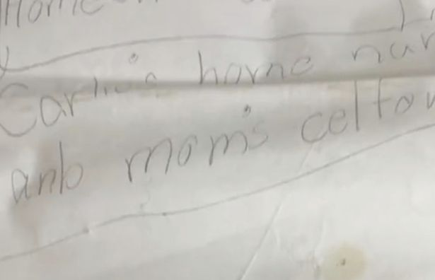

## Questions

1. QUESTION1
2. QUESTION2
3. …

## Collocations and Difficult Words

* **WORD** – DEFINITION
* **WORD** – DEFINITION
* …

## Countries, Languages, and Demonyms

* China Mandarin Chinese

## Highlighted Vocabulary

*Remove?*