# 3.5m SNAKE THAT ESCAPED ZOO, FOUND IN SHOPPING MALL

* **Difficulty: Easy**
* **Image-Align: 75p**

*A Burmese python escaped from the Blue Zoo Aquarium in America.*

Cara, an albino Burmese python from the Blue Zoo Aquarium, escaped from her enclosure on Monday evening. She was found two days later after an extensive search by employees of the zoo.

The Zoo had to close for two days due to Cara’s escape, because the employees all had to help in the search.

The Blue Zoo is an interactive aquarium which recently opened at the Mall of Louisiana in America. On Tuesday, the zoo had a specialist flown in to help in the search for Cara. They spent Tuesday night searching for her but could not find her anywhere. On Wednesday, the zoo was closed as the employees had to carry on with their search.

In the early hours of Thursday morning, Cara was eventually found. Cara was found in a small crawl space “in a wall, ceiling area,” said Ronda Swanson, chief marketing officer for the Blue Zoo Aquarium.

Victoria, Cara’s caretaker said that she had just left the zoo when she was informed that Cara had been found. She quickly turned around and sped back to the zoo.

“The Burmese python is an easy-going snake. They are one of the largest snakes and they have the kindest hearts. Cara came from a family that had little kids, and she was their puppy dog,” said Victoria.

The zoo shared the good news on social media with a video of Cara being ‘rescued.’ They said that she was unharmed, healthy, and safe once more.

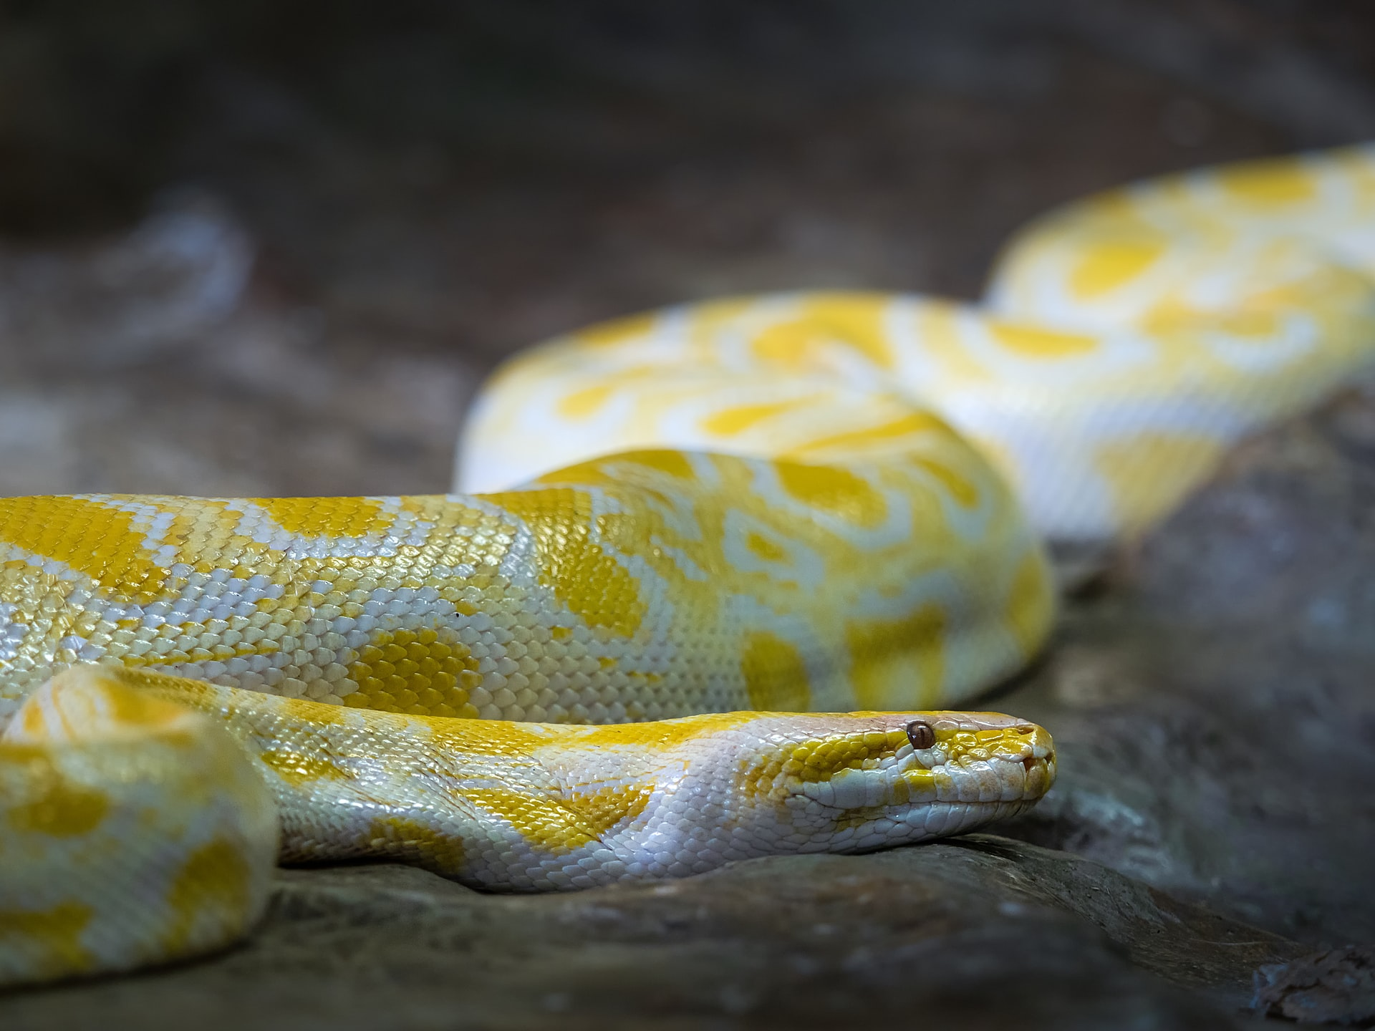

## Questions

1. QUESTION1
2. QUESTION2
3. …

## Collocations and Difficult Words

* **WORD** – DEFINITION
* **WORD** – DEFINITION
* …

## Countries, Languages, and Demonyms

* China Mandarin Chinese

## Highlighted Vocabulary

*Remove?*