# POLICE CHASE ENDS AT McDONALD’S DRIVE-THROUGH

*A police chase ended when a woman stopped at a McDonald’s to order food*

A woman who had stolen a truck and was being chased by the police, suddenly stopped to buy food. That is when the police caught her.

Johanna Gardell, 38, was identified as the person accused of stealing the truck. A man had phoned 911 and told them that an unknown woman had stolen his truck. He told them that his truck had GPS and that he could track its location

The police went to the area where the stolen truck was. They were stopped by another driver. The driver told them that his car had been hit by the truck minutes before.

The officer then continued and found the truck a few blocks further, with Johanna still inside. In a statement, the Police Department said, “The officer activated his blue lights, got out of his cruiser, and approached the stolen vehicle. The driver, Johanna, drove away as the officer walked towards her vehicle.” He got back into his cruiser and followed her at a slow speed, but she did not stop.

She suddenly started driving faster and drove through red traffic lights. The officer then deactivated his blue light and siren and stopped following her for safety reasons. She allegedly crossed into the wrong lane and oncoming traffic, hitting a van. She then pulled into the drive-through at a McDonald’s to try and order food.

Officers approached her in two vehicles and tried to arrest her. She started driving and intentionally hit one of the cruisers. She then veered off the road and the truck became stuck in a pile of mulch on the McDonald’s property. Here the officers pulled her out of the truck and arrested her. According to the police she fought and struggled with them during the arrest.

The police are now investigating the incident. Johanna is facing a litany of charges. These charges include failure to stop for police, leaving the scene of an accident with personal injury, assault, battery by means of a dangerous weapon, malicious mischief to motor vehicle, disturbing the peace, disorderly conduct, and the use of a motor vehicle without authority.

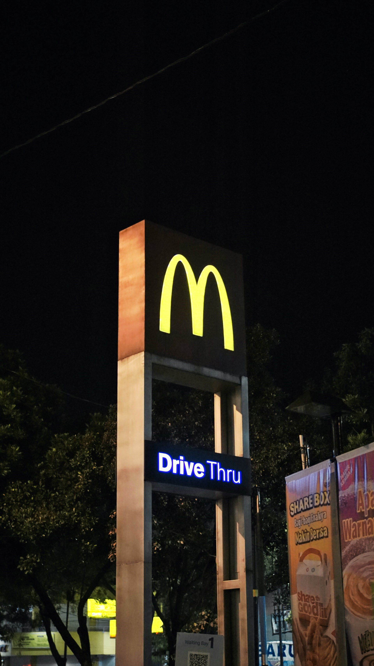

## Questions

1. How did the police know a truck had been stolen?
   1. The man whose truck was stolen, phoned 911.
2. Why did the officer stop chasing the woman?
   1. The officer stopped chasing her for safety reasons.
3. The woman fought against the police while best arrested. True/false
   1. True

## Collocations and Difficult Words

* **WORD** – DEFINITION
* **WORD** – DEFINITION
* …

## Countries, Languages, and Demonyms

* China Mandarin Chinese

## Highlighted Vocabulary

*Remove?*