# WHY IS INDIA THE WORLD CAPITAL OF SELFIE DEATHS

* **Difficulty: Medium**
* **Image-Align: 25p**

*More than 250 people have died across the world in search of the perfect selfie*

Since 2011, more than 250 people have died trying to take the perfect selfie. One country stands out as the world capital of selfie deaths.

The All India Institute of Medical Sciences found that more than half of the 259 selfie deaths and accidents that occurred between 2011 and 2017, occurred in India. Their study was titled, Selfies: A Boon or Bane? It was published late last year and was based on English-language reports of selfie deaths and accidents around the world.

Other countries with a high number of selfie-related deaths include Russia, the United States, and Pakistan. The majority of the “killfies” identified by researchers were caused by drowning, being hit by a car or train, or falling from a great height.

The researchers say that the total number of deaths could be much higher, because many cases are not reported and “death by selfie” is not recognised as an official cause of death. Near-misses were also not included in the study. One such example is where an Indian man survived being struck by a train while taking a selfie. Nor did it include 48 cases in 2017, where people reportedly suffered burns while taking selfies in front of a bakery that was on fire. These people ignored police demands to stop taking photos and move away from the burning building.

The question is: what is behind India’s “killfie” problem? Researchers say the high proportion of people below the age of 30 in India was a potential factor, as they were the people often killed when taking selfies. They also say another likely reason that India has a higher ratio of deaths to incidents than other countries, is that group selfies are more prevalent in India.

According to anthropologist Dr Jolynna Sinanan from the University of Sydney, visual culture was much stronger in India than in many other countries, including Australia. She also said, “It is not just advertising, or entertainment and media culture, but it is also through public messages, images such as gods and religious figures, framed photos and personal photos throughout the home… So, the way that selfie culture is more pervasive in India, is linked to these different kinds of public and private visual cultures.”

“Photos, whether they are posed selfies, are also about identity building in both a symbolic and material way that is related to that offline visual culture.”

Dr Sinanan researches the use of social media.

However, some people take this trend too far, as was the case of a group of bystanders who took selfies in front of three dying men. These men were lying on the road, covered in blood, and writhing in pain after being involved in a crash. Nobody assisted the men, nor did they call an ambulance.

Then there is also politics, class, and selfies. India still operates under a strict class hierarchy. Taking and posting selfies on social media is considered a way for people to promote themselves. It is also a way to boost their confidence and express themselves.

Politicians in India are now focusing on trying to stem India’s reputation as a selfie-death hotspot. Sixteen places in Mumbai have been identified as dangerous and declared as “no-selfie zones.” These places include popular tourist spots such as Marine Drive and Girgaum Chowpatty Beach.

Festivals have also gotten attention. The recent Hindu Kumbh Mela festival was declared a selfie-free event.

There is even an app that has been developed which is aimed at alerting users to dangerous selfie locations.

Here are some examples of deaths by selfie since 2017:

* Two teenagers drowned in the Tapi river after losing their balance and falling into the river, while taking selfies.
* Three men were crushed to death by a speeding train while taking selfies on the train tracks.
* A couple fell to their deaths at an overlook at a national park.
* A 28-year-old man was trampled to death by an elephant after sneaking into a wildlife colony and taking a selfie with the elephant.
* A man and an 11-year-old boy were electrocuted while taking selfies on top of the train.

Do you enjoy taking selfies? Have you or anyone you know done anything dangerous or silly in order to take a good selfie?

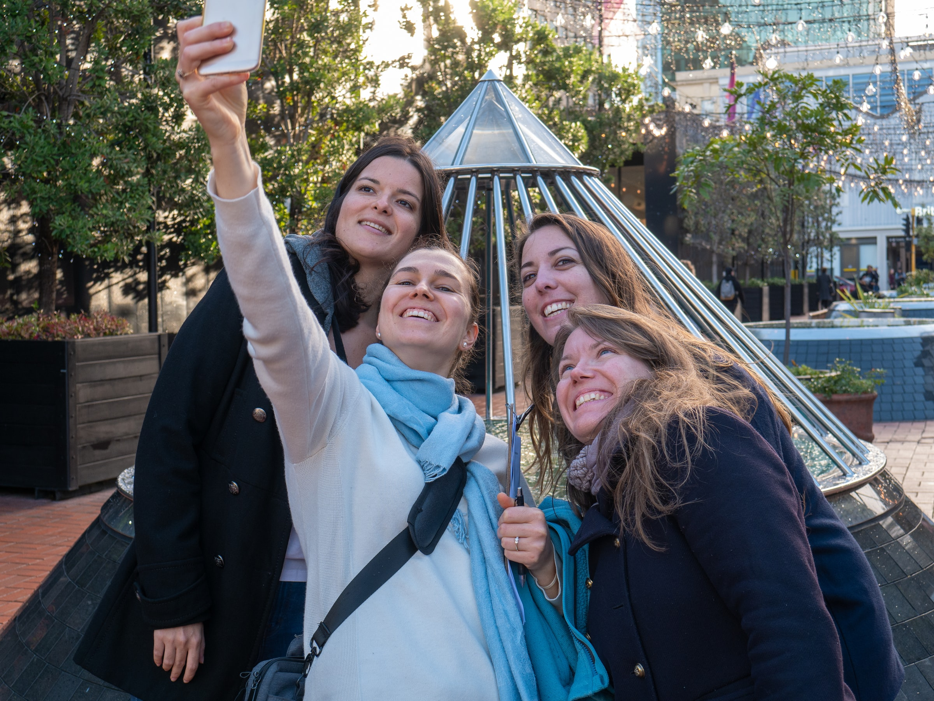

## Questions

1. QUESTION1
2. QUESTION2
3. …

## Collocations and Difficult Words

* **WORD** – DEFINITION
* **WORD** – DEFINITION
* …

## Countries, Languages, and Demonyms

* China Mandarin Chinese

## Highlighted Vocabulary

*Remove?*