# WOMAN’S AN ANCIENT ROMAN ARTEFACT IN HER GARDEN

*An ancient Roman artefact was used as a steppingstone for 10 years*

A woman living in Whiteparish, a village in England, had been using a slab of marble from her garden to get onto her horse for 10 years. She was surprised when she saw a wreath carved on its surface. She had found it in her garden about 20 years ago.

Some of the stone's history is known.

Experts confirmed that it was from the second century A.D. (800 years ago), and that it is worth a lot of money. It was carved in Greece or Turkey, but nobody really knows how it got to England.

An archaeologist who assessed the slab said that it was a rare find. The inscription on the slab reads: "The people and the Young Men honour Demetrios, son of Metrodoros, the son of Leukios".

The slab was not made in England even though the Roman Empire extended into the British Isles. It was estimated to have been taken to England about 300 years ago. Experts say that artefacts of this kind often got taken to England during the late 18th and 19th century. This was when wealthy aristocrats would tour Europe to learn about classical art and culture. Archaeologists think that is how the slab arrived in England.

What they do not know is how it ended up in this woman's garden. There are several possibilities though. He said they know that one nearby manor which may have been visited by travelling aristocrats, was destroyed by a fire in 1963. The rubble was probably re-used to build with in the Whiteparish area, and the slab taken to nearby houses and gardens along with the rubble.

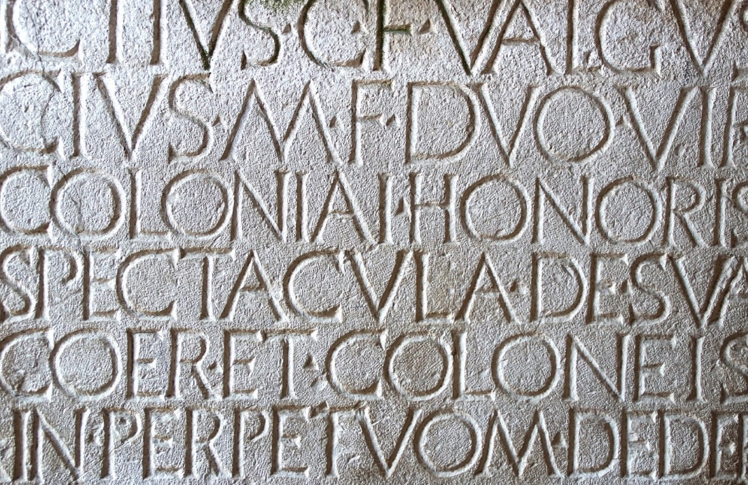

## Questions

1. In which country was this slab found?
   1. In England
2. Who toured Europe to learn about classical art and culture?
   1. Wealthy aristocrats.
3. In which countries do the experts think the slab was carved?
   1. Either Greece or Turkey.

## Collocations and Difficult Words

* **WORD** – DEFINITION
* **WORD** – DEFINITION
* …

## Countries, Languages, and Demonyms

* England English English
* Greece Greek Greeks
* Turkey Turkish Turkish
* Rome Latin Roman
* Europe European

## Highlighted Vocabulary

*Remove?*