# MAN WAS SWALLOWED BY A HUMPBACK WHALE

*I was completely inside his stomach*

In Provincetown USA, a veteran lobster diver, Michael Packard, entered the water a little before 8 a.m. for his second dive of the day. Little did he know he was going to have the experience of a lifetime.

His vessel, the “Ja’n J,” was anchored off Herring Cove Beach. It was not the only vessel in the area that morning. There was a whole fleet of boats catching striped bass. The water temperature was great, and so was visibility.

Licenced commercial lobster divers literally take lobsters off the sandy bottom. As Michael aged 56, dived down, he saw schools of sand lance and striper fish swimming by.

The ocean food chain was in full evidence, and at about 3 meters from the floor of the ocean, Michael realised what it felt like to be part of that chain.

“All of a sudden I felt this huge shove, and the next thing I knew, it was completely dark.” Michael recalls after his release from Cape Cod Hospital, on the same day. He said, “I could sense I was moving, and I could feel the whale squeezing the muscles in his mouth.”

Michael initially thought that he had been swallowed by a great white shark, but he could not feel any teeth and realised that he had not suffered any obvious injuries. He had been swallowed by a whale.

“I was completely inside, and it was completely black,” Michael said. “I thought to myself, ‘there is no way I am getting out of here. I am done, I am dead.’ All I could think of was my boys – they are 12 and 15 years old.”

Michael began to struggle, and the whale began shaking his head as if he did not like Michael moving around so much. “I saw light, and he started throwing his head from side to side, and the next thing I knew I was outside (in the water),” said Michael. He estimates that he was in the whale for 30 to 40 seconds before the it surfaced.

Crewman Josiah Mayo spoke to Michael’s sister and told her what had happened. Josiah told her that, “There was all this action at the top of the water,” then the whale flung her brother back into the sea. Josiah got Michael out of the water, called to shore by radio, and sped back to the Provincetown pier. Michael was taken to hospital by the Provincetown Fire Department.

Josiah described the whale as medium-sized.

Jooke Robbins, director of Humpback Whale Studies at the Center for Coastal Studies in Provincetown said, “Based on what was described, this would have to be a mistake and an accident on the part of the humpback.”

Jooke said, “It is not something I have heard happening before. So many things would have had to happen to end up in the path of a feeding whale.” She also said, “Incidents of feeding humpbacks injuring swimmers and divers, especially instances of swallowing, are exceedingly rare.”

The spot where Michael was diving is fraught with danger. Divers have been dragged out to sea – it had happened to him once. He was treading water for hours before he was rescued.

Has a man ever been swallowed by a whale before this incident? Reports say that a sperm whale swallowed a Cape Cod man off the Cape Verde islands, 150 years ago.

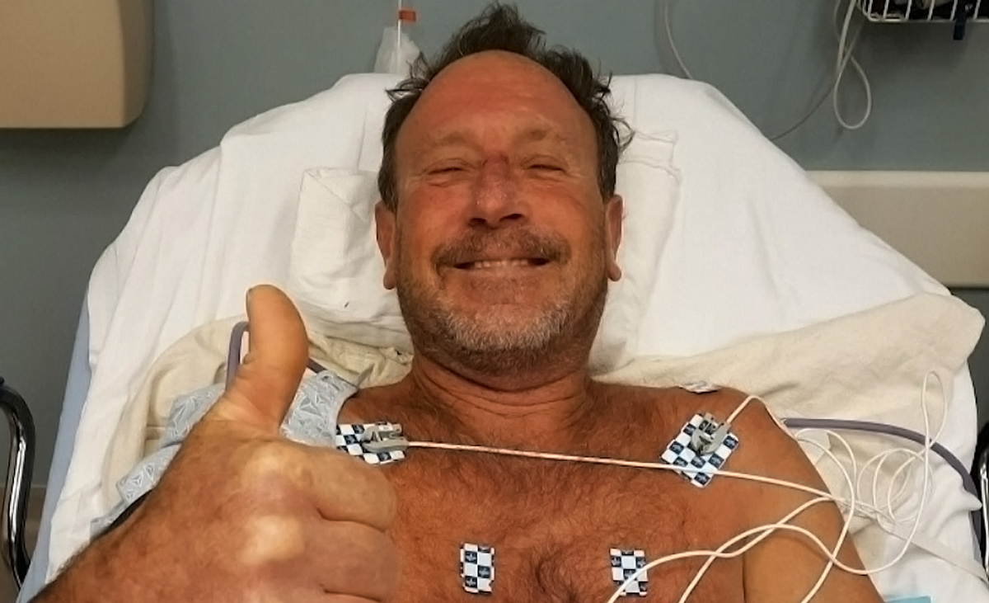

## Questions

1. QUESTION1
2. QUESTION2
3. …

## Collocations and Difficult Words

* **WORD** – DEFINITION
* **WORD** – DEFINITION
* …

## Countries, Languages, and Demonyms

* China Mandarin Chinese

## Highlighted Vocabulary

*Remove?*