# TEENAGER IN HOSPITAL AFTER SWALLOWING MAGNETS

*UK mother warns parents of dangerous social media trend*

A UK mom, Faye Elizabeth, has warned other parents of a dangerous social media trend after her teenage daughter ended up in hospital. Her daughter had to undergo major surgery.

Faye’s 13-year-old daughter swallowed 15 magnets that are used for a new “fake piercing” challenge on TikTok.

This trend sees children pretending to have piercings in their mouth by placing magnetic beads on the top and bottom of their tongues, or inside and outside their cheeks.

Faye said her daughter was admitted to hospital with stomach cramps. The doctors at first suspected appendicitis or food poisoning. After a while, her symptoms worsened, and she started “vomiting black water.” The doctors did an X-ray and discovered the magnetic beads in her stomach. She needed emergency surgery.

“She got part of her bowel removed... it was in two segments, so they had to re-stitch it back,” Faye explained. “They also found magnets inside her appendix, so they had to remove it. She now has a scar of about 15cm down her stomach.”

Faye explained that the magnets were not swallowed all at once. It happened over a matter of time. The magnets caused her daughter severe pain. “The magnets are all trying to stick together, so you can imagine the pain it causes, with all of them trying to pull and stick together. She could not eat or drink and received her nutrients via a drip. She was also in a lot of pain.”

“I have a little niece and she said loads of girls in her class have been doing the same thing. It is a trend that the children are following.”

Faye has urged other parents to stop their kids from joining the “fake piercing” trend sweeping TikTok.

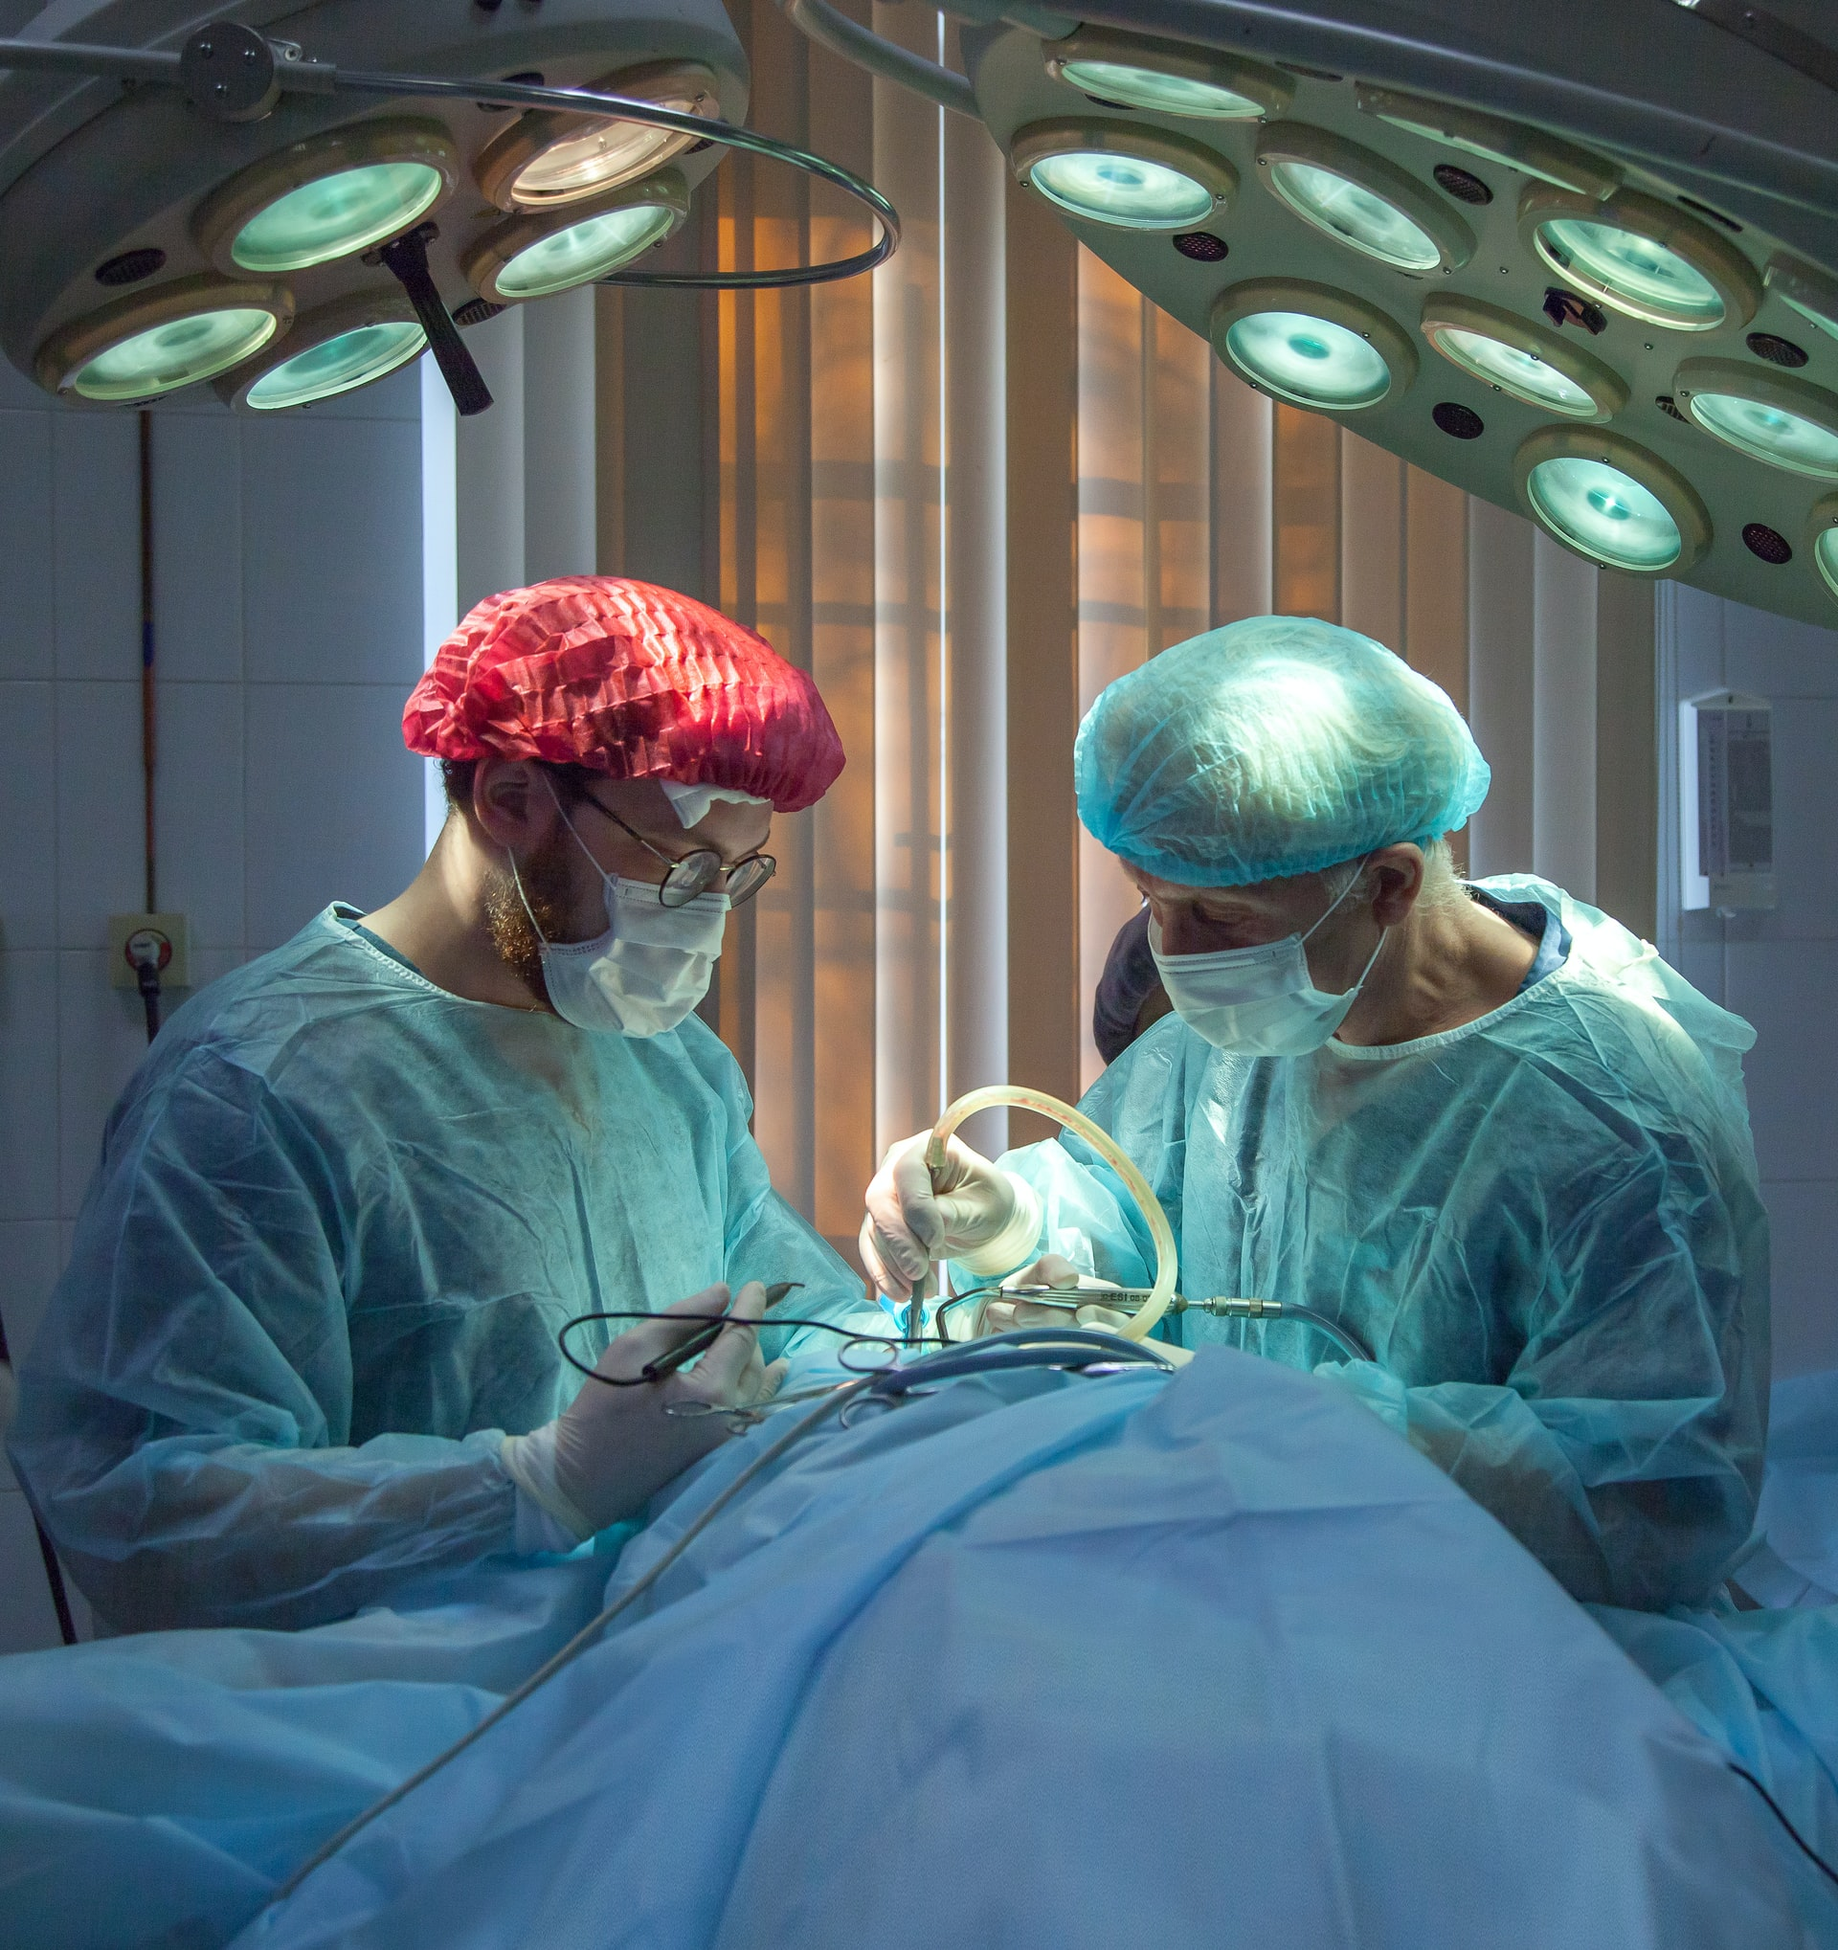

## Questions

1. QUESTION1
2. QUESTION2
3. …

## Collocations and Difficult Words

* **WORD** – DEFINITION
* **WORD** – DEFINITION
* …

## Countries, Languages, and Demonyms

* China Mandarin Chinese

## Highlighted Vocabulary

*Remove?*