# FAKE PIERCINGS A TREND ON SOCIAL MEDIA

* **Difficulty: Medium**

*Doctors are warning about dangerous TikTok challenge*

Fake piercings with magnetic balls pose a dangerous risk if the magnets are swallowed, doctors have warned.

This is the warning that was issued by Cincinnati Children’s Hospital:

“Warning: Families, be aware of a TikTok challenge where kids pretend to have tongue piercings by placing magnetic balls on their tongue. This is potentially deadly if they accidentally swallow them. Revisit the dangers of high-powered magnets and talk to your kids about the dangers magnets pose when swallowed.”

Dr Karan Raj warned that the swallowed magnets can clump together and risk squeezing the intestines and threatening blood flow. He also warned that it can be fatal without emergency bowel surgery. He added that two children were rushed to emergency surgery because of this TikTok challenge.

Another doctor, Dr Maha Hashim, a dental surgeon in London, said in a video that she posted, “This is not a fun thing to do. It is extremely dangerous, and it can be life threatening. You may end up having surgery, and you may not even survive the surgery. So, I urge all these youngsters to refrain from putting magnets in the mouth, with the risk of swallowing.”

One user gathered over 20 000 views on a TikTok video, showing two magnetic balls allegedly stuck on the top of the lip.

Some TikTok users responded by urging the “trenders” to call emergency medical services, while others wanted to know why the magnets were there in the first place. Others showed little empathy.

According to the US Consumer Product Safety Commission, a lot of these incidents of ingested magnets have resulted in surgery. They advise people to seek immediate medical attention if they swallow a magnet and to watch for symptoms like stomach pain, nausea, vomiting, and diarrhoea.

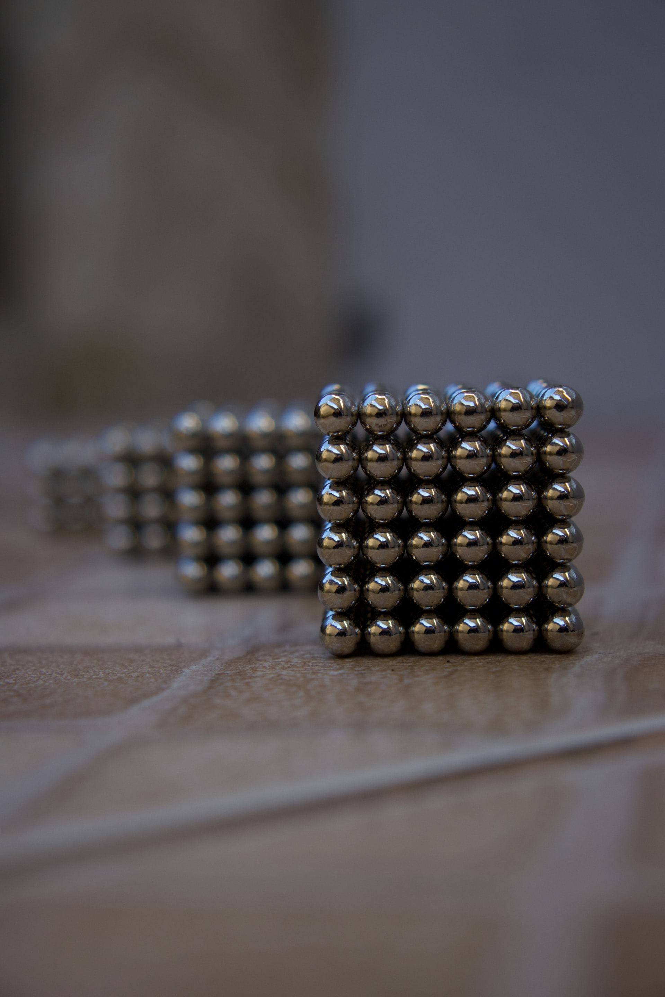

## Questions

1. QUESTION1
2. QUESTION2
3. …

## Collocations and Difficult Words

* **WORD** – DEFINITION
* **WORD** – DEFINITION
* …

## Countries, Languages, and Demonyms

* China Mandarin Chinese

## Highlighted Vocabulary

*Remove?*