# I FELL IN LOVE WITH MY BEST FRIEND’S UNCLE WHEN I WAS 12

* **Difficulty: Medium**

*A girl fell in love with a man 16 years her senior when she was 12*

Jamie, 27, met Nolte, 43, when she was visiting her friend Nikita, in 2007. Now after all this time they are finally together and are expecting a baby.

Jamie says, “It was love at first sight, despite the age gap.” It was not until December 2020 when they met up again and their friendship started blossoming.

Jamie tells us that she was 12 in 2007 when she met Nolte. He was 27 years old at the time. She did not let him know how she felt about him, and he did not say how he felt about her.

She added, “I became friends with his niece Nikita, and ever since then I have had a crush on her cute uncle. For me it was love at first sight and I knew he was going to be ‘the one.’ I made the first move in 2017 before I went abroad. On this occasion I told him that I was going to marry him one day, even though I knew he was in a relationship at that stage. He thought it was a joke and laughed, not taking me seriously at all. Little did he know how serious I was, and that I knew we would eventually be together.

In 2019 Jamie returned to her hometown after two years abroad. Nolte was working as a beekeeper and had been following Jamie on her social media pages. He was apprehensive about their age gap and did not want to contact her. He finally decided to contact Jamie via social media, after which they spent months just chatting and not meeting in person.

Then one day he decided to visit Jamie at the bar where she was working. He walked in and gave her a big hug. The very next day her friend Nikita arranged a wine tasting date for them. After that date, during which they also had their first kiss, their relationship developed quickly.

They have been very open about their relationship. Nolte’s parents were shocked at discovering their son’s relationship with their granddaughter’s best friend. Jamie says, “My parents were a bit shocked because we made it public on social media before telling them. They accepted it easily as they have known him for many years and had always liked him.”

Nikita was extremely excited about their relationship. She had been rooting for them since she found out that Jamie had a crush on her uncle. She is also the person that helped Jamie and Nolte get together.

Jamie had a secret relationship before she started dating Nolte. The man was 30 years her senior, but he sadly passed away. Nolte was married for five years when he was in his twenties and got divorced a few years ago.

Jamie explains why the age gap between them is working so well. “He knows what he wants and is past the ‘messing around’ stage in his life. He is more committed when it comes to love and starting a family. We understand each other and are honest with each other.”

They are giving advice to other couples who are also in ‘age gap’ relationships. “Do not let anyone tell you what is right or what is wrong when it comes to love and age. Never focus on age, it is literally just a number. If it feels right, then it is right. Focus on yourself – it is your life, and you must live it. Love who you want, and you will live a happy life,” says Jamie.

Nolte is currently working on a farm abroad but will be back for the birth of their child.

Jamie and Nolte have been in a serious relationship for nearly a year and are expecting their first child in a few months' time.

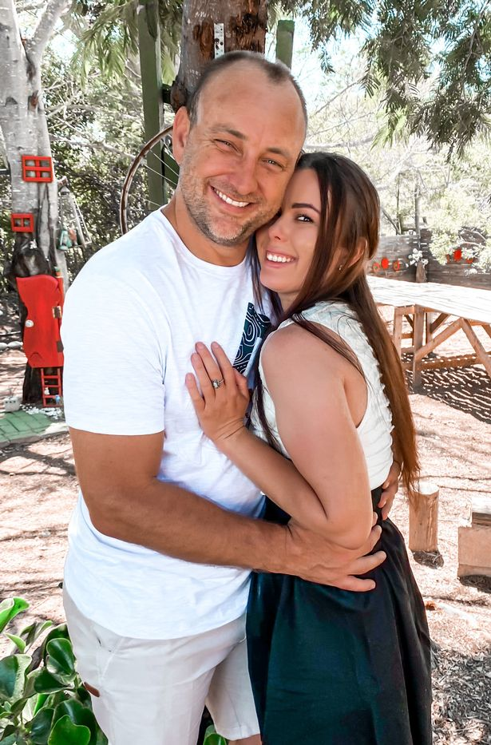

## Questions

1. How old was Jamie when she met Nolte?
   1. Jamie was 12 years old.
2. Jamie and Nolte’s parents were not shocked when they heard of their relationship. True/False?
   1. False
3. When Jamie returned after her trip abroad, what kind of work was Nolte doing?
   1. Nolte was a beekeeper.

## Collocations and Difficult Words

* **WORD** – DEFINITION
* **WORD** – DEFINITION
* …

## Countries, Languages, and Demonyms

* China Mandarin Chinese

## Highlighted Vocabulary

*Remove?*