# MOST COUNTRIES NOWHERE NEAR NET-ZERO EMISSIONS

*Pollution awareness has increased globally*

The global community has become more aware of pollution and realises the need for net-zero emissions.

Over the last decade the global energy system has become greener, but it is still far from achieving net-zero emissions by 2050. This issue has become diplomatically important for policymakers, but if changes are not implemented faster, this goal will not be possible.

Increase in the world's population, incomes, and demand for energy services in developing countries, has rapidly increased the demand for energy use. Although energy consumption has become less carbon-intensive, it has not been fast enough to offset the rapid increase in demand for energy.

In the ten years before the Covid-19 pandemic, global energy consumption rose at a rate of 1.9 percent per annum, whereas energy-related carbon dioxide emissions rose at an average rate of 1.4 percent.

Emissions have been considerably reduced by most countries, by replacing coal-fired power generation with gas, wind and solar, as well as by implementing improvements in combustion efficiency.

In the advanced economies of the Organisation for Economic Co-operation and Development (OECD), energy consumption increased only slightly (0.4 percent per annum) while emissions fell (0.4 percent per annum).

There were notable annual emission reductions in the following countries: Denmark – 4 percent, Britain - 2.8 percent, Italy – 1.8 percent, France – 1.7 percent, Spain – 1.3 percent, Germany – 1 percent, and the United States of America – 0.6 percent.

However, in developing economies that do not belong to The Organisation for Economic Co-operation and Development (OECD), there was a big annual increase in energy consumption, averaging 3.1 percent, and emissions, averaging 2.5 percent.

Energy consumption and emissions were down considerably, possibly due to the Covid-19 pandemic which caused lockdowns, quarantines, and businesses slowing down production. There is likely to be an increase in energy consumption and emissions when the economy recovers, lockdowns ease and passenger aviation is resumed. It is expected that this increase will hit a new record in 2023/24.

Commitment has been made by political leaders of the United States of America, China, and the European Union to achieve net-zero emissions by 2050 or 2060. In November, the United Nations climate summit takes place in Britain, and these commitments will be followed with interest by the media and the public.

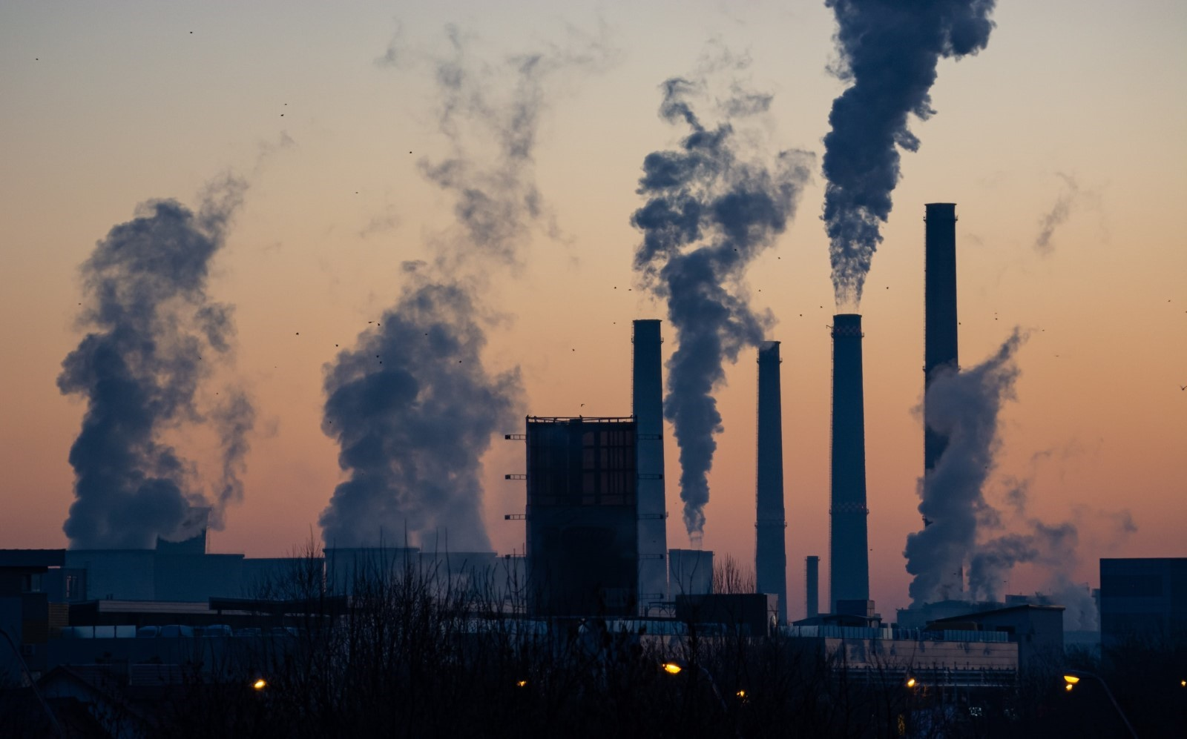

## Questions

1. What have a lot of countries done to reduce emissions?
   1. They are replacing coal-fired power generation with gas, wind and solar, as well as implementing improvements in combustion efficiency.
2. Where will the United Nations climate summit take place?
   1. Britian
3. What happened to decrease energy consumption and emissions?
   1. It is possibly due to the Covid-19 pandemic, which caused lockdowns, quarantines, and businesses slowing down production.

## Collocations and Difficult Words

* Policymakers – people that make laws or decisions.
* Combustion - burning
* Reduction – making something less.
* Quarantines – keeping people or animals apart from others for safety reasons.
* Carbon-intensive – pollutes a lot.

## Countries, Languages, and Demonyms

* Brazil Portuguese Brazilian
* India Hindi Indians
* China Mandarin Chinese
* Indonesia Indonesian Indonesians
* Philippines Filipino/English Filipinos
* Bangladesh Bengali Bangladeshis
* Vietnam Vietnamese Vietnamese
* United States of America English Americans
* European Union Europeans
* Denmark Danish Danes
* Britain English British
* Italy Italian Italians
* France French French
* Spain Spanish Spanish
* Germany German Germans

## Highlighted Vocabulary

*Remove?*