# TENSION ON MARS

* **Difficulty: High**

*Mission to Mars by three countries simultaneously*

February 2021 was New Year's Day on Mars, officially launching Martian Year 36. The Martian year is shorter than an earth year. In the future if any humans live on Mars, there will be fewer New Year's parties. Martian Year number one was in 1956. This was after there was a major dust storm on Mars and scientists started to watch for annual events on the planet.

There are a few excited but tense Martian celebrations now. The reason for these celebrations is because three different spacecraft have reached Mars. The spacecraft Hope, which belongs to the United Arab Emirates, was the first to arrive. It was their first long-range space mission so there was a lot of excitement when the craft went into temporary orbit on 9 February. Hope did not land on Mars, but it adjusted to a better orbit. After that it began to carry out metrological examinations which it will continue for a year.

The next day, 10 February, a Chinese spacecraft, Tianwen-1, went into Martian orbit. This makes China the sixth country to reach Mars' orbit. Tianwen-1 remained in orbit for a couple of months, after which China landed a large Lander-Rover pair, which is about as big as a car.

The Chinese landed their Lander-Rover on a large plain called Utopia Planitia, which is in Mars' northern hemisphere. The Rover carries various scientific gear and ground penetrating radar. This equipment will be used to look underground for potential water pockets.

USA spacecraft, the Perseverance Rover, landed in the Jezero Crater. Percy, the Perseverance Rovers' nickname, also carries a helicopter called Ingenuity. Percy will drive around doing surveys and looking for signs of life.

Evidence coming back from Mars is showing that there is a distinct possibility of life being found. They do not think they will find frogs hopping around but hope to find some kind of living bacteria. If they find living bacteria it will be a major discovery.

To carry out their missions, each of the three countries is using its own technology.

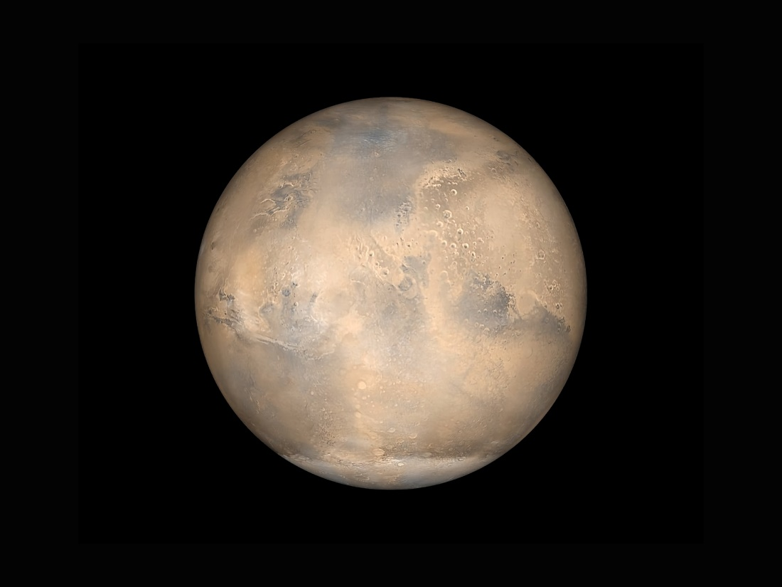

## Questions

1. Are the Martian years the same length as Earth years?
   1. No, they are shorter.
2. Where on Mars was Percy scheduled to land on February 18, 2021
   1. In the Jezero Crater on Mars.
3. Which are the three countries that sent spacecraft to Mars simultaneously?
   1. The United Arab Emirates, China, and USA.

## Collocations and Difficult Words

* Officially – In a formal and public way
* Long-range – Long distance
* Metrology – Application for units of measurements and testing procedures according to documented standards.
* Metrological examinations – Accurate and reliable measurements for trade, health, safety, and the environment.
* Water pockets – Cavities where water can accumulate.
* Nickname – A name that is different from the given name

## Countries, Languages, and Demonyms

* United Arab Emirates Arabic Emiratis
* China Mandarin Chinese
* USA English Americans

## Highlighted Vocabulary

*Remove?*