# SA TO BAN BREEDING OF LIONS IN CAPTIVITY

*Lions bred for trophy hunting in SA to be banned*

The Minister of Forestry, Fisheries, and the Environment, Barbara Creecy, said that the department has plans to ban the breeding of lions in captivity. The purpose of breeding lions in South Africa is for trophy hunting, and tourist purposes. This is done to make it a more "authentic" experience for visitors.

The rules for governing the hunting, trade, and keeping of lions, elephants, rhino, and leopards in captivity, were reviewed by a panel of experts. At a news conference, the minister recommended that domestication of lions by means of captive breeding and keeping must be stopped.

Creecy said, "We do not want captive breeding, captive hunting, and captive cub petting of lions. Legal hunting of the iconic species in a regulated environment will continue to be permitted. The report urged a stop to tourist interaction with captive lions, including cub petting." She also said that these recommendations were not aimed at constraining the hunting industry.

In South Africa, lions are raised in captivity for hunting and are kept in pens ringed with electric fencing. This has been a controversial issue for a long time. In the United States of America, Australia and several European countries, there have been numerous campaigns in recent years to ban the importation of captive-bred lion trophies. The minister said the tourism industry was susceptible to negative attitudes.

The government’s intention with the new regulations is to ensure that those who are interested in “authentic wildlife hunting” will still have such an experience. Creecy also said, "They will not be hunting animals that have been taken out of a cage."

Research by wildlife groups in South Africa have established that there are between 8000 and 12 000 lions at approximately 350 farms, that are raised for hunting, tourism, and academic research. Their bones are also used in medicine and jewellery in Southeast Asia.

According to the South African-based Endangered Wildlife Trust, there are only about 3 500 lions still living in the wild in South Africa.

"This is a win for wildlife and will ensure that lions will remain where they belong - in the wild," said the campaign manager for Africa, Edith Kabesiime of the World Animal Protection. She also said that thousands of farmed lions are born into a life of misery every year in South Africa. These facilities are cruel commercial breeding facilities and the decision the government had made is courageous.

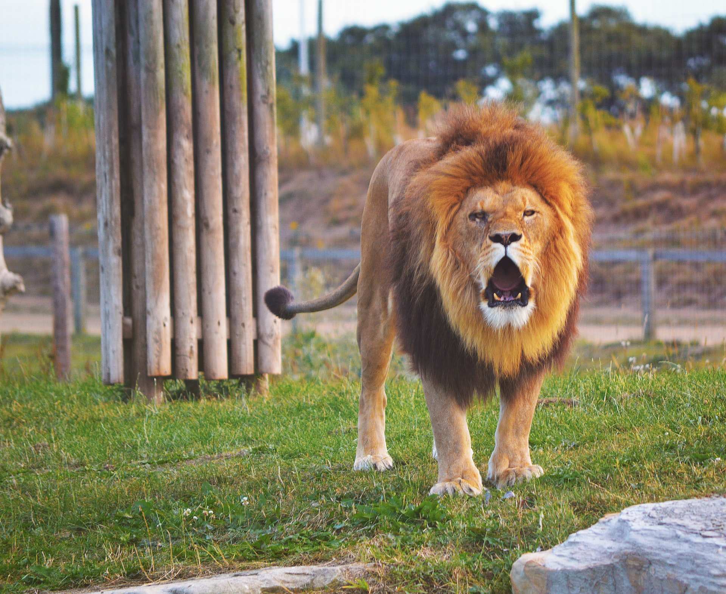

## Questions

1. Why are South Africans breeding lions in captivity?
   1. Lions are bred in captivity for trophy hunting and cub petting.
2. What are lion’s bones used for in Southeast Asia?
   1. The bones are used in medicine and jewellery.
3. How many lions in South Africa are still living in the wild?
   1. About 3500 lions.

## Collocations and Difficult Words

* **WORD** – DEFINITION
* **WORD** – DEFINITION
* …

## Countries, Languages, and Demonyms

* South Africa English South Africans

## Highlighted Vocabulary

*Remove?*