# SEED-SIZED CHAMELEON FOUND IN MADAGASCAR

* **Image-Align: 25p**

*Chameleon the size of a sunflower seed found*

Scientists say they have discovered a sunflower seed-sized chameleon. The scientists who were from Germany and Madagascar, say that it might the smallest reptile on Earth. They found the tiny chameleons in Northern Madagascar.

They named these chameleons Brookesia nana, or nano-chameleons. The male is about 13.5 mm long from his nose to the tip of his tail. The female is bigger at 29 mm long. The scientists, after examining these two chameleons, said they are both adults. Scientists say that something is allowing or causing the chameleons to miniaturise.

Scientists think that the chameleon's habitat is very small. Their habitat has now been put under protection because of deforestation. They recommended in their report, that the chameleon be listed as critically endangered to help protect it and its habitat.

The nano-chameleons hunt for mites on the rainforest floor and hide from their predators in blades of grass at night.

This chameleon’s closest relative is the Brookesia micra, which scientists discovered in 2012. The researchers were unable to find any more of these nano-chameleons on the island. They are hoping to find more in the future.

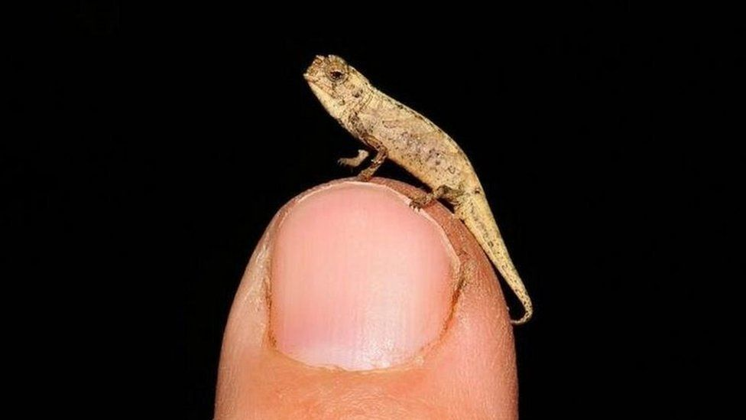

## Questions

1. In which country was the smallest chameleon found?
   1. In Madagascar.
2. Why was their habitat put under protection?
   1. It was put under protection because of deforestation.
3. In what year did the scientists find the Brookesia micra?
   1. In 2012.

## Collocations and Difficult Words

* Deforestation- the clearing of thinning of forests by humans.
* Miniaturise - make smaller.
* Habitat - the natural home or environment of an animal, plant, or other organism.
* Predator - an animal that naturally preys on others.
* Nano-chameleons - nano meaning small (one billionth)
* Closest relative - the members of your family who are most directly related to you, e.g., your parents, brothers, or sisters.
* Blade of grass – one leaf of grass

## Countries, Languages, and Demonyms

* Germany German Germans
* Madagascar French/Malagasy Malagasy

## Highlighted Vocabulary

*Remove?*