# Volcanoes - Mt St Helens

*The eruption of Mt St Helens in 1980*

When lava finds a way to escape from beneath the earth's surface, it creates a volcano.

In 1980, in Washington America, Mount St. Helens erupted. The high-speed blast caused a lot of damage. It was the first time in 123 years that Mount St. Helens erupted. This eruption happened after two months of earthquakes and small explosions. The blast destroyed and scorched 370km² of forest within minutes.

Volcanoes erupt in different ways. Some explode, like St. Helens. These explosions are immensely powerful and can fling huge boulders up to almost a kilometre away. This can cause massive landslides. Explosive volcanoes cause most of the volcano-related fatalities. When Mount St Helens exploded, 57 people and thousands of animals were killed.

The eruption released an avalanche of hot ash, gas, steam, and rocks that mowed down giant trees up to 24km away. Volcanic ash can cause aeroplane engines to fail, destroy crops, and contaminate water. It can even cause buildings to collapse.

Volcanic mudflows carried large boulders and logs, which destroyed forests, bridges, roads, and buildings.

Mount St. Helens produced more than 490 tons of ash that fell over a period of nine hours, and covered an area of over 56 980 km². The ash caused problems in cities 600km away.

The eruption caused the worst volcanic disaster in the history of the United States. It was the first large explosive eruption studied by scientists and observers using modern technology.

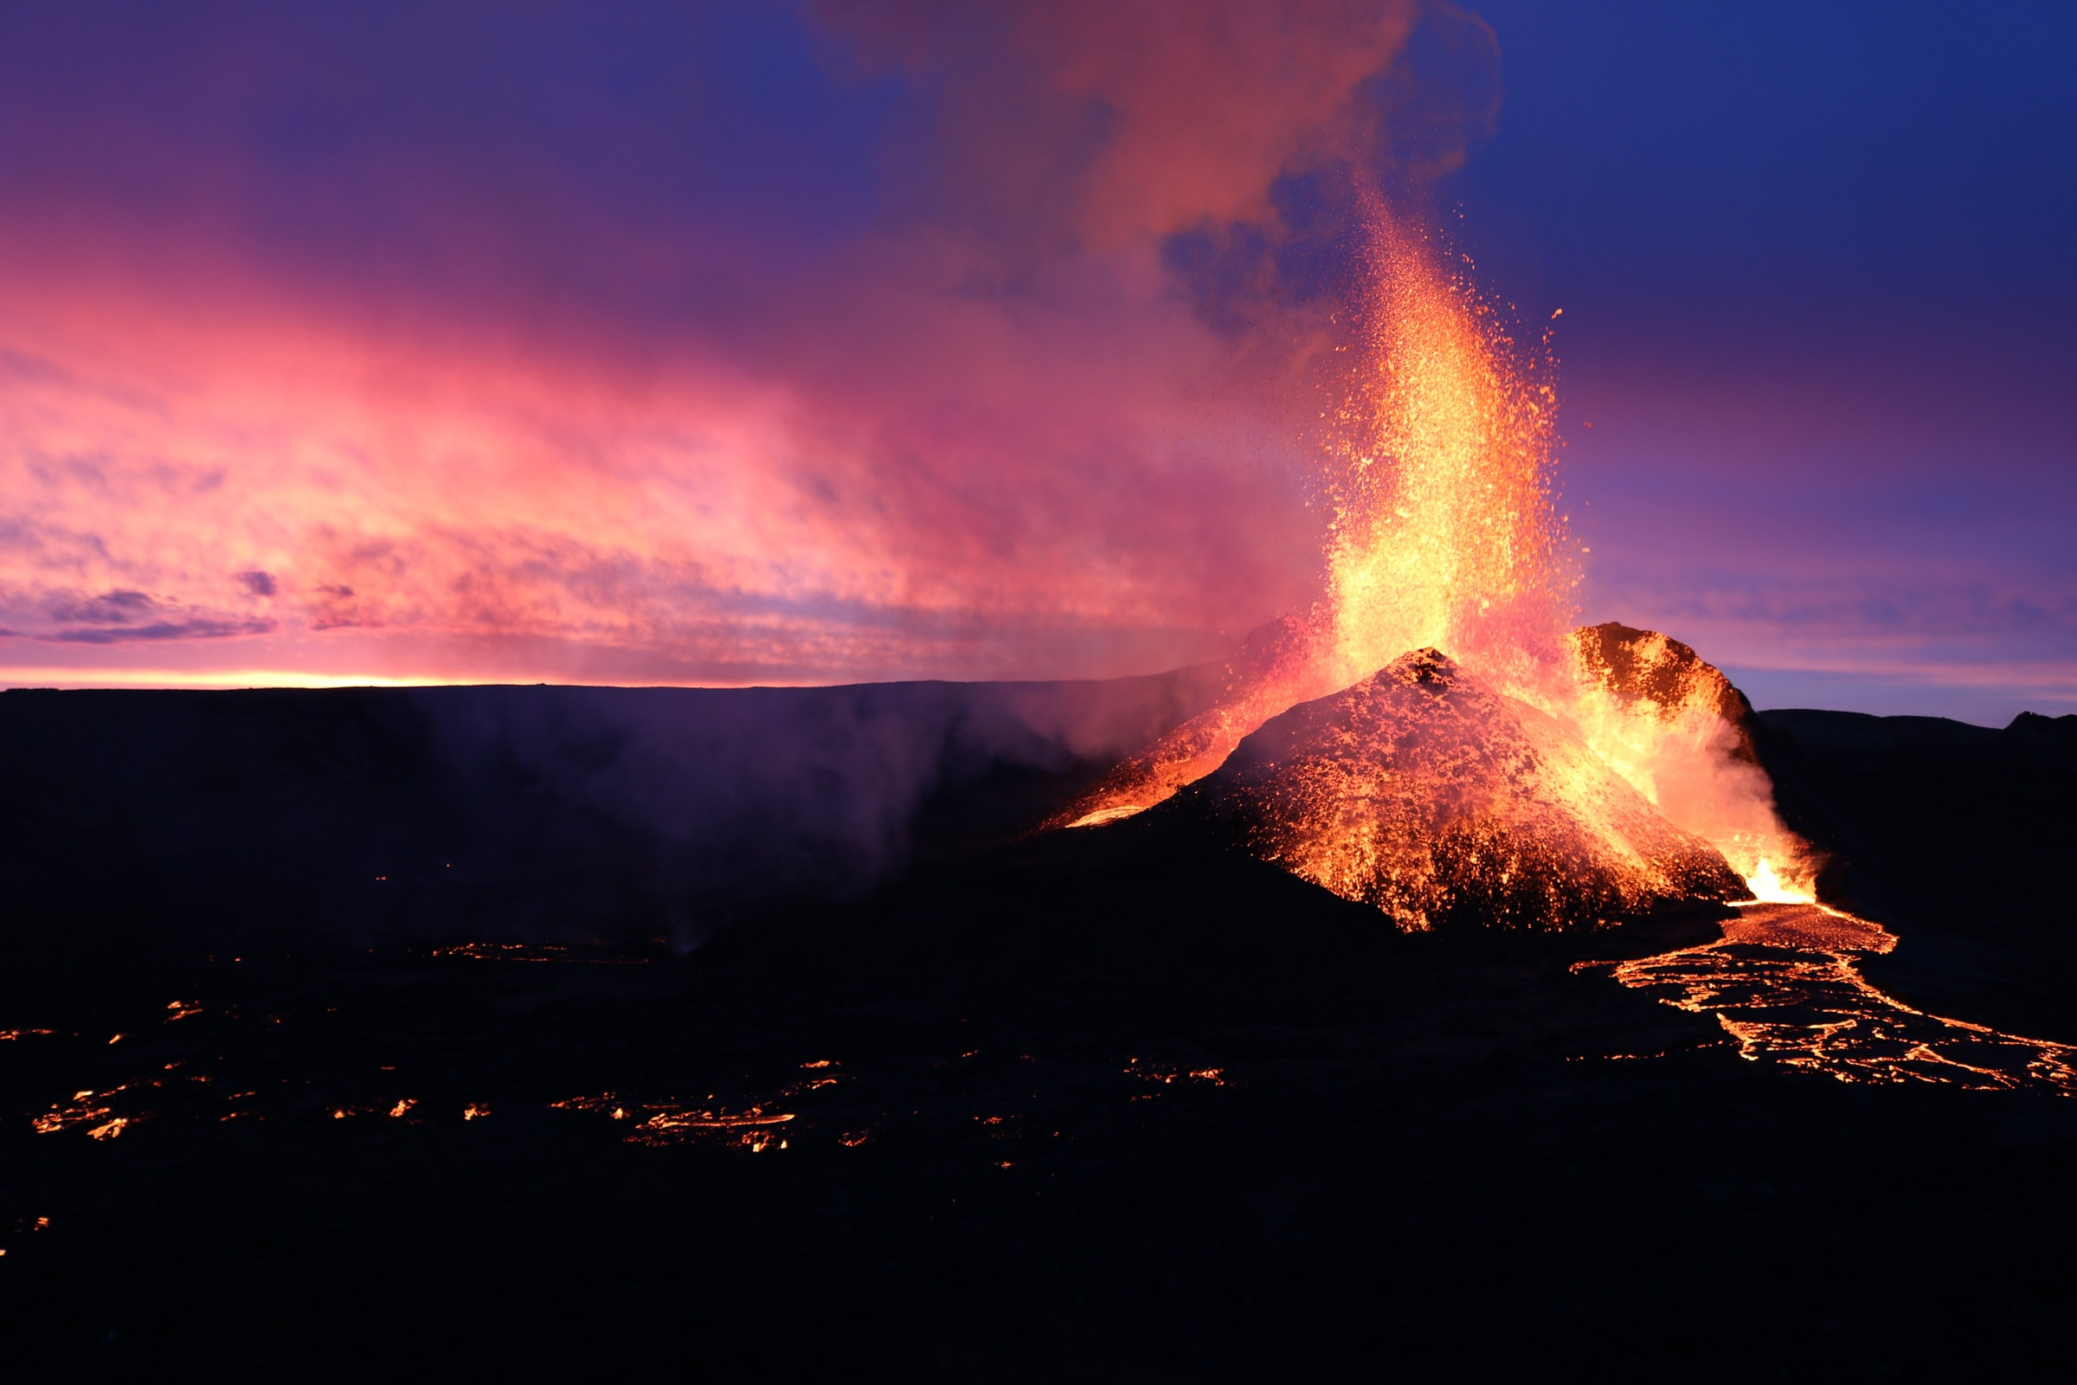

## Questions

1. How is a volcano created?
   1. It created when lava finds a way to escape from beneath the earth’s surface.
2. What kind of volcano is Mt St Helens?
   1. It is an explosive volcano.
3. Volcanic ash does not cause aeroplane engines to fail. True or False?
   1. False

## Collocations and Difficult Words

* Boulders – very large rocks.
* Landslide – a mass of earth or rock falling from a mountainside.
* Avalanche – a mass of snow, ice and rocks falling fast down a mountainside.
* Contaminated – if water is contaminated it is not good to drink. It can be contaminated by poison or human waste for example.
* Collapse – fall to the ground, e.g., building or a person.
* Mowed – to cut down or like a large amount of water flattening trees.
* Destroyed – damaging an object.
* Fatalities - deaths
* Immensely – “immensely big” means that something is very big.

## Countries, Languages, and Demonyms

* America English Americans

## Highlighted Vocabulary

*Remove?*