# DOLPHINS AND HUMANS HAVE SIMILAR PERSONALITY TRAITS

*A study of dolphins reveals some amazing facts*

A study has found that Dolphins have developed several of the same features as humans, even though dolphins and humans evolved in vastly different surroundings.

Researchers did a study of 134 male and female bottlenose dolphins at 8 facilities in different countries. The dolphins were not studied as a group but as individuals. The study showed that humans and bottlenose dolphins have certain personality traits which are similar. They found two traits that are the same - being curious and being social.

This has helped researchers understand how some human personality traits developed without being influenced by the environment they are in. This was also found when studying dolphins, despite having evolved in a vastly different environment.

Dr Morton, who led this research, said that it was the first time that the personality of dolphins had been studied in this way. He also said they thought dolphins were a great animal for this kind of study because they are intelligent and social just like humans. These are two traits that contribute to personality.

Dolphins, like many primates, have larger brains than what the body needs to function. The part that is not used to make the body function is used for intelligence. Intelligence gives primates the ability to be curious.

Dr Morton wants us to understand that some personality traits in dolphins and humans are the same, but this does not mean that that all personality traits are the same.

This study began in 2012 and was conducted at facilities in Mexico, America, France, the Bahamas, and the Cayman Islands.

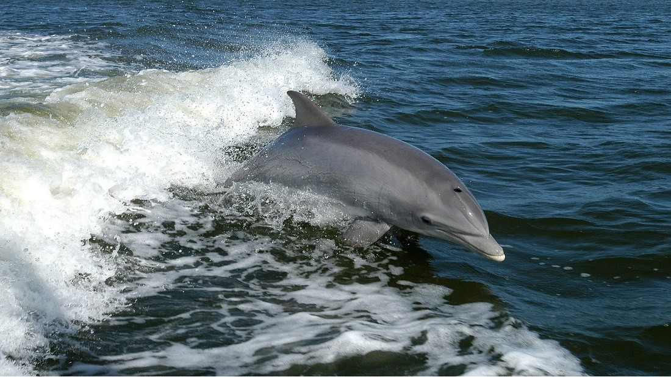

## Questions

1. Are human and dolphin personalities exactly the same”
   1. No, they are not.
2. Does our environment influence our personality traits?
   1. No, it does not.
3. What is the part of the brain that is not used for body functions, used for?
   1. It is used for intelligence.

## Collocations and Difficult Words

* Primates – a mammal – they have hands, feet that are like hands, and forward-facing eyes, and, except for humans, are typically agile tree-dwellers.
* A number of – e.g. There are a number of people at the shopping mall, there are a number of options to choose from. It means more than two but fewer than many.

## Countries, Languages, and Demonyms

* Mexico Spanish Mexicans
* America English Americans
* Bahamas English Bahamians
* Cayman Islands English Caymanians

## Highlighted Vocabulary

*Remove?*