# KFC AND DU FU THATCHED HUT MUSEUM TEAM UP

*At the peak of his literary life, Du Fu lived in a humble thatched hut*

Du Fu was an eight-century Chinese poet, now lauded as one of the greatest wordsmiths who ever lived. He lived in Chengdu in a modest thatched hut at the peak of his career as a poet.

For someone who had never had a fried chicken sandwich, he wrote about cooking cold noodles garnished with the leaves of the scholartree. At KFC in Chengdu, there is a holographic pyramid that beams 3-D images of his hut in spring, summer, winter, and fall.

Those seeking fried chicken are surprised by the elegance that greets them as they walk into the fast-food restaurant. The tables are covered in poems by Du Fu in the handwriting of the Qianlong Emperor. The tiles on the wall display brush paintings of rich designs from the Tang dynasty, Du Fu’s milieu and the era widely considered to be China's poetic golden age.

Du Fu lived a somewhat tragic life. He was a wanderer with ambitions to be a civil servant, but his career was cut short by rebellion and political missteps.

He made friends with another poet, Li Bai, whose work is considered the pinnacle of Chinese literature. It is said they were both fond of drinking and writing poems about drinking.

Du Fu did not have an easy life. His life was plagued by illness, war, and poverty. One of his children starved to death. His poetry drew little attention while he was alive, but after his death his 1500 poems became very popular. His works impacted the Chinese and Japanese literary canon for more than a millennium.

Chengdu is now the home of the Du Fu Thatched Museum which teamed up with KFC to establish this popular fast-food branch.

Illustration of Tang dynasty poet Du Fu.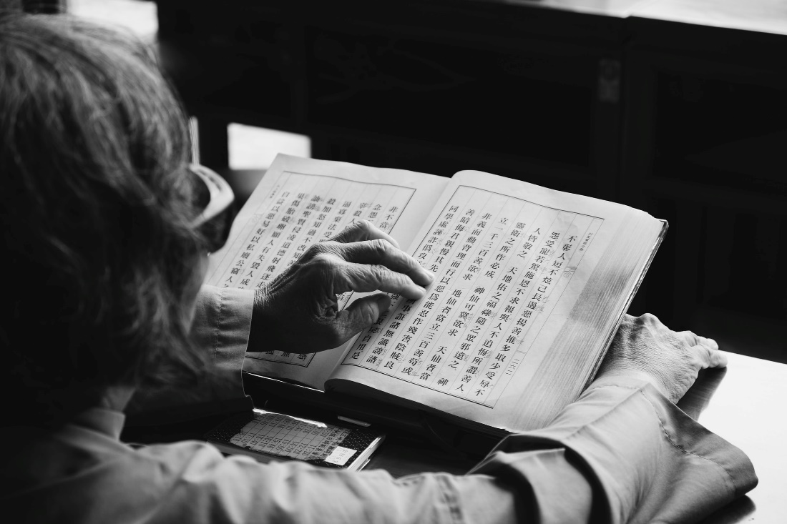

## Questions

1. His poetry drew a lot of attention when he was alive. True or False?
   1. False
2. Did Du Fu have an easy life?
   1. No, he did not.
3. Du Fu is a modern-day poet. True or False?
   1. False

## Collocations and Difficult Words

* **WORD** – DEFINITION
* **WORD** – DEFINITION
* …

## Countries, Languages, and Demonyms

* China Mandarin Chinese

## Highlighted Vocabulary

*Remove?*