# "516 Arouca" The World's Longest Pedestrian Suspension Bridge

Portugal builds the longest suspension bridge

A new suspension bridge has been built in the Portuguese town of Arouca. It is the longest pedestrian suspension bridge in the world and hangs 174m above the Paiva River. The "floor" of the bridge, which wobbles when you walk on it, is a see-through metal grid.

It is dubbed "516 Arouca" because of its length in metres. The bridge cost $2.8 million and was completed in approximately 2 years. The longest bridge before the 516 Arouca was the Charles Kuonen Suspension Bridge in Switzerland, which is about 494m in length. For the average person it takes about 10 minutes to walk across the bridge without distractions like stopping to take pictures or to admire the view.

A local resident was allowed to walk on the bridge before it was opened to the public. He says he was a little bit afraid, but it was definitely worth it. He said, "It was extraordinary, a unique experience, and an adrenaline rush."

The bridge is situated in the Arouca Geopark in the northern region of Portugal. Visitors can hike, go white water rafting, and explore historical sites. The Park is a geological heritage site, particularly because of the many fossils that can be found there.

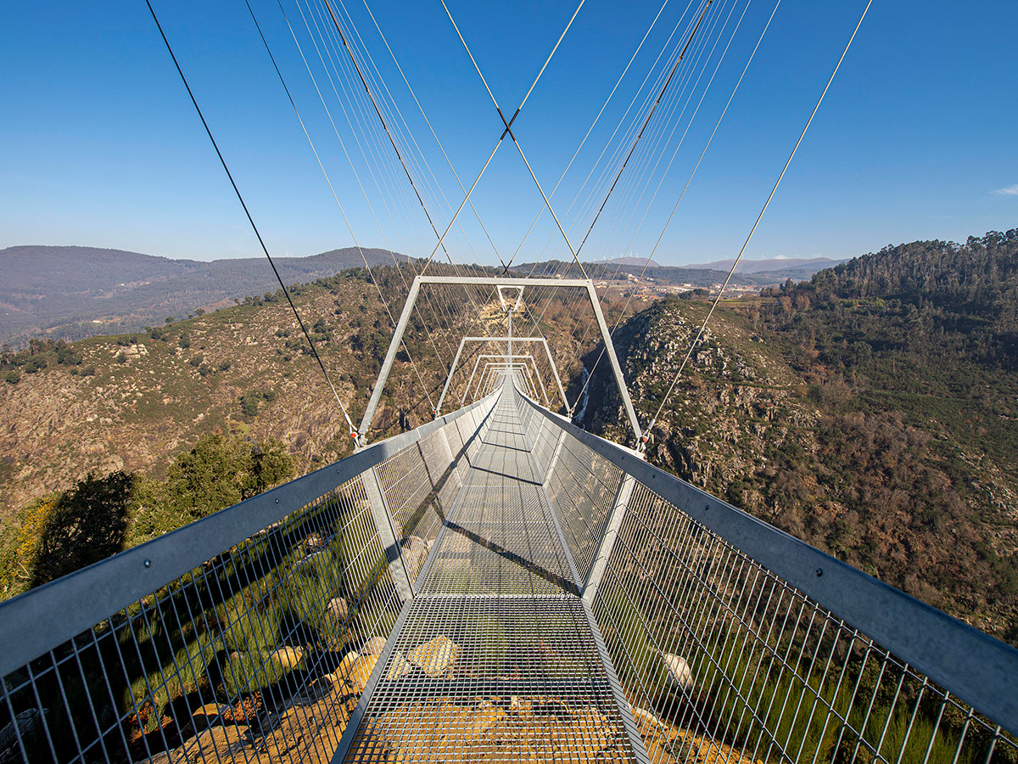

## Questions

1. In which country was the 516 Arouca built?
   1. Portugal
2. Why is it called the 516 Arouca?
   1. Because of its length in metres.
3. What is the Arouca Geopark?
   1. It is a geological heritage site.

## Collocations and Difficult Words

* **WORD** – DEFINITION
* **WORD** – DEFINITION
* …

## Countries, Languages, and Demonyms

* Portugal Portuguese Portuguese
* Switzerland German/French/Italian/Romansh Swiss

## Highlighted Vocabulary

*Remove?*