# Seats Filled for First All-Civilian Space Flight Crew - Part 1

*Four Civilians to Man Flight into Space*

A college science professor and an aerospace data analyst were named as two of the four crew members for a SpaceX launch into orbit around earth. This flight is planned for later in 2021, and it will be the first all-civilian space flight to take place in history.

The crew was introduced at a news briefing livestreamed from the Kennedy Space Center in Florida by SpaceX human space flight chief Benji Reed and billionaire entrepreneur Jared Isaacman. Jared Isaacman conceived the mission as part of a charity drive.

Isaacman is the founder and CEO of e-commerce firm Shift4 Payments. Isaacman is giving fellow billionaire Elon Musk an unspecified amount of money to pay for him and three others to go on this mission. They will be going in a SpaceX Crew Dragon capsule.

The flight is schedule for after September this year and is expected to last three to four days from launch to splashdown.

Isaacman, who is 38 years old, told the media, “When this mission is complete, people are going to look at it and say this was the first time that everyday people could go to space.”

This mission, which is called Inspiration4, is primarily to raise awareness and support for St. Jude Children’s Research Hospital. This hospital is a leading paediatric cancer research centre and is also one of Isaacman’s favourite causes. He has pledged $100 million of his own money to this institute.

Isaacman has appointed Haley Arceneaux as first crewmate for the flight. Haley is a physician’s assistant at the Tennesse-based hospital. She is 29 years old, a bone cancer survivor, and one-time patient at this hospital.

The third crew member was announced. He is Chris Sembroski, aged 41. He is an employee at a Seatle-area aerospace company and is an US air Force veteran. He was selected through a sweepstakes draw which had 72000 entries. This sweepstakes draw also raised $113 million, which Isaacman will donate to St. Jude hospital.

Sian Proctor, aged 51, was chosen through an online business contest run by Shift4 Payments. He is a geoscience professor at South Mountain Community College in Phoenix, Arizona. He is also an entrepreneur who was once a NASA astronaut candidate.

All four crew members will undergo extensive training which is modelled after the curriculum NASA astronauts use to prepare for SpaceX missions.

The Inspiration4 mission is not the only all-civilian crew rocket launch planned. British billionaire Richard Branson’ Virgin Galactic enterprise is busy developing a spaceplane. They aim to carry paying customers on suborbital excursions.

Ispiration4 is about more than a billionaire's joyride through space, organisers say. They promised that the crew will conduct several yet undetermined science experiments during its brief voyage.

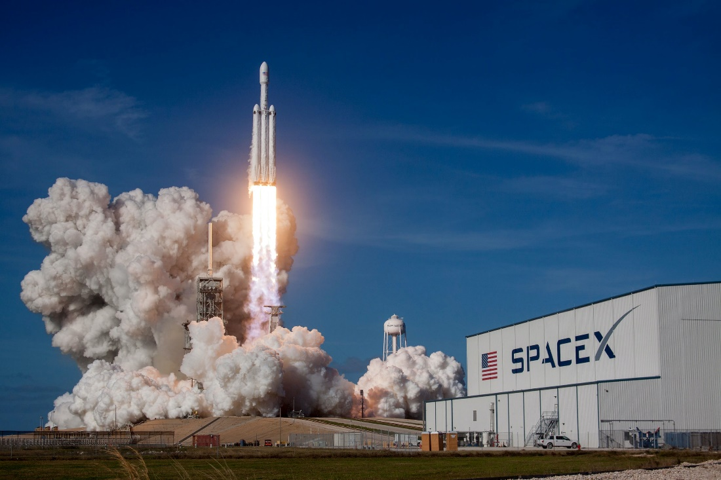

## Questions

1. How many people will be going up into space?
   1. Four.
2. Are they trained astronauts?
3. What was Isaacman’s main reason for organising this mission?
   1. To primarily raise awareness and support for St Jude Children's Research Hospital.

## Collocations and Difficult Words

* **WORD** – DEFINITION
* **WORD** – DEFINITION
* …

## Countries, Languages, and Demonyms

* USA/ America American Americans

## Highlighted Vocabulary

*Remove?*