# MAN BITTEN BY A SNAKE WHILE SITTING ON THE TOILET

*Nasty surprise for a 65-year-old while he was sitting on the toilet*

A 65-year-old man was absolutely flabbergasted when he felt “a pinch in the area of his genitals,” while he was sitting on the toilet. When he looked, he saw that there was a snake in the toilet bowl. It was a 1.6 metre reticulated python and it had bitten him.

The python is a constrictor, is native to Asia, and can grow up to 9 metres long. It is thought that the python had found its way into the toilet by means of the network of drains connecting all the apartments.

“Shortly after he sat on the toilet, the Graz resident – by his own account – felt a ‘pinch’ in the area of his genitals,” police said in a statement. The man needed treatment in hospital for minor injuries.

It could not be confirmed that the snake got into the toilet via the drains. It is thought that the python might have escaped from a neighbour’s apartment. The man’s neighbour, who owns 11 snakes, has been reported to the police.

The emergency services contacted a reptile expert who removed the python from the toilet, cleaned it, and returned it to its owner.

Reticulated pythons will not normally attack humans, but they will constrict or bite if they feel threatened, or if they mistake something for food.

Reticulated pythons are the world’s largest snakes.

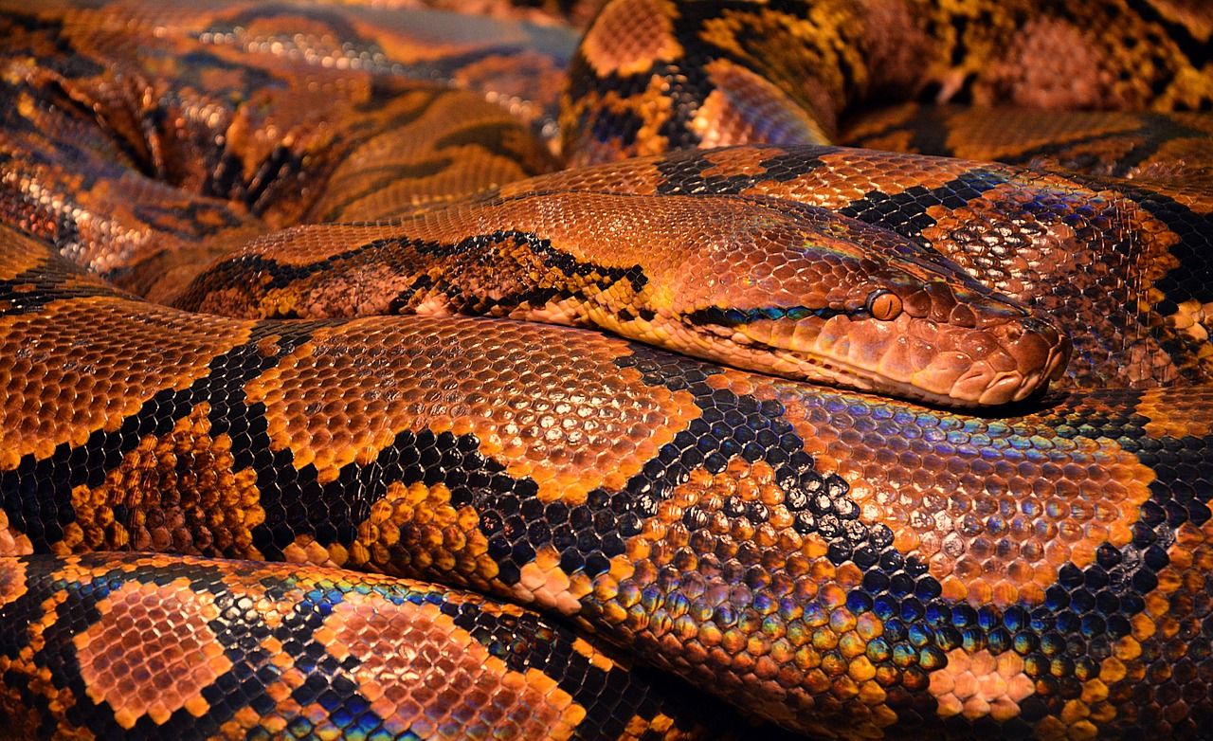

## Questions

1. The reticulated python is not the world’s largest snake. True or False?
   1. True
2. Do reticulated pythons normally attack and bite humans.
   1. No, they do not. They will only constrict or bite if they feel threatened.
3. Where did the man find the python?
   1. The man found it in his toilet.
4. How do they think the python got into the man’s toilet?
   1. They think he might have gotten into the toilet via the network of drains.

## Collocations and Difficult Words

* **WORD** – DEFINITION
* **WORD** – DEFINITION
* …

## Countries, Languages, and Demonyms

* Austria German Austrian

## Highlighted Vocabulary

*Remove?*