# “UGLIEST WOMAN ON EARTH” - STAR OF A FREAK SHOW (PART 1)

*Gasps of horror as audience sees star of freak show*

Mary Ann Bevan was born in December 1874 in Britain.

One of eight children, born into a poor family in Plaistow, east London, Mary Ann was normal and described as pretty when she was young. Despite the family’s poverty, she followed her dream and became a nurse.

At the age of 29 Mary Ann married Thomas Bevan and her appearance only started changing then. Thomas and Mary Ann eventually had four children.

She developed a condition called acromegaly. This disorder is caused when your body produces too much growth hormone, which causes a person’s hands and feet to become enlarged. It also changes the shape of the face, making it become larger and more masculine. When the bones and tissues increase in size very rapidly it is extremely painful. In those years, the doctors were unable to treat the disease. They did not have the knowledge of medicine to stop the disorder from changing someone beyond recognition. Today it can be treated and controlled.

When Mary Ann’s husband died 11 years later, she was destitute, having to support four children. Suffering from acromegaly, her appearance made it impossible to find work.

Then she saw the newspaper advert that was to change her life.

The advert read as follows: “Wanted: Ugliest woman. Nothing repulsive, maimed, or disfigured. Good pay guaranteed, and long engagement for successful applicant. Send recent photograph.” The advert was place by Claude Bartram who was the European agent for Barnum and Bailey, an American circus.

Claude had just returned from Europe to find more “talent” for his show. He was not successful in finding anyone to join the lucrative and cruel sideshow. As a last resort he placed the advert for new “talent.” Mary Anne sent a recent photograph and Claude’s interest was immediately piqued.

Read part 2 next week and find out how Mary Ann coped with being a “freak.”

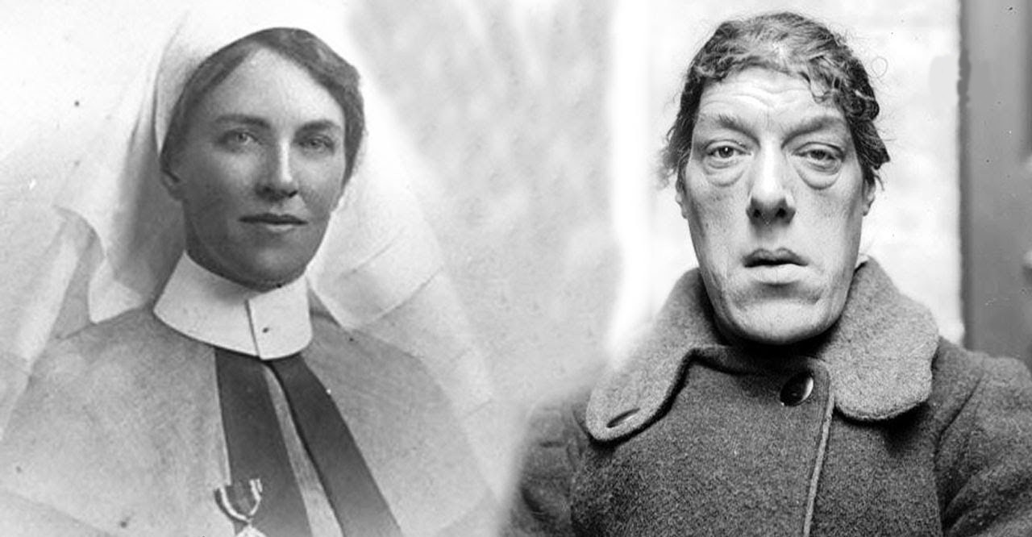

## Questions

1. In which country was Mary Ann born?
   1. In Britian
2. What sickness did she have?
   1. Acromegaly.
3. What causes this condition?
   1. The body produces too much growth hormone.

## Collocations and Difficult Words

* **WORD** – DEFINITION
* **WORD** – DEFINITION
* …

## Countries, Languages, and Demonyms

* Britian (UK) English British/Brits

## Highlighted Vocabulary

*Remove?*