# “UGLIEST WOMAN ON EARTH” - STAR OF A FREAK SHOW (PART 2)

*Mary Ann’s life after accepting Claude Batram’s offer*

Claude Bartram offered Mary Ann a position in the freak show, but she said that she did not like the idea of being used as an exhibit, and that she was shy and did not want to leave her children. Claude informed her that she would earn ten pounds per week for a year, plus travelling expenses and all the money from the sale of picture postcards of herself. This would enable her to educate her children. She finally agreed.

In the beginning, Mary Ann toured Hampshire in England. Her success led to a job offer from P.T. Barnum who owned PT Barnum Circus. She agreed, and in 1920 left England by boat to join the American based circus.

When she arrived in America, she was on the cover of every newspaper. They heralded her as the “Ugliest Woman on Earth.” The public was fascinated with Mary Ann’s appearance. She ended up star of the show, and more popular than the bearded ladies, conjoined twins, little people, giants, and people that were physically disabled.

Spectators had little regard for moral issues and went in vast numbers to see Mary Ann in the flesh. To make her look as unattractive as possible, she was made to wear clothes that enhanced her masculine look and physique. During the next two years Mary Ann earned 20 000 pounds, which is worth about 500 000 pounds now.

With her earnings she could afford to put her children into boarding school while she was working. She missed them a lot and regularly wrote to them. Knowing that she could provide for her children and give them a better life, she suffered through the insults and the fact that she was “put on display.”

In 1925 Mary Ann returned to Europe to participate in an exhibition in Paris. Finally, she spent the rest of her life with the Coney Island Dreamland Show. It is said that she had a severe drinking problem in the last years of her life and lost a lot of her money due to making bad investments.

She died in 1933 at the age of 59. Her dying wish was to be buried in England and her children buried her in Ladywell and Brockley Cemetery in South London.

Interesting fact: P.T. Barnum is the circus maestro portrayed by Hugh Jackman in the movie The Greatest Showman.

There is more to Mary Ann’s story. Read part 3 to find out.

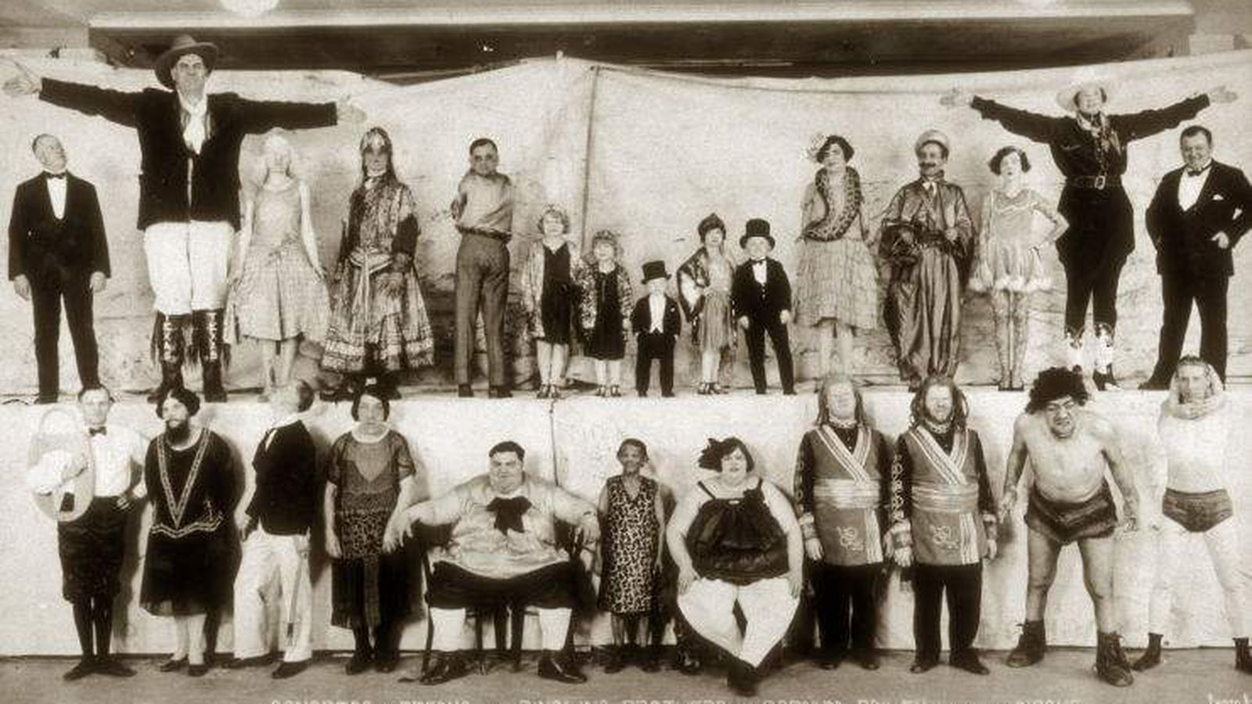

## Questions

1. Did Mary Ann make enough money after she joined the circus, to support her and her children?
   1. Yes, she did.
2. When Mary Ann died, was she a rich woman?
   1. No, she was not.
3. How old was Mary Ann when she died?
   1. She was 59.

## Collocations and Difficult Words

* **WORD** – DEFINITION
* **WORD** – DEFINITION
* …

## Countries, Languages, and Demonyms

* China Mandarin Chinese

## Highlighted Vocabulary

*Remove?*