# UGLIEST WOMAN ON EARTH – PART 3

*Doctors upset at the exploitation of Mary Ann’s looks*

There are some interesting stories surrounding Mary Ann’s appearance and illness. Even though society was less sensitive to these kinds of things than it is today, some kind people did speak out in defence of Mary Ann.

Harvey Cushing, a neurosurgeon, wrote to Time magazine in 1927, complaining of how it made fun of the ugliness of his patient. He wrote, “This unfortunate woman who sits in the sideshow of Ringling Brothers ‘between Fat Lady and Armless Wonder’ and ‘affects white lace hats, woollen mittens and high laced shoes’, has a story which is far from mirth-provoking. She, previously a vigorous and good-looking young woman, has become the victim of a disease known as acromegaly .... being a physician, I do not like to feel that Time magazine can be frivolous over the tragedies of disease.”

In 2006, another doctor, Wouter de Herder, a consultant endocrinologist from Holland, also complained after he saw a birthday card in a UK shop. The card showed close-up photographs of Mary Ann. He wrote to the greeting card manufacturer, Hallmark, saying that it was inappropriate to make fun of Mary Ann.

Dr de Herder said, “I immediately recognised the photo as I had just written an article about Mary Ann. She had been an attractive young London nurse but then suffered from the painful disease called acromegaly.”

Hallmark agreed to stop distributing the cards of Mary Ann but would not recall any cards that were already in the shops. They remarked, “Once we found that this lady was ill rather than simply being ugly, the card was withdrawn immediately, as it would breach anything we would do in terms of making fun of anyone who was poorly.”

Rober Knutzen, chief executive officer of the Pituitary Network Association, an international support group for people with acromegaly, said, “To make money from the misery and misfortune of others is shameful. This is corporate greed taken to its lowest level.”

How do you feel about companies exploiting people with disabilities for money? Would you do it for the money if you were in the same position as Mary Ann?

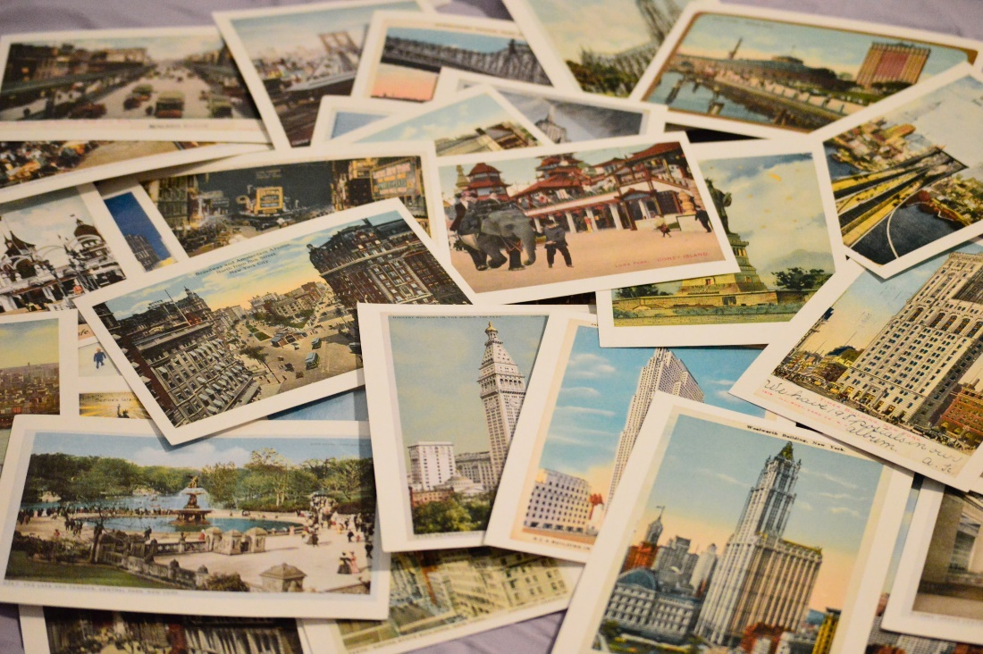

## Questions

1. In what year did Dr de Herder see birthday cards with photographs of Mary Ann, in a shop in the Uk?
   1. In 2006.
2. Did the doctors agree with the fact that Mary Ann and so many others were on display at shows?
   1. No, they did not.
3. Did Hallmark stop producing and supplying the cards after they received the complaint?
   1. Yes, they did.
4. What did Hallmark refuse to do?
   1. They refused to recall any cards that were already in the shops.

## Collocations and Difficult Words

* **WORD** – DEFINITION
* **WORD** – DEFINITION
* …

## Countries, Languages, and Demonyms

* China Mandarin Chinese

## Highlighted Vocabulary

*Remove?*