# ALLIGATOR SURPRISES FAMILY IN THE MIDDLE OF THE NIGHT

* **Image-Align: bottom**

*Family is woken up by an alligator on their front porch*

A family in Florida was woken up in the middle of the night by their dog barking. When they went to check why he was barking so frantically, they found an alligator on their front steps. According to them, this has never been an issue that they have had to deal with before.

Steffany Spratling, of Rockledge, Florida, spoke to the media and told them that while there are alligators in the area where they live, they had never come right up to the houses before.

At 2:00 am, while Steffany and her family were sleeping, their dog, Capone, started barking like crazy. They turned the porchlight on, only to see the alligator sitting on their doormat.

They waited to see if the alligator was going to leave, but he just paced from the window where Capone was barking at their son's bedroom window. Steffany called the police and they tried to draw it away from the Spratling home. The police were unable to remove him on their own and decided they needed help.

Talking to Steffany through a window, the police told her that they had called a trapper and that he was on his way. A trapper is a person who specialises in catching wild animals.

When the trapper arrived, he managed to catch the alligator successfully. Nobody was hurt but there was slight damage to a pillar. Fortunately, it was minimal and can be repaired.

Steffany thinks that someone in their area might be feeding the alligators. The reason for this is that some of their neighbours have also had problems with them, where they found the reptiles close to their houses as well.

The Spratling family and their neighbours live next to a canal, and they always see alligators in the back sunbathing or swimming. They usually just watch them and do not bother them. Steffany says this is the first time that one of them had ventured to their front door.

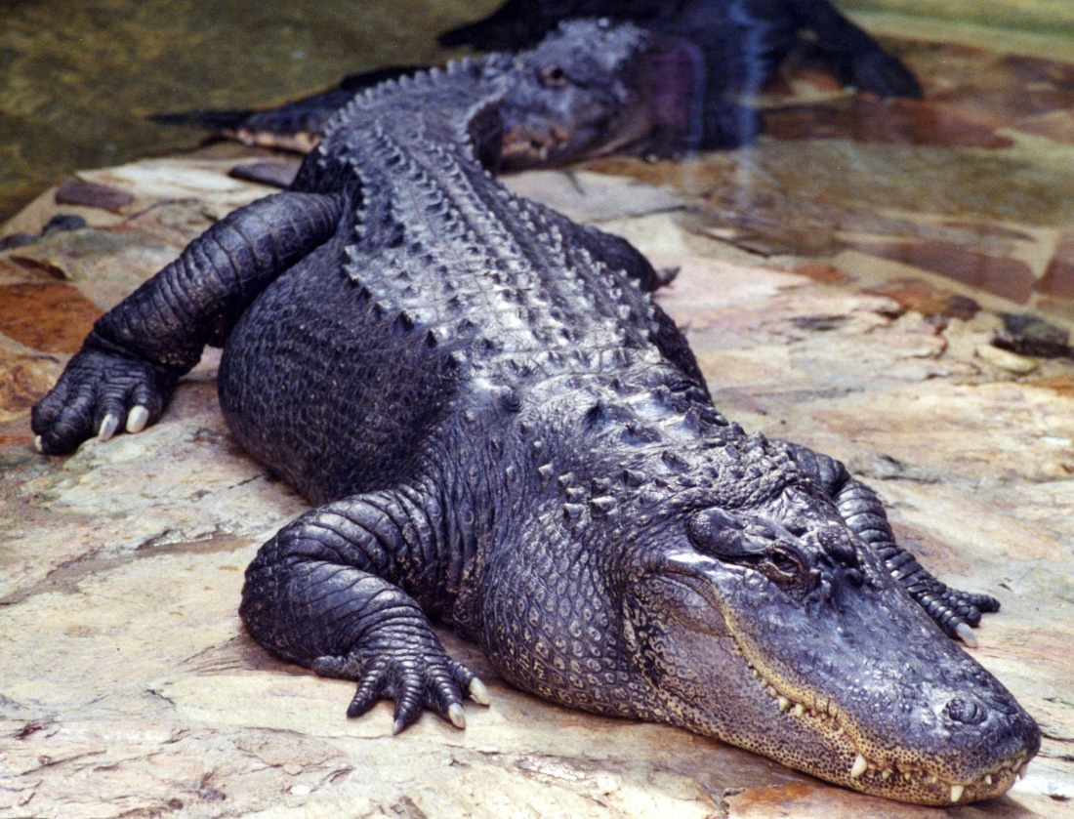

## Questions

1. Where did the Spratling find the alligator?
   1. On the front steps of their house.
2. The family was waiting for the alligator to leave. When he did not who did the family call?
   1. The police.
3. Were the police able to catch the alligator?
   1. No, they did not.
4. The Spratling family think there is a reason the alligators are suddenly going up to the houses. What is this reason?
   1. They think someone is feeding the alligators.

## Collocations and Difficult Words

* **WORD** – DEFINITION
* **WORD** – DEFINITION
* …

## Countries, Languages, and Demonyms

* China Mandarin Chinese

## Highlighted Vocabulary

*Remove?*