# AUSTRALIAN JEWELLER MAKES BIZARRE JEWELLERY

*Jewellery made from dead people’s teeth*

An Australian jeweller, Jacqui Williams, aged 29, sells jewellery made from dead people's teeth. She even uses ashes and hair of the deceased. She has also had requests from pet owners. She says, “It seems I was always drawn to the morbid side of life, even as a child.”

Jacqui started her own business called Grave Metallum Jewellery when she could not find work as a jeweller. She had studied for a diploma in jewellery and object design at Melbourne Polytechnic until 2017 but struggled to find employment within the jewellery industry. That is when she started her own business.

For the first two years it was not easy as she was working full time in bars and restaurants and running her own business. On her days off and before shifts she would work on custom orders and making new pieces of jewellery. In the third year of starting her business and working shifts, she got a part-time job as a gardener at a local cemetery. She then quit her jobs at the bars and restaurants and was incredibly happy because she did not have to work night shifts anymore.

Jacqui says, “Most mothers will have a collection of their children’s teeth, and a lot of people will hold onto their own pulled teeth, which family find after a parent, child or sibling has passed away.” She is even sent teeth that have been removed after the person has died. Gold of metal capped teeth are always removed from the body before they are buried or cremated.

Jacqui spends between six and eight weeks to make each custom piece and it costs between 190 pounds and 5400 pounds.

She has made a sterling silver and brass framed hourglass, using the ashes of her client’s grandfather instead of sand. Her most expensive piece is a 18ct rose gold wedding ring. The client wanted her husband’s tooth set amongst sapphires and garnets.

Although her friends and family support her business, she has had some criticism on social media. She says, “I receive all sorts of different reactions. Some people love my work, others hate it, some are disgusted by the teeth and bone work. I do this work because I want to help people deal with their grief and loss. My interest in helping others deal with their grief started when I lost my best friend a few years ago. Grief is always easier to deal with when shared.”

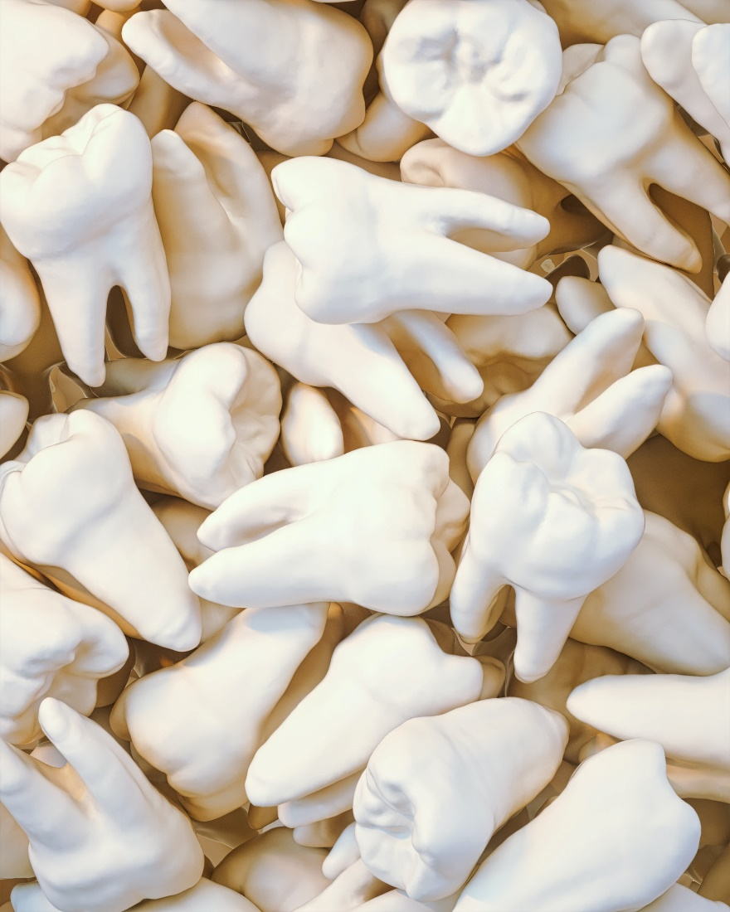

## Questions

1. What is Jacqui’s business called?
   1. Grave Metallum Jewellery.
2. Was it easy for her to get work after getting her diploma?
   1. No, it was not.
3. What is her reason for making this bizarre jewellery?
   1. She says she wants to help people deal with their grief and loss.

## Collocations and Difficult Words

* **WORD** – DEFINITION
* **WORD** – DEFINITION
* …

## Countries, Languages, and Demonyms

* China Mandarin Chinese

## Highlighted Vocabulary

*Remove?*