# A REAL-LIFE MOWGLI LIVING IN AFRICA

*Real-life Mowgli spends his time in the forest eating grass and fruit*

Zanziman Ellie is a 21-year-old who lives in a village in Rwanda in Africa. He refuses to eat the food his mother prepares for him; he cannot speak and has difficulty hearing. His mother believes he is a special child as he is her only child that has survived. She lost five other children at birth.

Ellie, as he is known amongst the villagers, goes to the forest surrounding his village and looks for bananas, other fruits, and grass to eat.

Ellie was born with microcephaly. Microcephaly is a condition where, when the baby is born, the head is smaller than that of a normal baby. This has led to learning difficulties, and because of this Ellie does not go to school. He is also afraid of his fellow villagers.

His mother says all he does is run. He runs away from people and wherever he runs she must run after him. She is scared that if she does not follow him, he will not return home to her. His mother made a lasso to catch him when he is running away from her.

A film company has made a film about him. The villagers told the film crew that they all try and keep Ellie away from the forest and safe from danger.

Elie's mother said that the neighbours see her son as an animal and not a human being. The children and adults bully him.

One neighbour said, “Everyone knows he is different; we have never seen a person who can graze in a field as animals do.”

According to the film Born Different, Ellie’s head was the size of a tennis ball at birth.

Ellie has never received any formal education because of his disabilities. He does however understand his mother. He will immediately react to any instructions she gives him.

The film company has started a crowdfunding campaign to help Ellie’s mother, who is now single and unemployed. Due to her unemployment, they often run out of food, and this also forces Ellie to forage in the forest for fruit and grass.

Ellie’s story has gone viral, and people have not only given donations but has also left messages for Ellie and his family.

These are some of the messages that have been posted on social media:

* “I grew up being bullied by mean people all my life, therefore I like to back people who are bullied, especially those with disabilities.”
* “Everyone should have the opportunity to have a good life, free from being bullied!!!”
* “I want to protect his smile.”

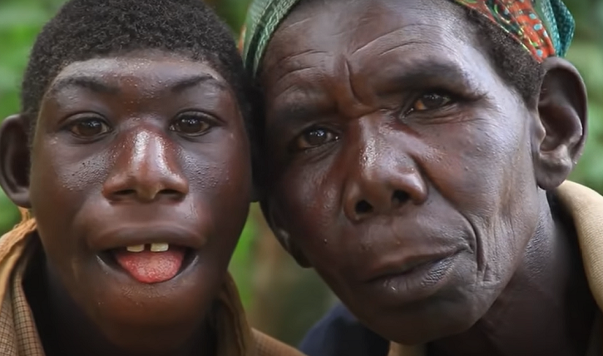

## Questions

1. What was different about Ellie when he was born?
   1. His head was smaller than other new-born babies.
2. What does Ellie eat and where does he get his food from?
   1. Ellie finds his food in the forest, and he eats fruit and grass.
3. What do the neighbours do to Ellie?
   1. They bully Ellie.

## Collocations and Difficult Words

* **WORD** – DEFINITION
* **WORD** – DEFINITION
* …

## Countries, Languages, and Demonyms

* China Mandarin Chinese

## Highlighted Vocabulary

*Remove?*