# 2021’s TRICKIEST WORDS TO PRONOUNCE

*Do you know how to pronounce these words?*

This list was commissioned six years ago by Babbel, a language-learning platform. The company has headquarters in Berlin and New York. Another US company, which produces subtitles for live TV, did a survey to see which words television presenters and newsreaders are pronouncing incorrectly.

Some of the words that made it onto the list in 2021 are as follows: Omicron, the virus, Tsitsipas (the Greek tennis player), and cryptocurrency Dogecoin.

Esteban Touma, a stand-up comedian, and teacher for Babbel Live, said that newscaster in the US have struggled with 2021’s new words and names.

Here are a few of the words and names:

* **Cheugy (CHOO-gee/):** A Generation Z term to mock outdated and unfashionable things, or someone who is trying too hard, it is often used to poke fun at Millennials.
* **Chipotle (chih-POHT-//lay/UK - ɪˈpəʊt.leɪ/US - tʃɪˈpoʊt.leɪ/):** The US fast food chain started a viral trend in 2021 by challenging people to pronounce this name.
* **Dalgona (tal-goh-NAH):** A Korean treat made with melted sugar and baking soda, as seen in the hit show Squid Game.
* **Dogecoin (DOHJ-//coin):** Despite having an image of a dog as its logo, the cryptocurrency’s name is not so straightforward.
* **Eilish (//EYE-lish):** She may be one of the world’s biggest stars, but Billie Eilish’s name is still causing a problem for some TV presenters.
* **Ethereum (ih-THEE-ree-um):** Another cryptocurrency with another tricky name.
* **Glasgow (GLAHZ-go/UK - ɡlɑːz.ɡəʊ/US - ˈɡlæz.ɡoʊ/):** This may seem a strange one but the COP26 host city may be a challenge for some people not from the UK, with President Biden and Barack Obama struggling to say it correctly.
* **Kelce (KELs):** NFL player Jason Kelce of the Philadelphia Eagles said that his teammates and the media had been mispronouncing his name for years.
* **Omicron (AH-muh-raan/OH-mee-kraan/UK - əʊˈmaɪ.kron/US - ˈoʊ.mɪ.krɑːn**/**):** A new variant of the COVID-19 first identified in November. It is named in keeping with the WHO’s system of identifying variants with Greek letters. The strain is pronounced differently in the US and the UK.
* **Shein (SHEE-in):** A popular Chines “fast fashion” company.
* **Stafanos Tsisipas (STEH-fuh-nos TSEE-tsee-pas):** The Greek tennis player, ranked fourth in the world, is one of the game’s brightest young stars and reached the French Open final in June.
* **Yassify (YEAH-sih-fai):** A trend in which multiple beauty filters are applied to famous pictures or portraits for comic effect.

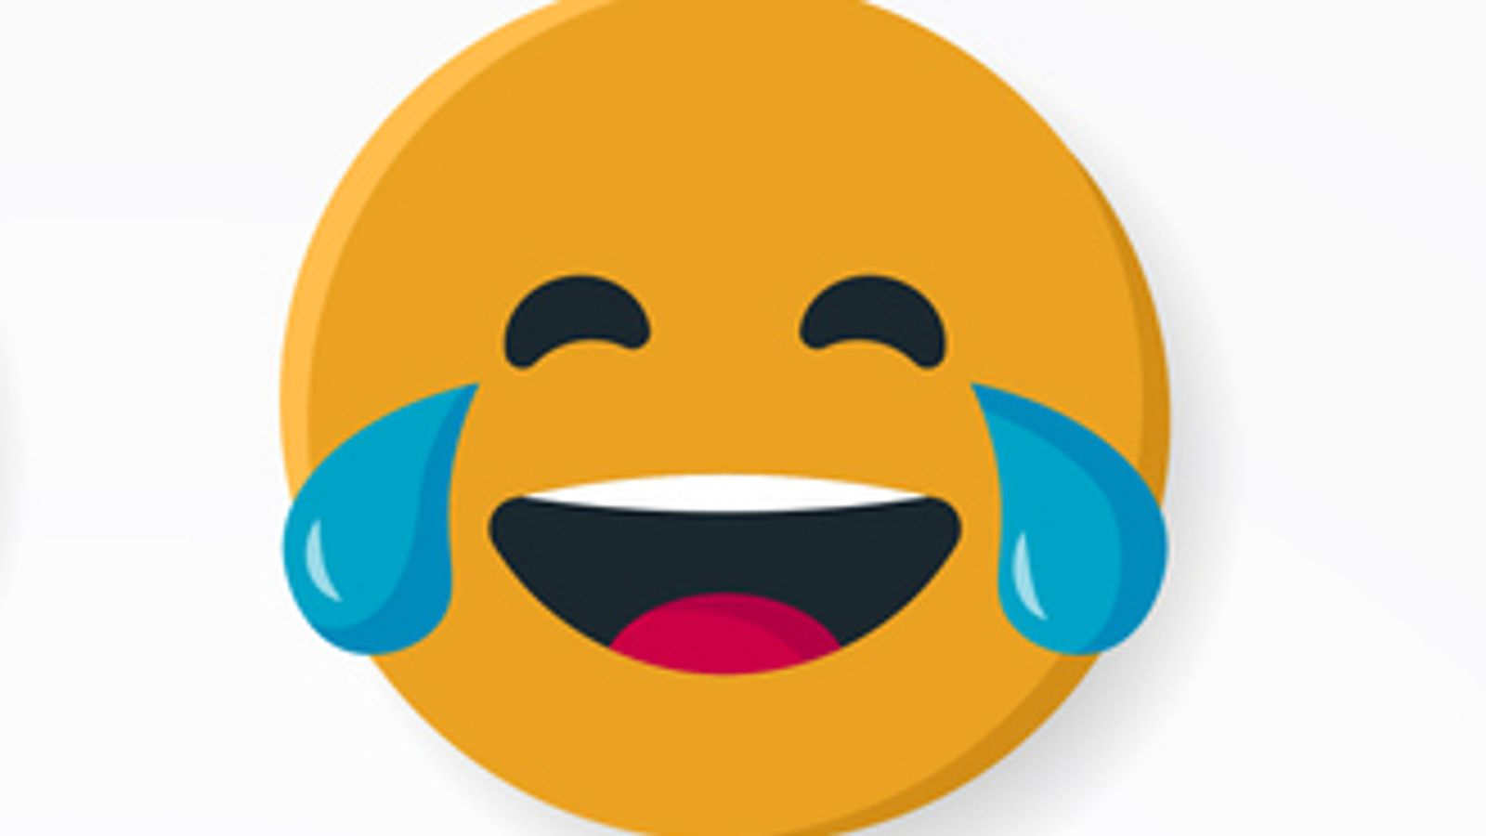

## Questions

1. QUESTION1
   1. ANSWER
2. QUESTION2
   1. ANSWER
3. …

## Collocations and Difficult Words

* **WORD** – DEFINITION
* **WORD** – DEFINITION
* …

## Countries, Languages, and Demonyms

* China Mandarin Chinese

## Highlighted Vocabulary

*Remove?*