# DOUG THE MUTANT POTATO

* **Image-Align:** top

*Colin thought it might be some strange fungal growth*

Colin Craig-Brown, a small farm owner from Hamilton, New Zealand, got a giant surprise when his hoe struck an object beneath the soil.

He dug it out, and after scraping off a piece and tasting it, he realised it was not a fungal growth but a giant potato! His wife Donna said, “We could not believe it. It was huge!”

Colin says that the potato is self-sown – he did not plant it - and may have been growing for a couple of years. “Doug” weighs 7.8kg and Colin is waiting to hear if the potato made it into to the Guinness Book of Records as the heaviest potato. The current record, which has been held since 2011, is a potato that was grown in Shepton Mallet, Somerset, and weighed 4.98kg.

The potato has been enjoying a bit of a celebrity status since they decided to name the mutant-looking vegetable “Doug.” Colin built a small cart to pull “Doug” around town for people to see.

Colin said, “We put a hat on him. We put him on Facebook, take him for walks, and give him some sunshine. It is all a bit of fun. It is amazing what entertains people.”

It is proving difficult to look after this monster potato because it is beginning to dry out, and it is also starting to get mouldy. Colin insists that this potato has not had its chips (not ready to throw away) yet, and that he is keeping “Doug” in the refrigerator. Colin plans to turn “Doug” into potato vodka.

He has no special advice for other gardeners who want to grow giant vegetables. His only suggestion is to throw a load of cow manure and straw in your garden, and then wait to see what happens!

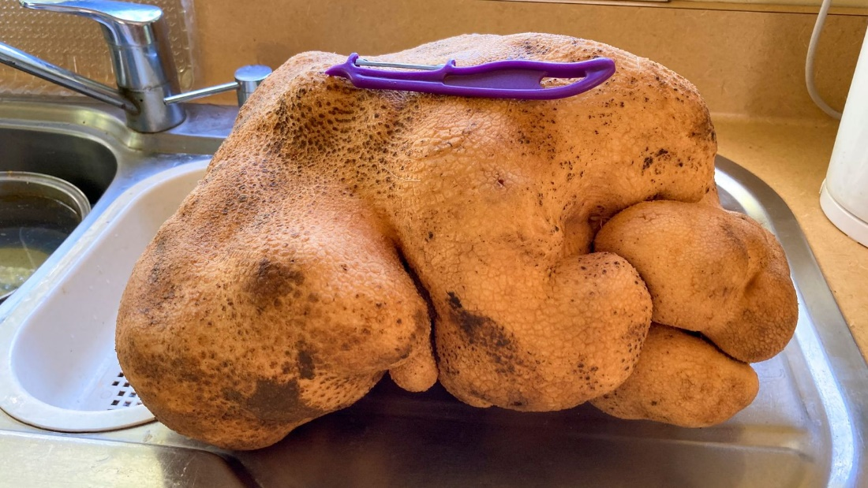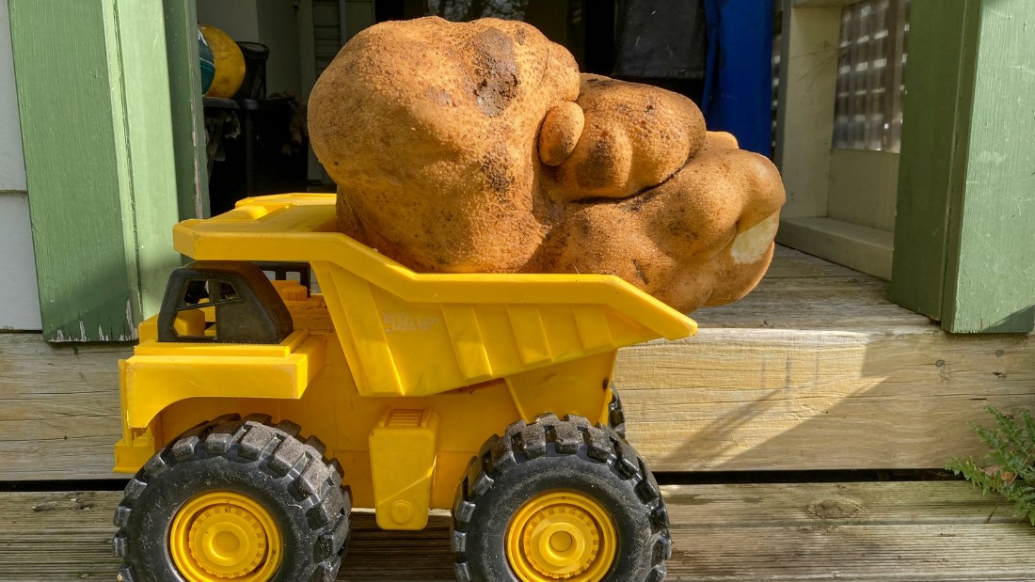

## Questions

1. QUESTION1
   1. ANSWER
2. QUESTION2
   1. ANSWER
3. …

## Collocations and Difficult Words

* **WORD** – DEFINITION
* **WORD** – DEFINITION
* …

## Countries, Languages, and Demonyms

* China Mandarin Chinese

## Highlighted Vocabulary

*Remove?*