# WOMEN EARN MONEY CRYING AT FUNERALS

*Their husbands died and they decided to make extra money*

We might not like death and funerals, but they are a fact of life. Crying is normal for most people when a family member or someone we know dies. Some people though, find it exceedingly difficult to express any emotions, but not for this group of women from Ghana, Africa.

The women decided to make some extra money after losing their husbands. So, what could they do? They did not want to knit, sew, or sit around making tea and chatting all day. They decided to make themselves available to cry at funerals! They became official mourners.

The fee for their service is charged according to the size of the funeral. They dress in black when they attend a funeral and cry for all to see. The surprise is that it does not look fake but looks very real.

They do not think they are doing anything wrong and say they are crying for mourners who are unable to do so themselves.

What do you think? Is it wrong to pay someone to cry at a loved one’s funeral? Is it unethical of the women to charge a fee for doing this?

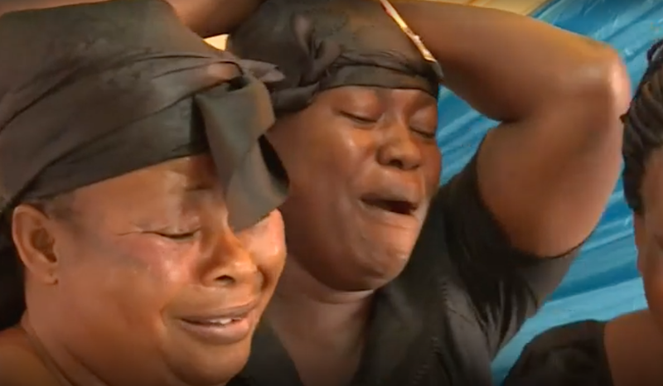

## Questions

1. QUESTION1
   1. ANSWER
2. QUESTION2
   1. ANSWER
3. …

## Collocations and Difficult Words

* **WORD** – DEFINITION
* **WORD** – DEFINITION
* …

## Countries, Languages, and Demonyms

* China Mandarin Chinese

## Highlighted Vocabulary

*Remove?*