# AUSTRALIAN FIGHTS OFF CROCODILE WITH POCKET KNIFE

*Man of 60 escapes the jaws of a crocodile after being dragged into the water*

A 60-year-old man from Brisbane, Australia, stabbed a crocodile repeatedly in the head to escape its vicious jaws. The crocodile dragged him into the river, where the man managed to retrieve his pocketknife from his belt and fight off the animal.

Wildlife officer Matt Brien said the man was “lucky to be alive” after the attack on a remote riverbank on the man’s farm. “There was a struggle, and he fortunately escaped the grip of a four to four-and-a-half metre crocodile. The odds of surviving such an attack are about zero.”

The man had gone fishing on his property last week, where he shooed away a male crocodile from the riverbank so that he could take over the spot. Then the predator struck, lunging at him, and grabbing hold of him!

“The man described seeing the crocodile seconds before it lunged at him, knocking him over as he was about to cast his fishing rod” Matt Brien said. In a desperate attempt to stay out of the river, the man grabbed onto the branch of a mangrove tree. The crocodile had his jaws clamped around the man’s boots at this stage.

Mat said, “The man said that as he entered the water, he managed to retrieve his knife from his belt and stabbed the crocodile in its head until it let him go.”

The man then scrambled out of the water to escape the vicious animal.

The man was given emergency treatment at a nearby hospital and was then flown to another hospital where he was still recovering a week later.

Matt thinks that the crocodile was targeting the other crocodile that the man shooed away at first, and the man just ended up in the wrong place at the wrong time.

“It was an absolutely harrowing experience that I will not forget in a long time,” the man said.

Since the saltwater crocodiles were declared a protected species in 1971, the crocodile population has exploded, with attacks on humans increasing in recent years. Thee “salties,” as they are known, are a common feature in Australia’s tropical north and can grow up to seven metres long and weigh more than a ton.

Fatalities are reasonably rare, and locals and visitors are warned to keep their distance from crocodile-inhabited waterways.

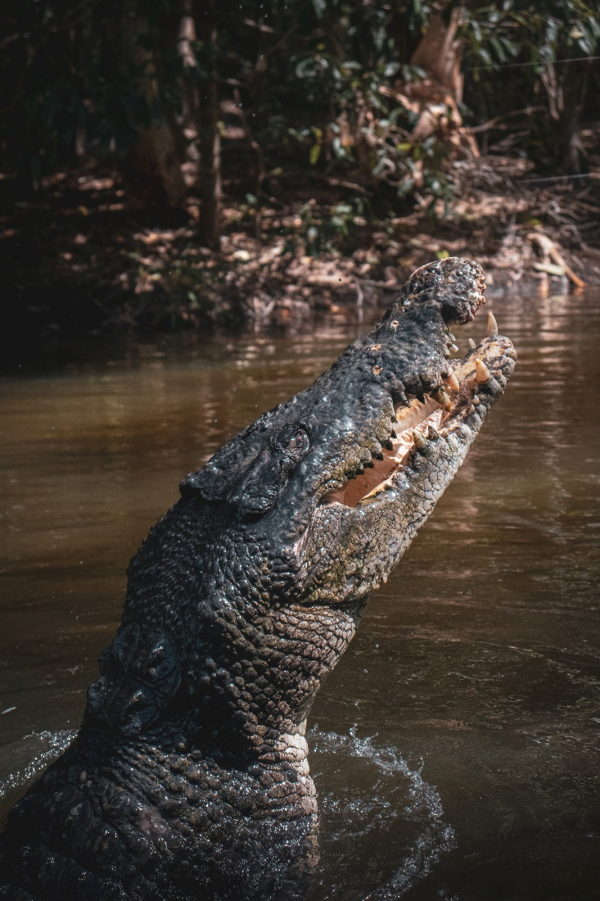

## Questions

1. QUESTION1
   1. ANSWER
2. QUESTION2
   1. ANSWER
3. …

## Collocations and Difficult Words

* **WORD** – DEFINITION
* **WORD** – DEFINITION
* …

## Countries, Languages, and Demonyms

* China Mandarin Chinese

## Highlighted Vocabulary

*Remove?*