# TWINS WHO HAVE DIFFERENT BIRTH DATES

*Twins born on a different day, month, and year*

On New Year’s Eve in California, USA, Fatima Madigal went into labour. She had her son Alfredo Antonio Trujillo at 11:45pm on 31 December 2021. Fifteen minutes later, just after the clock struck midnight, his sister Aylin Yolanda Trujillo was born, making her the first baby to be born at that clinic in 2022.

Fatima said, “It is crazy to me that they are twins and have different birthdays. I was surprised and happy when she arrived at midnight.”

Twins with different birthdays are a rare occurrence and it is estimated that the chance of them being born in different years is one in two million.

The doctor in attendance said that the birth of the twins has been “one of the most memorable” of her career. She also said, "It was an absolute pleasure to help these little ones arrive here safely in 2021 and 2022. Whan an amazing way to start the new year!”

Two years ago, an Indiana couple also had twins - one twin was born on 31 December 2019, and the other on 1 January 2020.

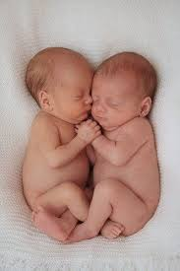

## Questions

1. QUESTION1
   1. ANSWER
2. QUESTION2
   1. ANSWER
3. …

## Collocations and Difficult Words

* **WORD** – DEFINITION
* **WORD** – DEFINITION
* …

## Countries, Languages, and Demonyms

* China Mandarin Chinese

## Highlighted Vocabulary

*Remove?*