# CAMELS BANNED FROM BEAUTY CONTEST

*Camels' lips and noses are being injected with Botox to make them look more attractive*

Riyadh, the capital of Saudi Arabia, holds the King Abdulaziz Camel Festival in a nearby desert. This event lasts for a month and breeders can compete for a winner's prize of $66m. This event aims to preserve the camel’s role in the kingdom’s Bedouin tradition and heritage.

Similar events take place across the region.

In 2021 officials conducted the biggest crackdown ever on camels that received Botox injections. The crackdown led to more than 40 entries being disqualified. The winner is decided by the shape of an animal’s head, neck, hump, dress, and posture. Botox, facelifts, and other cosmetic alterations make the camels more attractive.

The camel beauty contest is the highlight of this big festival. They also have camel races, camel sales, and camel milk tasting.

Officials have found that breeders had stretched out the camels' lips and noses, used hormones to boost muscles, injected heads and lips with Botox, inflated body parts with rubber bands and used fillers to relax their faces. The SPA reported that the organizers would, in future, be imposing “strict penalties on manipulators.”

In Saudi Arabia, the breeding of camels is a multimillion-dollar industry.

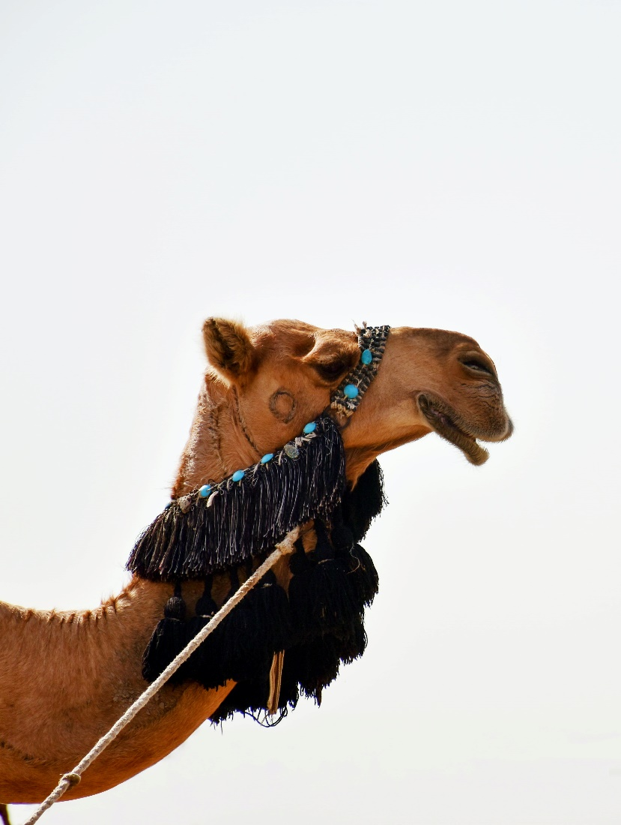

**[INSERT IMAGE HERE]**

## Questions

1. QUESTION1
   1. ANSWER
2. QUESTION2
   1. ANSWER
3. …

## Collocations and Difficult Words

* **WORD** – DEFINITION
* **WORD** – DEFINITION
* …

## Countries, Languages, and Demonyms

* China Mandarin Chinese

## Highlighted Vocabulary

*Remove?*